

№127 жалпы орта білім беретін мектебі

Ашық сабақ

Тақырыбы: «Learning about Minecraft»
Пән мұғалімі: А.А.Қыдырбаева
Сыныбы: 8“b”
Күні: 26.11.2021

2021-2022 оқу жылы

Term 2  Unit3"Entertainment and media" | School: №127 secondary school
Date: 22.11.2021 | Teacher’s name: Kydyrbayeva A.A.
Grade 8B | Number present: |  | Number present:
Theme of the lesson: | Learning about Minecraft
Learning objectives(s) that this lesson is contributing to | 8.C10 use talk or writing as a means of reflecting on and exploring a range of perspectives on the world  8.S7 use appropriate subject-specific vocabulary and syntax to talk about a range of general topics, and some curricular topics
Lesson objectives | All learners will be able to:  - Recognize and use vocabulary to do with television.  Identify the meaning of the text about television broadcasting in the past and present.  Most learners will be able to:  Discuss and give opinions about television technology in the past and present.  Some learners will be able to:  Express ideas about television technology in the past and present building  .
Plan
Planned timings | Teacher’s activities | Pupil’s activities |  | Marks | Resources
Beginning  the lesson | The lesson greeting.  The teacher sets the lesson objectives, letting students know what to anticipate from the lesson.  Warm up. Free talk.  - What type of television do you have at home? (digital, satellite)  - Do you know how television works?  - What video games do ypu like? Why? | Students respond to greeting  Answer the questions |  | Formative Assessment  Comments | Internet
Main Activities | Dividing into 2 subgroups  The class is divided into two groups by the card method. 1 group chose the picture, the second group chose the words.  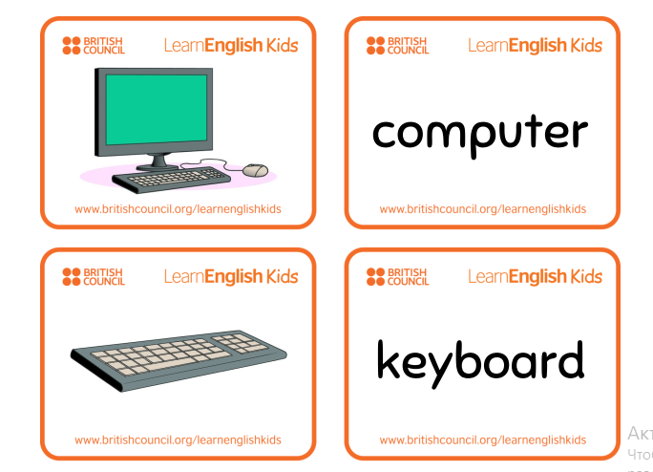  Ex.1 p.41. Conveying the meaning of new words. Use of dictionaries. Vocabulary matching task.  Answers:  A) satellite dish  B) interference  C) aerial  А) спутниктік антенна  В) кедергі  C) әуе  Ex.2 Skimming.  Ender Dragon  The monster that u have  to beat to complete the  game  Pig  YOUR ARCH ENEMY  (Some of u know Sky hates squids well i hate pigs)  Zombie  Not a Real nice creature  What game are these words from?  Ex.3 Detailed reading.  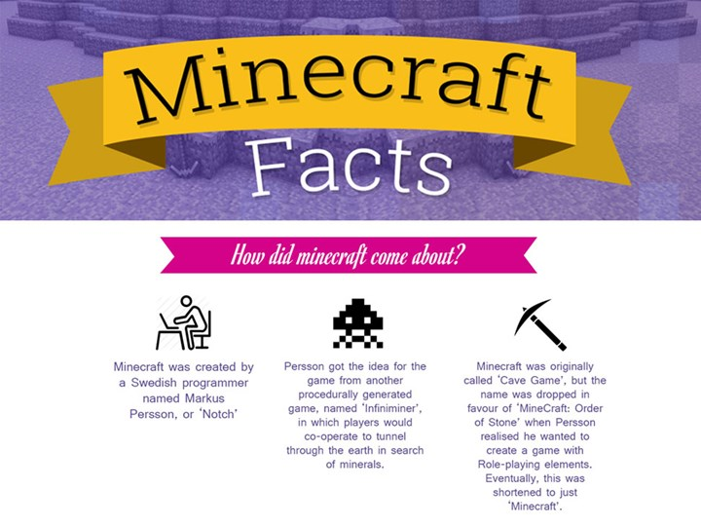  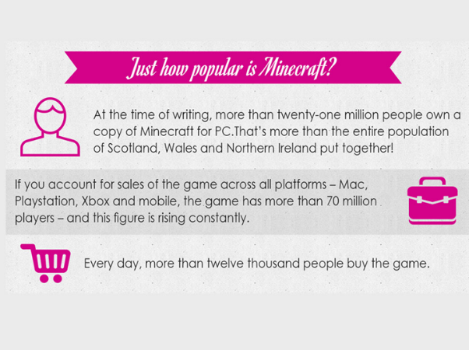  Ex.4 Try to use a laptop and watch video with tasks!  Transcript  A teacher at the front of the class — looks pretty standard, right? Students at their laptops, yep, all seems pretty normal here. But hang on a minute, they're playing Minecraft!  The game started life here in Sweden. It's now played all around the world. And in this school these guys aren't using Minecraft in their breaktime, they're using it in a lesson, and the lesson is compulsory.  'It felt a bit weird at first, 'cause he was like "We're gonna play Minecraft" and we were just thinking, OK, what's this gonna be about?'  'We usually do it in different lessons. We usually use science, social studies and maths.'  The students at this high school in Stockholm, the capital of Sweden, have used Minecraft to design a city of the future and solve real-life problems like recycling.  'The only limit is, like, your imagination, your fantasy and that's a very fun idea because it brings forward the creative side of you.'  'Instead of, like, drawing or thinking, like, in your head about what it's gonna look like you can visualise it in Minecraft.'  But not everyone's a fan.  'I'm not so much into Minecraft myself.'  'I'm not either.'  'But I can, like, I do not enjoy just building houses like we did in school because I think it's kind of boring.'  But when it comes to gaming it's the one thing that students definitely know more about than the actual teachers, so how do they feel about that?  'The children and the students are expert in Minecraft, many of them, and they can do all kinds of things that you can't imagine. But you have to accept it and focus what your task is, er, mainly to keep ... keep them to co-operate and learn from each other.'  Some people think video games should stay out of the classroom, but here at this school in Sweden it's now part of everyday life.  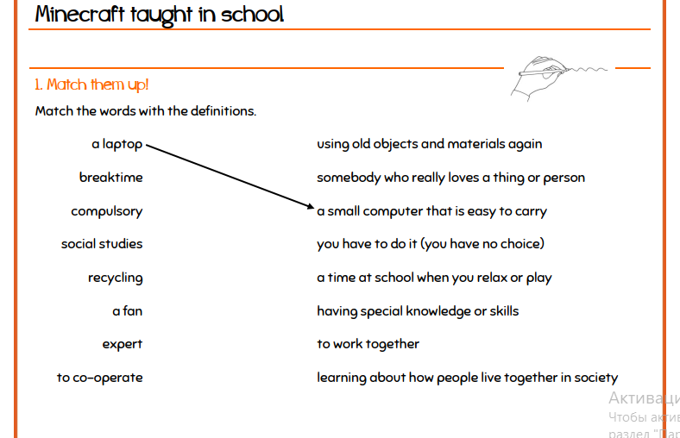  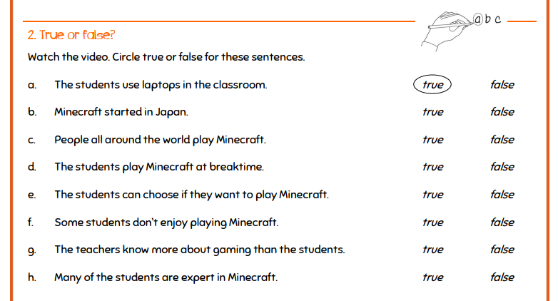  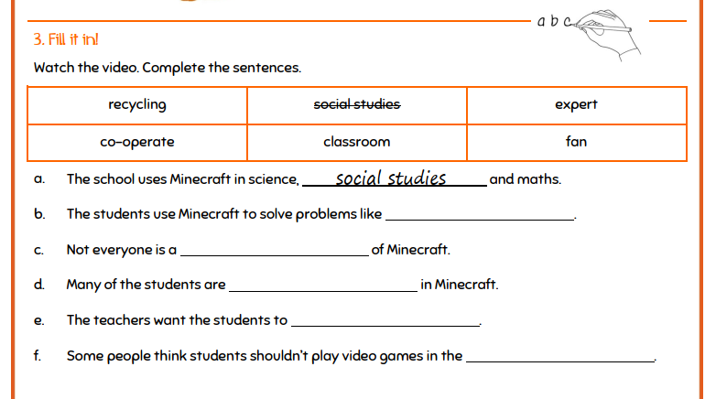  Ex.5 Grammar “Gerund and Infinitive”  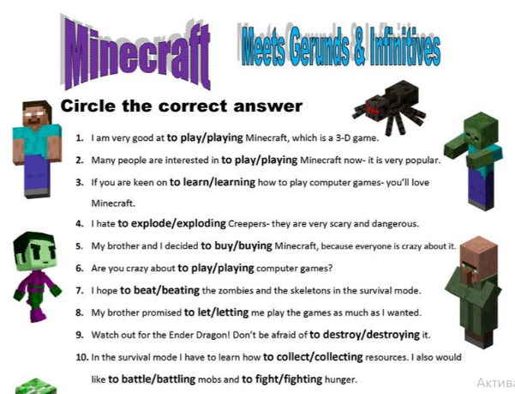  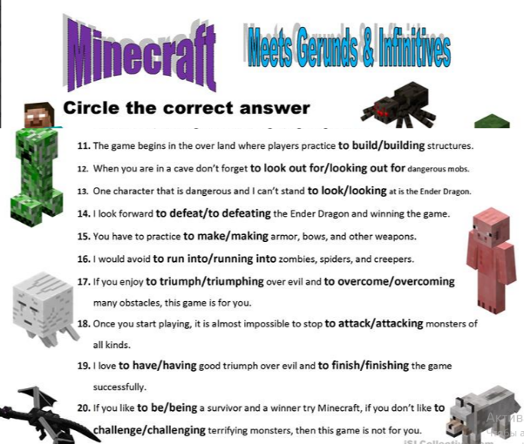 | Flashcards “Tehnology”  Students complete the information.  LEARNING ABOUT MINECRAFT | Quizlet  Presentation  https://www.youtube.com/watch?v=xwkYnggCwB8&feature=emb_imp_woyt |  | Emoticon | Presentation  Handouts with task
Ending the lesson | Giving the hometask. Presentation "To build our school through Minecraft games and describe, write comments on that work ".  Self-assessment.  Students express their attitude to the lesson and give self-assessment using the method: “Six thinking hats”:  - Green: How can you use today's learning in different subjects?  - Red: How do you feel about your work today?  - White: What have you leant today?  - Black: What were the weaknesses of your work?  - Blue: How much progress have you made in this lesson? (Now I can, I still need to work on, I've improved in, Today I learnt... )  - Yellow: What did you like about today's lesson?  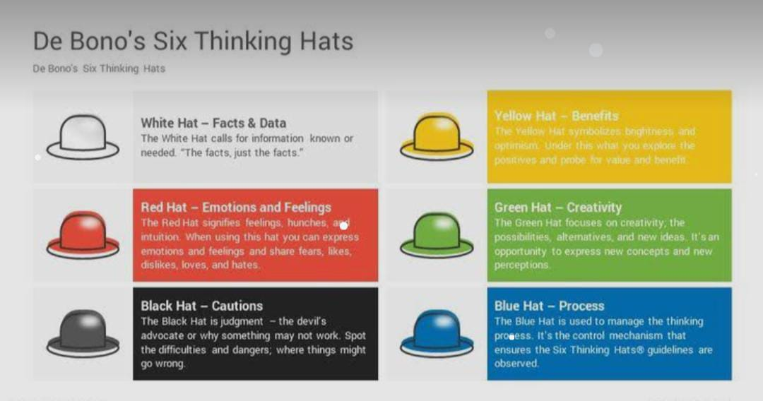 |  |  | Marks | Emoticon

