Lesson plan
Unit of a long-term plan  All about me. Term 1 Lesson 5 My clothes and things |  | School: secondary school №9
Date: |  | Teacher’s name: Zhusipova G. Zh.
Class: 2 |  | Number present: |  |  | Absent:
Lesson title: |  | My clothes and things
Learning objectives (s) that this lesson is contributing to (link to the Subject programme) |  | 2.UE3 use basic adjectives to describe people and things  2.W5 copy letters and familiar high frequency words and phrases correctly  2.S4 respond basic supported questions about people ,objects and classroom routines.
Lesson objectives |  | All learners will be able to: to collect pairs of matching cards.  Most learners will be able to: describe clothes by using colours.()  Some learners will be able to: make up three sentences about themselves
Assessment Criteria |  | 1.Give descriptions of friends using adjectives of colour  2.Tell the following phrases: What are your friend wearing today? She/he is wearing a yellow/red/blue/purple/green T-shirt, dress, skirt etc.  3.Write sentences about themselves
Value links |  | Respect your friends and each other.
Cross curricular links |  | Kazakh language
Previous learning |  | I can…  Use cards and ask “Can questions” to elicit answers about different abilities. Can you swim? Yes I can. No I can’t.
PLAN
Planned timings | Planned activities (replace the notes below with your planned activities) |  |  |  |  | Resources
Start  2min | Learners are introduced lesson objectives.  Greeting: Good morning pupils.  Starter: I will show a video about new vocabulary. |  |  |  |  | https://www.youtube.com/watch?v=taoCF1cKZSY
Middle  5min  15min  10min | - Pre watching task: Introducing with new vocabulary:  Now dear pupils let’s learn our new words. I will say new words and show pictures: cap, coat, shirt, blouse, sweater, trousers, skirt, dress. Pupils let’s repeat new words after me. Pupils will repeat new words in choral repetition, then they will repeat new words in turn and show pictures.  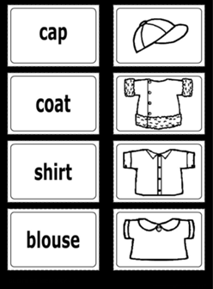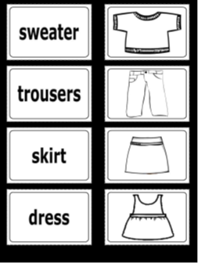  Teacher will introduce the structure What are you wearing today? with video.  While watching task: Pair work  Learners start to do a memory task: in that task learners try to collect pairs of matching cards.  Vocabulary bank: learners look at the vocabulary bank and try to remember the clothes spelling:  - choose only 5 words: dress, skirt, blouse, cardigan, sweater  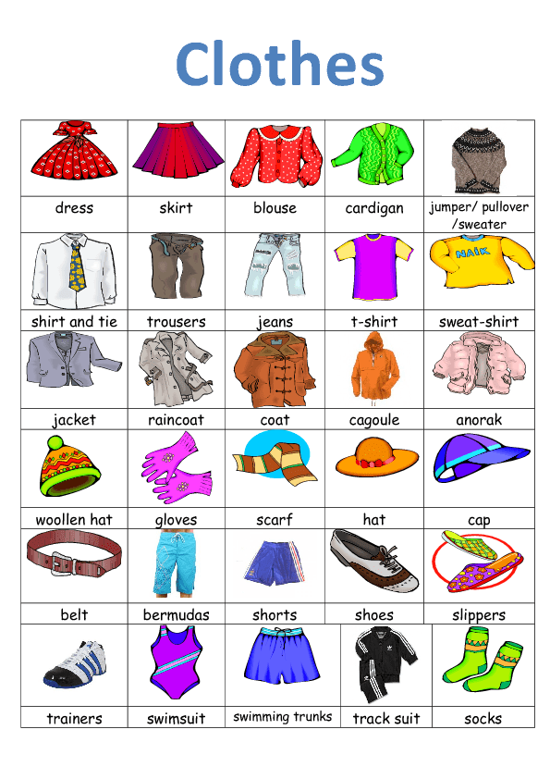  Differentiation by support: While pupils work in pairs, a teacher observes and provides necessary help to low-achieving students.  FA: Criteria of assessment of while learning task:  Post watching task: (I)Clothes picture test  1.At first I will give Picture test worksheet  2. There are ten questions (pictures of the words) in this activity.  3. Pupils look at the picture, then read the words on the right.  4. Pupils choose the word that matches the picture.  5. If a pupil is right he gains one point.  6. If a pupil answer is wrong, he or she can show the the correct one.  At the end of the picture test, pupils see their total score.  Differentiation by task: (I) make up three sentences about themselves |  |  |  |  | http://www.freddiesville.com/videos/clothes-what-are-you-wearing/
  Criteria | Descriptor
  Say and show new words | Say 8 new words and show them in pictures
  Criteria | Descriptors
  find | 1.find 5 things from the cards
  remember | 2.remember these 5 words spelling
  try to collect pairs of matching cards. | Matching cards with their names
End  3min | Pupils give feedback with the traffic lights. If pupils understand the theme clearly they will show the green colour of traffic lights. If pupils don’t understand anything they will show the red traffic light. If pupils understand the theme partly they will show yellow colour of traffic lights.  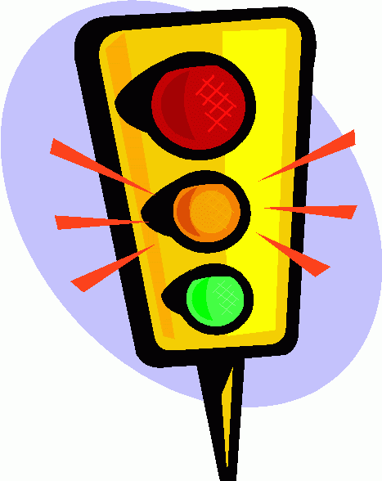  Homework : learn by heart : cap, coat, shirt, blouse, sweater, trousers, skirt, dress
Additional information
Differentiation- how do you plan to give more support? How do you plan to challenge the more able learners?  Differentiation by success criteria  Differentiation by task.  Differentiation by support. |  |  | Assessment- how are you planning to check learner’s learning?  Formative assessment  Assessment by criteria | Health and safety check  Whiteboard and video is used no more than 7 minutes
Reflection |  |  | Use the space below to reflect on your lesson. Answer the most relevant questions from the box on the left about your lesson
Summary evaluation
What two things went really well (consider both teaching and learning)?
1:

2:

What two things would have improved the lesson (consider both teaching and learning)?

1:

2:

What have I learned from this lesson about the class or individuals that will inform my next lesson?

