Ybyrai Altynsarin school

Theme of the lesson: The strange and beautiful land of Australia

|  |  |
| --- | --- |
| Unit 3: | Holidays and travel |
| Teacher’s name: | Zhaksilikova Gulnur |
| Date: | 19.11.2021 |
| Grade: 7 A | Number present: absent: |
| Learning objectives(s) that this lesson is contributing to: | 7.L1- understand with little support the main points in extended talk on a limited range of general and curricular topics;  7.L.5.- recognize the opinion of the speakers in supported extended talk on a range of general and curricular topics; |
| Lessonobjectives: | * To learn about places, animals and sports in Australia * To talk about Australia and what landmarks, animals and sports are special to my country * To improve listening and speaking skills |

**Plan:**

|  |  |  |  |  |
| --- | --- | --- | --- | --- |
| **Part of the lesson/Time** | **Teacher’s activity** | **Student’s activity** | **Assessment** | **Resources** |
| **Beginning of the lesson**  Warming-up  **5 min.** | **Organization moment:**  The teacher greets students; students respond to greeting and take their places.  *Hello, boys and girls! How are you?*  **“I wish….**” method helps to start the lesson with telling supporting words to each other.  ***Checking of the home task***  What was your hometask ? | Students come to the blackboard, tell supporting words to each other. They write words on their stickers and give to each other | “Good job!  Well done!”  9-10 point-  Great!  7-8point-  Good!    6-5point- Try again! | Power point slide.  Stickers |
| ***Pre-learning***  **5min.** | **“Tv game show.”**  Teacher use wordwall.net web site for revise the previous lessons material.  After that Teacher introduces the aim and theme of the lesson.  **Students watch the video**  Do you know what they are?  What country is it?  How do you think what is the theme of our lesson? | Stunets look at the interactive board and choose one card.  **Aim:** Revise the previous lessons material. Find out how much do they remember  **Efficiency:** Students refresh their mind before starting new theme.  Today we are going to talk about Australia.  The theme of our lesson is The strange and beautiful land of Australia. | **Descriptor:**  -identify the card  - know vocabulary of previous lesson.  Total: 1point for each answer | Interactive board  <https://wordwall.net/resource/25303411>  https://youtu.be/nlQIUCN2HdU |
| **Middle of the lesson**  Presentation part.  **10 min.**  Individual work  5 min | you should read correctly the words  Phonetic drill. T: Pupils, look at the blackboard and repeat the following words after me. We will need these words at our lesson today.  Australia [ə 'streɪljə] - Австралия  kangaroo [ ͵kæŋɡə 'ru:] - кенгуру  camel race | ˈkam(ə)l reɪs |- түйе жарысы  the Common wealth [ 'kɔmənwɛlθ] - ортақ байлық  Kookaburra [ 'kʊkə ,bʌrə]- Кукабурра  Sheep shearing | ʃiːp ˈʃɪərɪŋ |- қой қырқу.  Teacher show pictures of Astana  And describe the pictures. | Students open their books on page 36 and write down new words.  Practice the pronunciation.  Students know about the most beautiful places in Astana | **Descriptor:**  **-**can spell the word  -can label the picture  Total: 1point | Whiteboard  Student’s book  Interactive board    https://wordwall.net/resource/25308606 |
| After listening to the video say if these statements are True or False:   1. Uluru is a giant desert in Australia. 2. Alice Spring is a capital of Australia. 3. Camel racing first brought to Australia in the 1800s. 4. Australia produces more oil than any other country. 5. Sheep shearing is a kind of sport. 6. Australians make everything a sport, even the animal they hate most. 7. Australian rule football is the country’s favourite sport. 8. Native animals of Australia are kangaroos, koalas and wombats.   Answers : 1- F, 2- F, 3 -T, 4 -F,  5- T, 6 -T, 7 -T, 8- T. | They use wordwall.net web site from their mobile phones. | **Discriptor**  - Demonstrate the ability to answer with the appropriate information;  - Choose the correct answer.  Total: 1point for each answer | https://wordwall.net/play/25306/821/957 |
| Team work  **10 min.** | Group 1  There are a lot of strange and unusual animals in Australia. We know about kangaroo. And what about others.  Look at the pictures. Read the descriptions and match pictures A,B,C,D with texts 1,2,3,4. Work in groups.   |  |  | | --- | --- | | **Words** | **Pictures** | | 1)Echidna [ikidna] |  | | 2)Dingo |  | | 3)Platypus |  | | 4)Kookaburra [‘kukә,burә] |  | | 5)emu [imju] |  |   Group 2  Read the text about famous places and match them with the pictures:   |  |  | | --- | --- | | **Words** | **Pictures** | | 1)The Sydney Opera House |  | | 2)Uluru |  | | 3)Kakadu national park |  | | 4Parliament House |  | | 5)Mount Koscuiszko |  | | Studentd look through new words an  Each team presents their versions  Check each other  Other teams check and evaluate them. | **Descriptor:**  -cooperate as a team  -work with new words  -can complete the groups  Total: 1point | Whiteboard Student’s book Poster |
| **End of the lesson.**  5 min      **Reflection**  Individual work:  **5 min.** | **Game: What is missing?**  Look at the board.T here are some new words which we have learned today.You should remember them and close your eyes. I ‘ll take away one word and you should guess what word is missing?  Uluru, The Sydney Opera, Canberra, surfing, dingo, Kukaburra, koala , emu, sailing  ✓ I have just learnt  ✓ I know  ✓ I want to know | Students should remember words. They should find missing words  ***Aim:*** To know how many students got the theme.  **Differentiation:** ***«Conclusion»*** method is used to finish the lesson. | **Descriptor:**  -Remember words  -Find missing words  Students evaluate each other :  Well done! Brilliant! Good job! I like it! | Whiteboard  Poster:  Stickers  Cards |

**«Ыбырай Алтынсарин атындағы орта мектеп» коммуналдық мемлекеттік мекемесі**

Келісемін БекітемінӘ/Б жетекшісі: Мектеп директоры : ______М.А.Орынбаева ________Б.Б.Досаева

**Aшық сабақ**

**Тақырыбы : The strange and beautiful land of Australia**

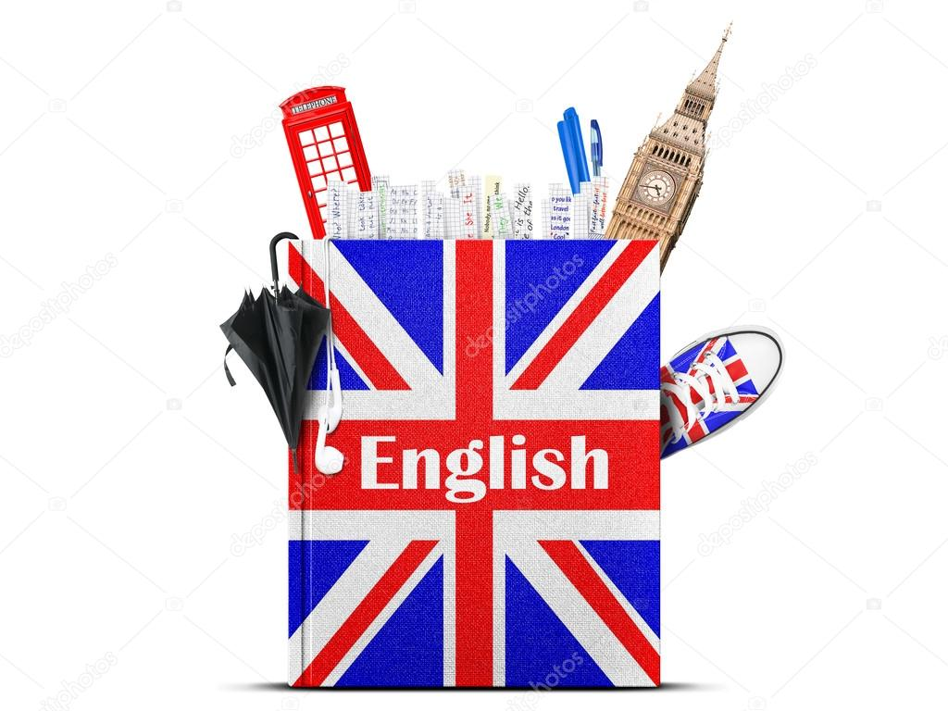

Ағылшын тілі пәні мұғалімі : Жаксиликова Гулнур

2021-2022 оқу жылы