* **Lesson aim:** to introduce the nouns (name of person, place, thing and animal);
* **Class level:** 2
* **Lesson length:** 40 min
* **Text and reasons for using it:** “Kate’s bike”
* **Target grammar area analysis (form, meaning and pronunciation):** nouns (name of person, place, thing and animal);
* **Lesson plan:**

Teacher greets students; students respond to greeting and take their places.

Get students ready to the class by greeting them, asking questions about their feelings.

Teacher: Hello! How are you today?

What is the day today?

What is the date today?

Who is absent today?

As a warming up learners sing a song “Let's Count to 20 Song For Kids”

<https://www.youtube.com/watch?v=0VLxWIHRD4E> - 5 min

* **Lesson procedure:**

1. Teacher will show a picture and ask questions:

T: What do you from this picture?

Who are there?

What are there?

Where is it? - 7 min

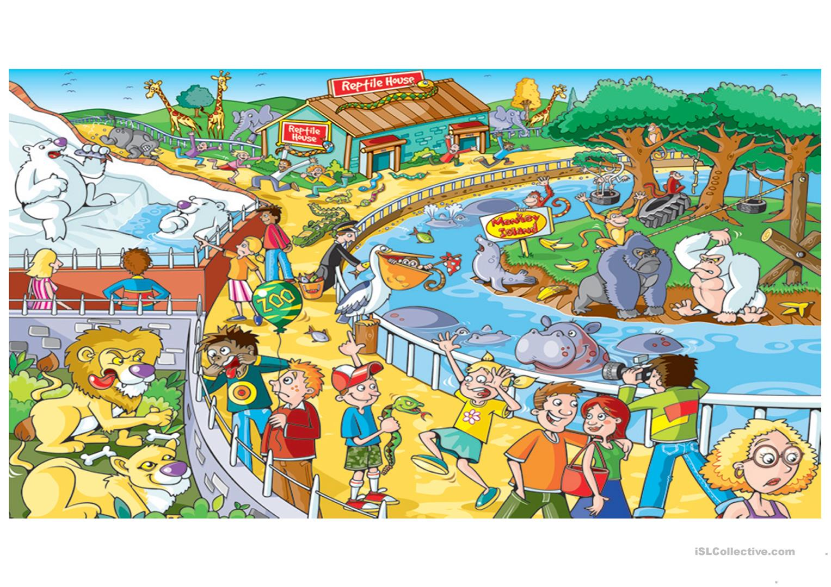

1. **Watch the video about nouns** “NOUN SONG | LEARN ENGLISH”

<https://www.youtube.com/watch?v=8p5UhEKmA7g> – 3 min

1. **Work with flashcards “Nouns” – sorting out: -** 10 min

|  |  |  |  |
| --- | --- | --- | --- |
| **Person** | **Place** | **Thing** | **Animal** |
| mother | school | pencil | dog |
| baby | sea | book | hen |
| sister | zoo | door | tiger |
| doctor | mountain | flower | monkey |
| man | Almaty | paper | elephant |

1. **Read the text;** find the nouns and write under each columns: - 10 min

|  |
| --- |
| Kate’s bike  Kate loves to ride her bike. Her bike is pink with a green basket. She pedals down her street. She can ride it to school. She likes to put flowers and snacks in her basket. Kate can go very fast down hills. She is careful when she crosses the street. Riding bikes is fun! |

**Answer:**

|  |
| --- |
| Kate’s bike  Kate loves to ride her bike. Her bike is pink with a green basket. She pedals down her street. She can ride it to school. She likes to put flowers and snacks in her basket. Kate can go very fast down hills. She is careful when she crosses the street. Riding bikes is fun! |

|  |  |  |  |
| --- | --- | --- | --- |
| **Person** | **Place** | **Thing** | **Animal** |
|  |  |  |  |
|  |  |  |  |
|  |  |  |  |
|  |  |  |  |
|  |  |  |  |

1. **Reflection and Assessment: -** 5 min

Teacher will give to students picture; students should to stick under the name of nouns;

|  |  |  |  |
| --- | --- | --- | --- |
| **Person** | **Place** | **Thing** | **Animal** |

|  |  |  |  |
| --- | --- | --- | --- |
|  |  |  |  |
|  |  |  |  |