School:
Subject: | English
Unit:3 | My family and friends
Teacher’s name:
Date: | 29.11.2021
Grade:1 v | Number present: absent:
Theme of the lesson: | Days of the week
Learning objectives(s) that this lesson is contributing to: | 1.L3recognize the spoken form of a limited range of basic and everyday classroom words  R2 recognize initial letters in names and places  1.S3 pronounce familiar words and expressions intelligibly
Lesson objectives: | All learners will be able to: Recognize and name the days of the week  Most learners will be able to: Name the days of the week without mistakes  Some learners will be able to: recognize,name and ask questions about days of the week
Assessment criteria | -say days of the week correctly  -create words from the letters and spell letters correctly
Lesson plan:
Part of the lesson/Time | Teacher’s activity | Student’s activity | Assessment | Resources
Beginning of the lesson  Warming-up  Team work  5 min. | Organization moment:  1.Greeting.  Teacher asks students to stand upand through the ballot each other to ask the question: “How are you?”  -I’m good and you?  -How are you?  -Fine,and you?  Warm up  Teacher shows pictures (7 balloons, 7 kids), and asks: what else can be seven? | Studets stand and sing song greeting song.  The aim: To develop Ss speaking skills and create friendly atmosphere  Efficiency: By asking each other questions they feel better and feel the support of others. | At the organization moment T tries to award active Ss. «The praise» method is used to evaluate Ss with phrases like:  “Good job!  Well done!” | CD player  Microphone  Picture,flashcards

Pre-learning  Pair work  10 min. | Teacher introduces the theme of the lesson.  Then the teacher divides the learners into three groups:  1stgroup – Monday  2ndgroup - Wednesday  3rdgroup – Friday  Teacher explains today’s new words, but in previous lesson they have known the first three days Monday, Tuesday, Wednesday.  - Day-күн  - Week-апта  - Thursday- бейсенбі  - Friday-жұма  - Saturday-сенбі  - Sunday – жексенбі  To practice that new words teacher shows video about days of the week. | Students look at cards and repeat after the teacher  Then they watch the video and repeat | Descriptor:  - learned by heart new words  - can spell  Total:1 sticker | Whiteboard  Cards  Pupils Book  https://youtu.be/mXMofxtDPUQ
Middle of the lesson  Presentation part.  Individual work  10 min. | Task1. Sund…y Mon…ay Tue..day Thu..sday  Wedn …sday F…iday Satu….day  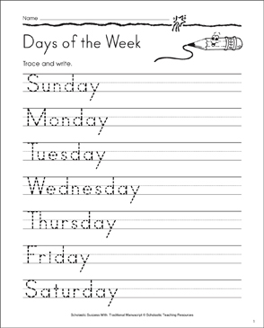  Teacher gives to students worksheet,they should trace and write the missing letters | Students will trace the Days of the Week. Then they will write the missing letters. After this they will make up the words from the letters | Descriptor:  A learner  -traces the Days of the Week  -writes the missing letters  -makes the words from the letters  Total:2stickers  Great job! Fantastic! Can you repeat this words. Yes, you are right | Whiteboard  Pupils Book  Flashcards  worksheets
Pair work  5 min. | Teacher tells the colour of the each day and learners should stick that colours on the board    Monday is red  Tuesday is yellow  Wednesday is purple  Thursday green  Friday is orange  Saturday is purple  Sunday is blue | Students make with color papers rainbow days of the week. Teacher tells the colour of the each day and learners should stick that colours on the board. In the end they create a rainbow | Descriptor:  A learner  -works in pairs  - define the colour  - makes with colour papers rainbow days of the week  2 sticker for each other  Great! Your picture is very nice. Is it Wednesday? Good, your pronunciation very good. | Whiteboard  Pupils Book  Poster
Team work  12 min | The next task: Play the game(“Line elimination”, “Buzz on days of the week”)  First teacher divides the learners into four groups then show all seven numbers to introduce,then teacher give number(f.e:6-Saturday) for each team  The second game is “BUZZ on days of the week”  Tacher introduces a rule of game. | Students will work withteam.Students should find which days is it and they find them first  Which team don’t find days correctly,they exits the game  Students will make a big circle, work with full class. | Descriptor:  A learner  - understand the word  -work with group  -say and find correctly days of the week  “Can you repeat days of the week. Oh, you can identify them correctly.  Very good work!” | Whiteboard  Pupils Book
Reflection  3 min | Teacher explain learners what colours green, yellow and red means. Then they stick colours to the traffic lights. Traffic light method is used to find out was the lesson clear or not. Use the stickers.  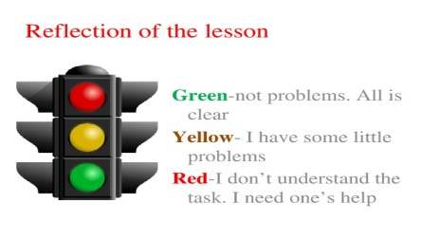 | Ss use their stickers to show their knowledge according to the lesson | Can name the days of the week, describe the colors and give the translation. | Cards  Stickers

