№ 264 school- lyceum

Demonstrative lesson
The theme: “ I want to be healthy. Food”
Class: 4 “B”
Teacher: Baisalova Farida

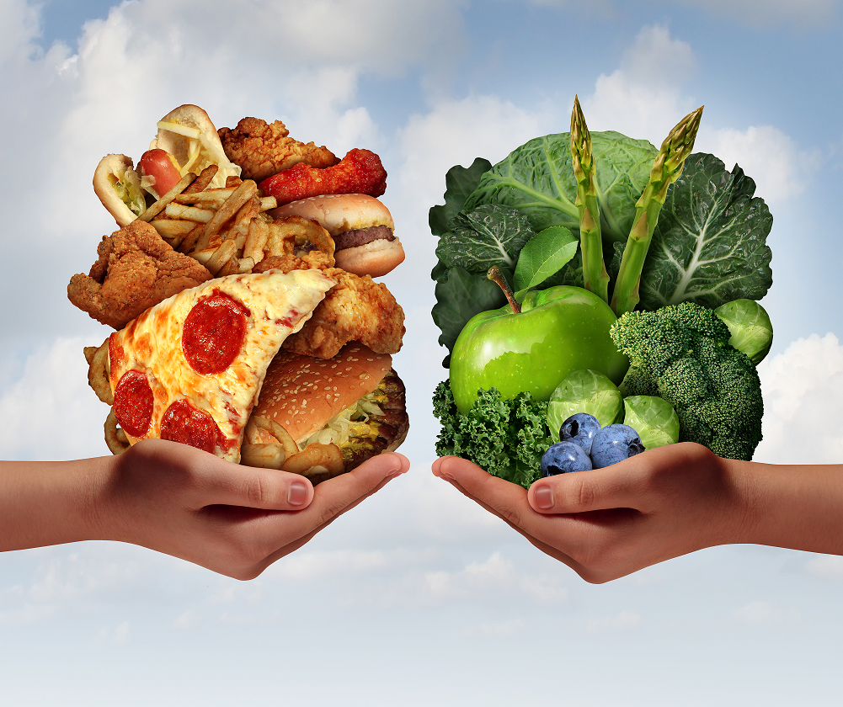

Kyzylorda, 2016
Date: | 14/11/2016
Level: | 4 “B”
The theme of the lesson: | I want to be healthy. Food.
Objectives: | - To practice “ Past Simple, sound U- [ju:], [u:], [Ʌ]”  - To expand pupils ‘ vocabulary on the topic ;  - To develop pupils’ reading and listening skills for understanding specific information;  - To develop pupils’ speaking skills through the dialogue;  - To develop their speaking ,reading , listening, writing skills through their given tasks ;
Objectives: Students wil be able : | - To use Past Simple, Negative form  - To use specific vocabulary on the topic  - To understand specific information and demonstrate their understanding;  - To ask about actions  - To develop their speaking, reading, listening, writing skils through the given tasks;
Tasks | Frontal work | Group work | Pair work |  | Individual work
Tasks | Listen and repeat | Listen , put the foods on the table. | Choose the words with a long u sound |  | Answer the questions  Complete the sentences with the words from the box
Main idea | Talking about hygiene
Further tasks | To learn by heart the new words
Lesson Procedure( Teacher’s and students’ activities)
Stage | Activity |  |  | Interaction |  | Resources | Formative assessment (smiles)
Organization | Greeting.  Asking the day and date.  Checking up of the attendance.  Checking up the home task by giving sweets. Telling about how to be healthy, and food |  |  | T ―>  S―>S
Introduction | Teacher’s speech.  Let’s watch video. After watching video, pupils find today’s theme.  Today’s new theme “ I want to be healthy. Food.  By making puzzle pupils divide into two groups.  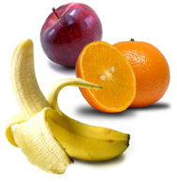  Pupils will divide into two groups as “Healthy, Unhealthy Food.  - Too much [tu: mɅtʃ]-өте көп  - cheese [ tʃiːz ]- ірімшік  - Ingredient [ın’gri:dıәnt]- құрамы  - Pickles [‘pık(ә)l]-тұздалған қияр  - Sandwich meat [‘sәеnwıdƷ mi:t]-туралған ет  - Lettuce [‘letıs]-салат жапырағы  - Tomato [ təˈmɑːtəʊ ]  - Bread [bred]-нан  Fridge [frıdƷ]-тоңазтқыш  Well, open your copybooks and write down the date. |  |  | T―>whole class |  | A notebook, a book
Practice | Pupils divide foods for healthy , unhealthy food.  Listen and repeat sound U- [ju:], [u:], [Ʌ]. |  |  | Group work
Production | Choose the words with a long u sound |  |  | Pair work
Production | Answer the questions  Complete the sentences with the words from the box  “Apple Tree”, pupils match the verbs. |  |  | Individual work
Reflection | Lesson was interesting  Lesson was boring  Lesson was very interesting
Assessment | Evaluating by their collected smiles

