Lesson plan

Unit 5. Reading for pleasure |  |  |  | School: №14
Date: |  |  |  | Teacher name: Mustafaeva A.A.
Class: 7 |  |  |  | Number present: 10 | Absent:-
Theme of the lesson: |  | Romeo and Juliet-William Shakespeare
Learning objectives(s) that this lesson is contributing to |  | 7.S9 use imagination to express thoughts, ideas, experiences and feelings  7R4 read independently a limited range of short simple fiction and non fiction texts
Lesson objectives |  | Learners will be able to:  - express an opinion  - identify specific information from the story
Assessment criteria |  | Learners have met 7.4.2.1 if they can demonstrate comprehension of specific information and detail.  Learners have met 7.3.3.1 if they can express opinion and support it with necessary examples.
Value links |  | Responsibility, respect
Cross curricular links |  | Literature
ICT skills |  | White board
Previous learning |  | Fiction and nonfiction texts
PLAN
Planned timings | Planned activities |  |  |  |  |  | Resources
Beginning  Middle | I. Greeting T: Good morning, children! I am glad to see you. How are you? What date is it today? P.: Today is ..... of.....T: Yes. It is winter. What is the weather like today? P: It is cold, windy.  The psychological approach to the lesson:  «A compliment» The name reflects the essence of statements of the pupils is the verbal expression of positive emotions in relation to the partner. « Come and make a circle. Look at your partner and tell him how he looks today, use what adjectives to describe appearance». Begin your statement with a reference name. Use the model of "You look so...!" - “You are so ... today!” students is the verbal expression of positive emotions in relation to the partner  Assessment during the lesson: There is a paper on the desk. Learners must complete money if the learner gives successfully answer  II. Checking up their homework. To say that he understood with method of continuation  Fiction and Non-fiction literature - Robinson Crusoe-Daniel Defoe    - Brainstorming  Watch a video and answer the questions.  1. What about this video?  2. What do you know about it?  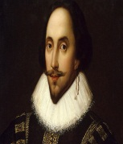  The first teacher divided students into groups by choosing one of the stickers from the tree.  1. Romeo and Juliet  2. William Shakespeare  - Task 1.  Groups read the text method` Jigsaw`  then pair up with someone from the other group and tell them about their story, and listen to the other one. To help students remember their story you may get them to take notes. Alternatively, the students can keep the article with them to refer to. Be careful though, as lazier (or ingenious) students will either read the article aloud, or simply give it to their partner to read!!  First group`s learners read a short story “ Romeo and Juliet”  Second group`s learners read a short text “William Shakespeare. Then the pupils answer the following questions:  to use method of ‘The Board Magazines’  1-st group 2-nd group  Task 2. Role play. Who is the best role player?  (Students read the dialogue and play the role . At first they choose a card with heroes’ names )  Romeo: I don`t know your name. I saw you just a few minutes ago. I want to talk to you, but I don’t know what to say.  Juliet: You don’t have to say anything.  Warm up  Students stay face to face. must do :  If the teacher tells 1 – they clap their hands  If the teacher tells 2 – they sit down  If the teacher tells 3 – they jump  Task 3. Compilation of sentences from sections and tell True or false ( Learners make sentences on the poster and check each other then write White boar True or False )  - Lord Capulet wants to dance.  - Juliet dances with Romeo.  - Tybalt wants to talk to Romeo.  - The Prince of Verona told the families to stop. |  |  |  |  |  | to give a picture of the heart    slide  Formative assessment with smile and money  to watch a video  Formative assessment with smile  tree and stickers  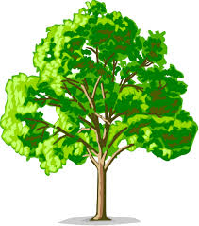    Worksheets are on the board  Formative assessment with smile and money  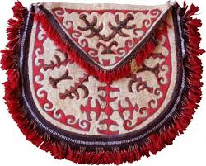  book and word sheet    glue and word sheet and poster  
  What is clear to me on this topic? What do I know? | What news did I learn in the text?
End | Reflection  Ask learners what difficulties they had during the lesson.  Feedback ‘Smart owls’  ( Students write their names and stick the Smart owl ) Homework  To find some information about Romeo and Juliet |  |  |  |  |  | smart owl  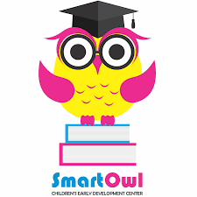  stickers
Additional information
Differentiation – how do you plan to give more support? How do you plan to challenge the more able learners? |  |  | Differentiation by support and outcome – teacher might decide on the number of words used by an individual learner during the speaking activity |  |  | Health and Safety links
Assessment – how are you planning to check learners’ learning? |  |  | • Monitor how much vocabulary learners can use in their speaking.  • Monitor how learners find the answers during the reading for specific information activity  • Monitor how learners complete the vocabulary tasks |  |  | Use the space below to reflect on your lesson. Answer the most relevant questions from the box on the left about your lesson.
Reflection  Were the lesson objectives/learning objectives realistic? What did the learners learn today? What was the learning atmosphere like? Did my planned differentiation work well? Did I stick to timings? What changes did I make from my plan and why? |  |  |  | Use the space below to reflect on your lesson. Answer the most relevant questions from the box on the left about your lesson.
The lesson went well as the students were engaged in the class and pair discussions. Students contributed to discussions and shared their ideas with the peers.
Most of the students were able to complete the reading task successfully, although some of the learners struggled with the new words while reading.
Next time, I should provide more scaffolding with the new words to the certain students.

Summary evaluation

What two things went really well (consider both teaching and learning)?
1: Class\ pair activities

2: Differentiated task

What two things would have improved the lesson (consider both teaching and learning)?
1: Providing scaffolding

2:

What have I learned from this lesson about the class or individuals that will inform my next lesson?
Students love reading about teenagers like them and find similarities in their lifestyles. Students love doing creative tasks, especially when they have a choice. Everyone was engaging in doing a creative task with high motivation and excitement.

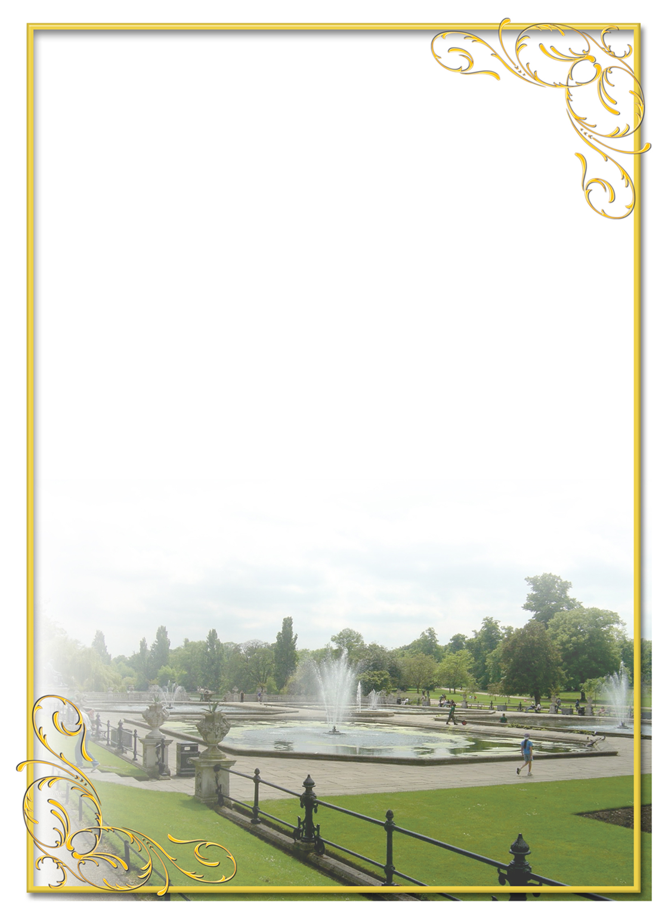
Secondary school №14

The theme: Romeo and Juliet-William Shakespeare

Grade 7 “A”

Prepared by Mustafaeva Alfiya Altaeva

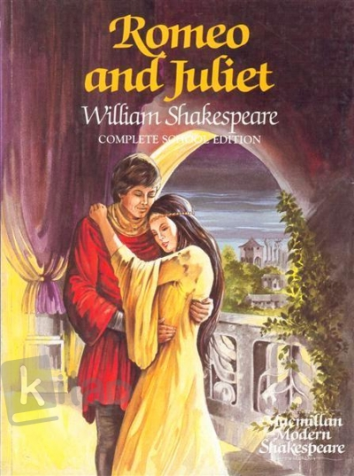

Kosozen 2019

