Short term plan

Unit: My country |  |  | School: 17
Date: 18.09.21 |  |  | Teacher’s name: Issak Saltanat
Grade 6 |  |  | Number present: | Number absent:
Theme of the lesson: |  |  | My country
Learning objectives(s) that this lesson is contributing to |  | 6.R2 understand specific information and detail in texts on a range of familiar general and curricular topics including some extended texts.  6.S7 use appropriate subject specific vocabulary and syntax to talk about a wide increased range of general and curricular topics.  6.UE6 use questions including prepositions at what time, in which direction, from whose on a range of familiar general and curricular topics.
Lesson objectives |  | - identify specific information and detail about travelling and tourism  - apply suitable subject specific vocabulary to talk about “National heroes”.
Assessment criteria |  | -find out with little support specific information and detail  - use appropriate subject specific vocabulary and syntax
Language objective |  | To read and talk about Travelling and Tourism  New vocabulary: equipment, check-in, to book, travel agent, accommodation, traffic jam, stuck, temple.  Prepositions: across, above, on, among, next to, at, towards, in, round, down.
Value links |  | Respect for self and others, cooperation.
Cross curricular links |  | History
ICT skills |  | Working with smart board, Internet.
Plan

Planned timings | Planned activities |  |  |  | Resources
Beginning the lesson | Organisation moments:  Greeting. Dividing into 2 groups”.  Crossword  Guess a crossword to know the name of our lesson  - Okay, well done the theme of our lesson is “National heroes”.  1.it's fluid made by bees  2.the organ of hearing  3.waste material; refuse or litter.  4.a large round juicy citrus fruit  5.the opposite of the cheap  6.of a size that is less than normal or usual. |  |  |  | crossword
Middle | Make a poster [Group work]  What should a national hero be like?  What do you associate with …?  Focus on reading  Pre-reading  Vocabulary  Farmer worker  Test pilot  Railway worker  Singer  Painter  Soloist  Performer  Trainer  Cosmonaut  Students, look at these photos.  who are the people? What are they famous for?  While reading  Read the text “Our heroes” Write the names of jobs for each person.  Ex. 3, P.29, Text “Our Heroes”.  Farm worker, test pilot, singer, painter, trainer, performer, cosmonaut, soloist, railway worker.  Descriptor:  -complete the table according to the text  Descriptor  A learner  • revises grammar rule;  • completes sentences with correct words from the box.  Post reading  Make up the questions about national heroes.[GW]  Imagine that you are journalist and asks questions about these heroes  - Descriptor:  - Read the text again  - Make the questions about national heroes  Grammar: question tags  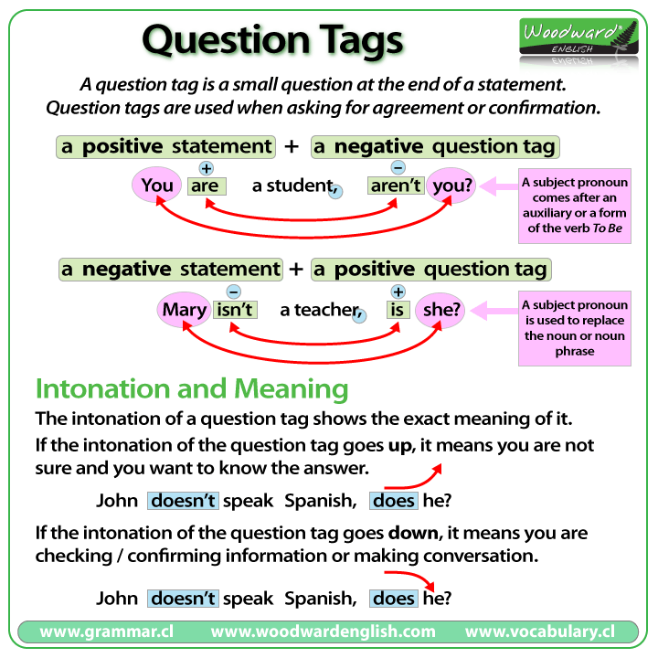  Look at the video and listen to about question tags  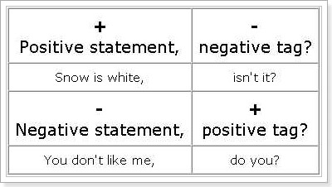  Complete the sentences (be careful: ‘I am’ → ‘aren’t I’ but ‘I’m not’ → ‘am I’ do-don’t, does-doesn’t , can -can’t). Add the tag question. [individual work]  - 1. She is from a small town in China, ________________ ?  - 2. They aren’t on their way already, ________________ ?  - 3. We are late again, ________________ ?  - 4. I’m not the person with the tickets, ________________ ?  - 5. Julie isn’t an accountant, ________________ ?  - 6. She doesn’t have any children, ________________ ?  - 7. He is very handsome, ________________ ?  - 8. They aren’t in Mumbai at the moment, ______________?  - 9. You aren’t from Brazil, ________________ ?  - 10. They live in London________________ ?  - 11. He can’t drive ,______________?  - 12. She can swim,____________? |  |  |  | posters  cards
  Toktar Aubakirov | Roza Baglanova | Abilkhan Kasteev
Ending of the lesson | Feedback  “Bloom’s tree” |  |  |  | Picture
End  1min | Feedback: Teacher asks students what task was difficult to them and which pair worked well.
Additional information
Differentiation –  how do you plan to give more support? How do you plan to challenge the more able learners? |  |  | Assessment –  how are you planning to check learners’ learning? | Critical thinking
Differentiation:  -more able learners should express their opinion according to the text.  -less able learners match words in the correct place  -more able learners write True or false activity  -Less able learners match the Bangkok landmarks and places with the descriptions.  Pre-reading  Match the words with definitions  Most support  by providing a video  Some support  By pronouncing new vocabulary  Minimal support  highlight new words |  |  | Brainstorming activity. (W)  Talk with whole class.  Teacher make observation and provide with correct answers  Pre-reading  Match the words with definitions  will assess by thumbs. Thumbs up, middle or down.   - matching all sentences correctly   - matching with some sentences correctly  -matching sentences incorrectly  While reading  Teacher make observation and make notes  Speaking  Teacher will assess S’s answers by smiles  Writing  will assess by thumbs. Thumbs up, middle or down.  - matching all sentences correctly  - matching with some sentences correctly  -matching sentences incorrectly | Students think critically, exploring, developing, evaluating and making choices about their own and others’ ideas

