Unit: 6 The natural world |  | School–gymnasium №53 named after K. Turyssov
Date: 03.02.2021 |  | Teacher name: Orynbayeva G.A.
CLASS: 8 E |  | Number present: 12 |  |  |  | absent: 0
Theme of the lesson: |  | Reading: The lost world
Learning objectives(s) |  | 8.R3 understand the detail of an argument on a growing range of familiar general and curricular topics, including some extended texts;  8.W3. write with moderate grammatical accuracy on a limited range of familiar general and curricular topics;
Lesson objectives |  | Learners will be able to:  -explain the formation of past passive  -choose the correct synonyms  -prove the text
Assessment criteria |  | Recognize basic general questions without support  Provide unprepared speech to answer a variety of questions at sentence level with limited flexibility  Apply the rule for past passive
Plan
Planned timings | Teacher's actions |  |  |  | Pupils’ actions |  |  | Assessment | Resources
Beginning  5 min  10 min  Middle  20 min  End  5 min | Organization moment.  Get students ready to the class by greeting them, asking questions about their feelings  Checking hometask.  “Brainstorming method”.  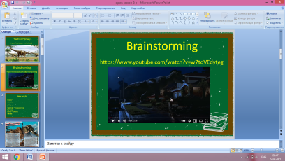  New lesson.  Teacher shows the pictures.  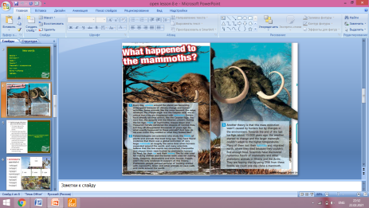  Watching video. Teacher shows a video about endangered animals.  Teacher explains the tasks  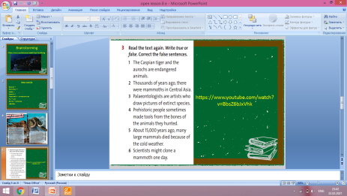  Teacher gives the exercise for the finding true and false sentences  Teacher gives the words for finding synonyms  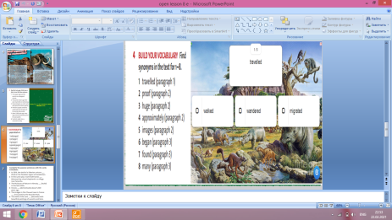  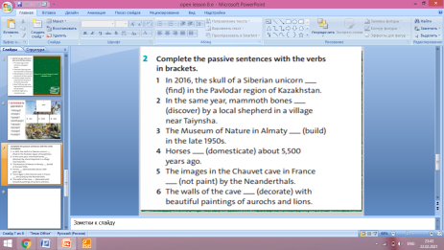  Feedback. For the feedback we will talk about “Traffic lights”    -Green The lesson is clear for me  -Yellow I have got some question  -Red I don’t understand anything  Home task:  Student’s book : Ex 3 p 71 |  |  |  | Pupils wish their best wishes to each other.  A learner  remembers the grammar theme: past passive  Pupils listen to teacher  Pupils guess the new theme  Pupils correct the false sentences  A learner finds the synonyms for the following words.  Pupils listens to the teacher about different forms of words  Pupils complete the sentences  A learner completes the following sentences. Use verbs in brackets  Learners evaluate themselves |  |  | Descriptor:  -a learner chooses the correct words  Praise verbally  Descriptor:  - A learner writes True or False  Praise verbally  Descriptor:  - A learner writes the words  Praise verbally  Descriptor:  - A learner completes sentences Praise verbally | Slide 2  Student’s book p 70  Slide 3  Student’s book p 70  Slide 4  Slide 5  Slide 6  Student’s book p 70  Slide 7  https://learningapps.org/16968968  Slide 8  Slide 9  Student’s book ex 2,p 71  Slide 11
Additional information
Differentiation – how do you plan to give more support? How do you plan to challenge the more able learners? |  |  |  | Assessment – how are you planning to check learners’ learning? |  |  | Healthandsafetycheck
Differentiation by questioning:  -Explain the formation of degrees of adjectives;  -Prove degrees of adjectives.Differentiation question for more able pupils:  -Use adjectives to describe people;  -Choose the correct degrees of adjectives.  Differentiation question for more able pupils:  - Use degrees of adjective correctly;  -Demonstrate their understanding giving feedback in sentence level |  |  |  | Oral feedback  Expert Envoy  Voting  Praising |  |  | Health saving technologies.  Be careful and attentive
Reflection  Were the lesson objectives/learning objectives realistic?  Did all the learners achieve the lesson objectives/ learning objectives? If not, why?  Did my planned differentiation work well?  Did I stick to timings?  What changes did I make from my plan and why? |  |  | Use the space below to reflect on your lesson. Answer the most relevant questions from the box on the left about your lesson.
Summary evaluation
What two things went really well (consider both teaching and learning)?
1:Creating of a positive learning environment at the beginning of the lesson.
2:Identifying synonyms

What two things would have improved the lesson (consider both teaching and learning)?
1: Assessment of learners knowledge during doing tasks
2: Understand the meaning of the text.

What have I learned from this lesson about the class or individuals that will inform my next lesson?
I will pay attention to the pupils understanding

