Esyk college of humanities and economics (name of the educational organization)
Lesson plan or short-term plan for a teacher of vocational education
Lexical and grammatical descriptions of English and Kazakh nouns
Teacher’s name |  | Bulekbaeva Zhanar
Date:08.09.2021
Group: 212 |  | Number present | Number absent
Learning objectives |  | respect differing points of view;  understand main points in extended texts on a wide range of familiar and some unfamiliar general and curricular topics;  interact with peers to make hypotheses about a wide range of general and curricular topics;  use speaking and listening skills to provide sensitive feedback to peers  understand specific information in unsupported extended talk on a wide range of general and curricular topics, including talk on a limited range of unfamiliar topics
Planned timings | Teacher's actions |  |  | Students actions | Assessment | Resources
Beginning  10 min | Welcome, inventory  Good afternoon, students!  How are you today?  Before begin our lesson, lets sing together greeting song!  Create positive psychological atmosphere  The "Circle of Happiness" method. Students create a circle and take turns wishing good wishes.  Let's check your knowledge. We're going to play a game of "You to me, I to you." You should give the ball to the next student with a question. And he should answer.  «Lost letters game»  You did a good job. Now, pay attention to these letters. They are positioned incorrectly. To find out the topic of today's lesson, compose the words in the correct order. |  |  | sings a song  wish each other good wishes |  | Hello To All The Children Of The World - YouTube
Middle  30 min  10 min  10 min  5 min  5 min  5 min | Students are divided into groups: the "Seasons" method  1-group “Spring”  Lexical and grammatical description of English and Kazakh nouns. Common and proper nouns.  make a cluster  2-group “Summer”  Countable and uncountable nouns  presentation on the topic  3-group “Autumn”  Concrete and abstract nouns  video on the topic  4-group “Winter”  Classes of English and Kazakh nouns  Make Venn diagram  Assignment-1  Group work  “Questions on the envelope”  Each person from one group will make 1 question on their topic. When all the questions are ready, they put them in an envelope. Then all the groups will exchange envelopes and answer questions.  Assignment-2  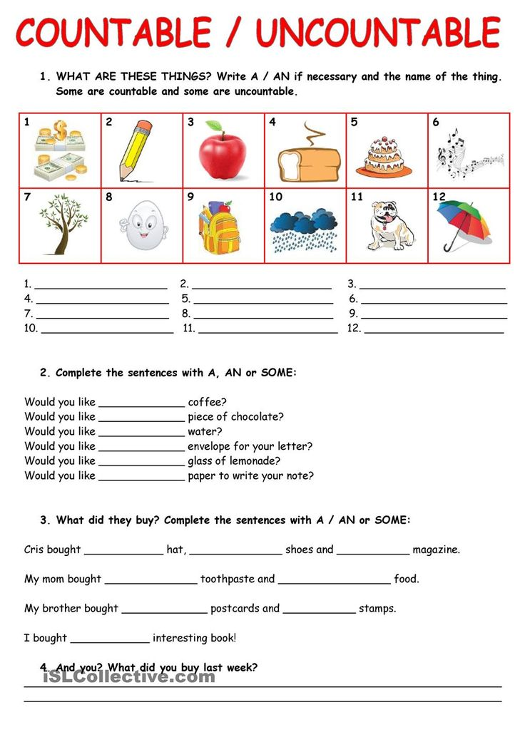  Assignment-3  "dictation game" Group game Each group is given a piece of paper, which is divided into two parts: one contains concrete, the other contains abstract nouns. Within 2 minutes, which one writes more words, that group wins.  Refreshing moment  “Karaoke”  Assignment-4  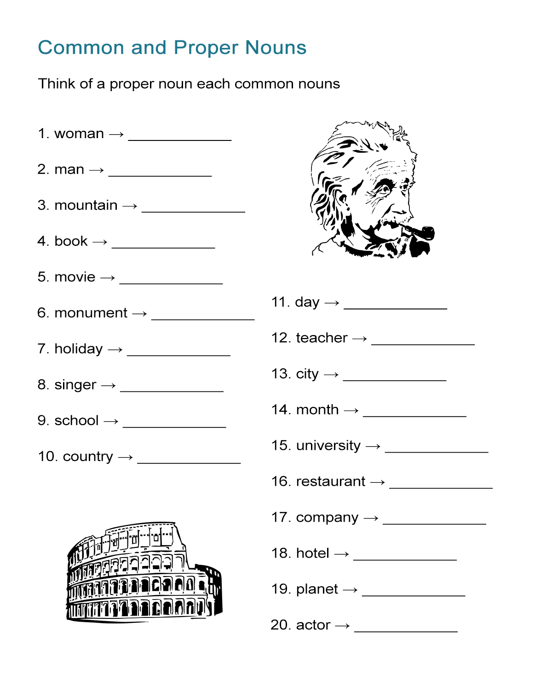 |  |  | Each group will do work on their own topic. They will work in a group, after, they will defend their topic in front of the whole group.  make up questions and answer each other's questions  do the exercises: Determine the countable and uncountable, put words correctly, and complete the sentence  write examples of concrete and abstract noun  students will sing a song that they themselves have chosen  come up with their own names for each common noun | Groups rate each other "Two stars, one wish"  "right or wrong"  Student evaluation of each other  all groups receive certificates  Teacher praise  Well done,  great | grammar textbook, Internet resources, Whatman paper, markers  Envelope, paper  task cards  Game Paper  Music  Task paper, marker
  Concrete nouns | Abstract nouns
End | Conclusion  “cluster” method  what new have I learned in this lesson?    Reflection  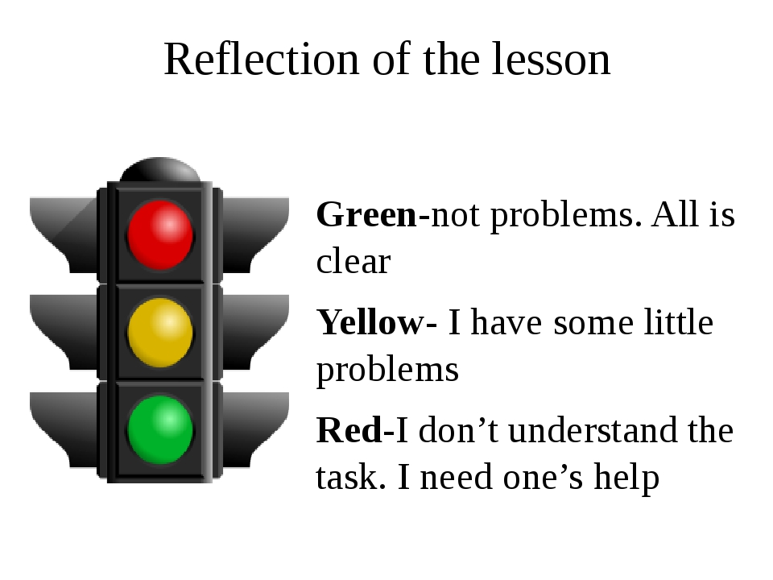 |  |  | summarizes the knowledge gained in the lesson |  | Cluster  traffic light

