***№3 Y.Gagaryn secondary school***

*English week*

***“At the Party” competition***

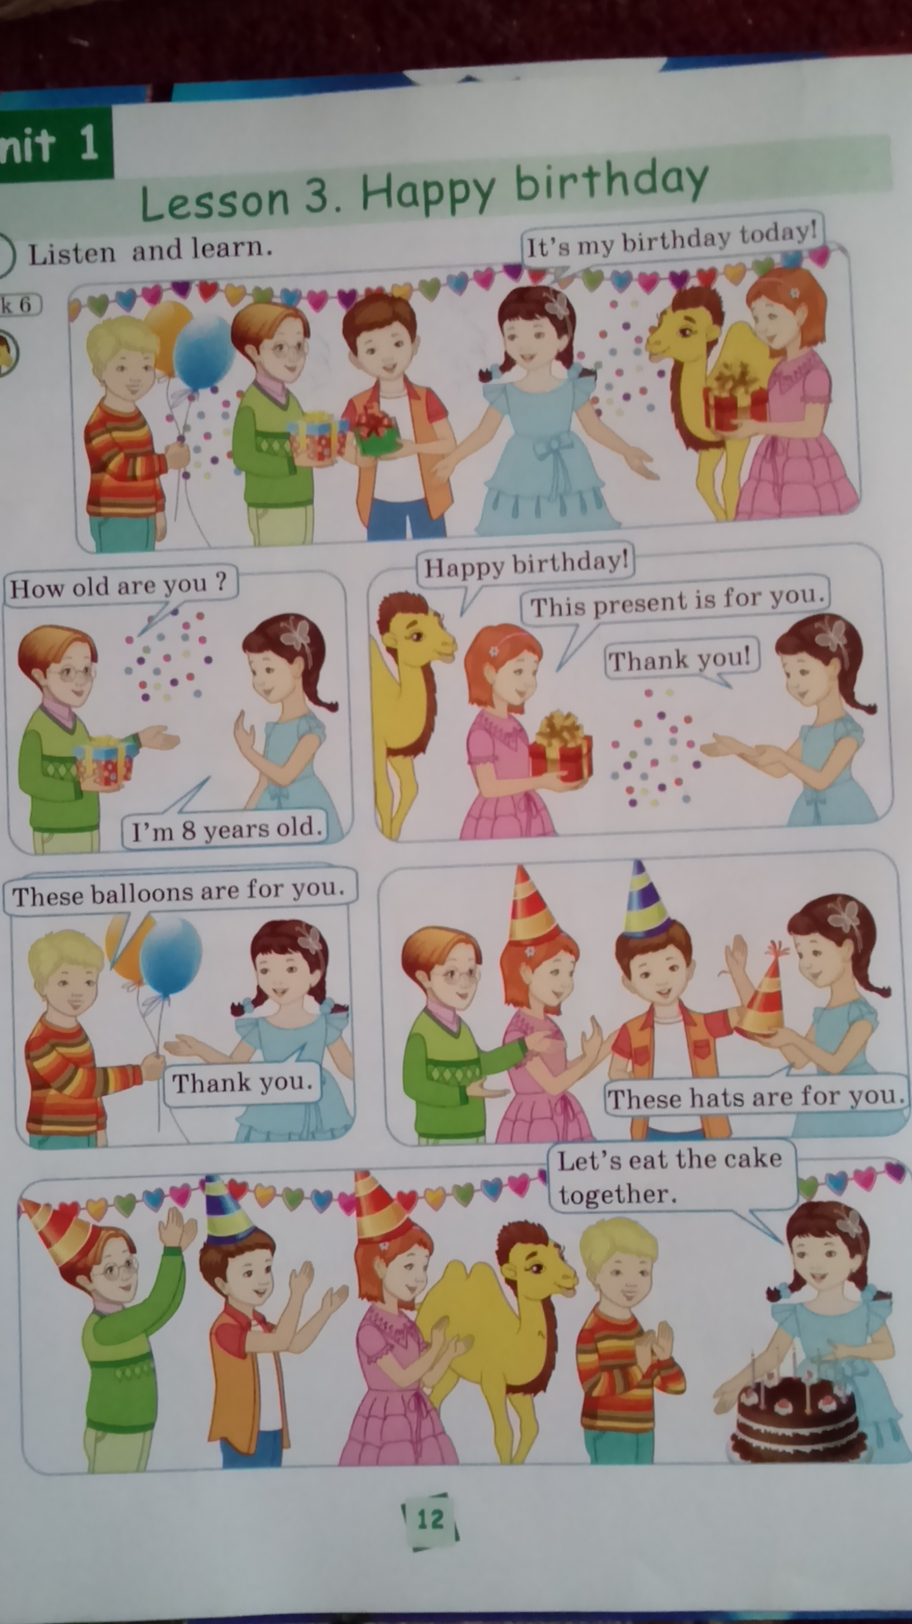

**Happy birthday to you!!!**

***Grade: 5“B”***

***English teacher: Fazylova B.A.***

***2018-2019 school year***

**The theme:** “At the Party” competition

**Grade:** 5”B”

**The aims:**presentation of the competition, to develop pupils’ abilities, bring up love, develop pupils’ speaking skills, oral speech, dialogical skills and habits.

**Visual aids:** interactive board,cards, posters, ball, cards on the tasks, etc.

**The type of the lesson:** competition

The procedure of the lesson:

1. **Organization moment:**

Teacher: - Good day, dear boys and girls! Welcome to our Birthday Party! We are glad and happy to see you here in this Party!

* Now, today we’ll play some interesting games with you and sing and dance, do and give our presents to our Johnny!
* Now, let’s I introduce our friend Johnny. Today is his birthday! He is 11 years old today!
* Let’s sing the song “Happy Birthday” together for Johnny!
* Stand up, everyone please! Now, let’s go! 1-2-3… You must clap for him ok?!

**Musical break:**

Song: “Happy Birthday”

Happy birthday to you,

Happy birthday to you,

Happy birthday to Johnny!

Happy birthday to you!

* Thank you very much! Now. You may take your sits/places! Enjoy this birthday!
* Ok! Now, we will play the game which called “Medical examination”, “At the optometrist”!

**Groups:**

* At the first you must to divide into 2 groups! This is the first group “Cool” and this is the second group “Clever” ok?!
* Who is bestest and quickest today at this party?
* Now, let’s start to introduce ourselves and friends in your group! Who is first? Which team start the introducing?
* Ok, introduce your group, please!

My name is ….. I’m 11. This is Ainur, this is Murat, etc.

-thank you! You may sit!

- Our juries, give their points for introducing, please!

- next please!

1. **Competition**

* Now, we play the games. It’s called “Medical exams”. Look here at the interactive board please! There are some interesting games and tasks for you!

**Slide 1.**

Tour 1.

“Medical examination”

(from each teams 2 students come for this game);

* Now, pupils you are at the medical exams! You will do medical physical exercises!
* ***Stand up!***
* ***Hands up!***
* ***Turn around …***
* ***Sit down!***
* ***Hands down …***
* Now, you’ll go to the Optometrist! There are interesting game for you!

Slide 2

***“At the Optometrist”***

*Stand up! …*

*Go to the blackboard*

*Sit down …*

*Close your right eye*

*Name the Letters!*

*Close your left eye*

*Name the Letters!*

Slide 3

***Name the Letters!****Әріптерді ата!*

***Aa Bb Cc DdEeFfGgHh Ii***

***JjKkLl Mm NnOo Pp Qq Rr***

***SsTtUuVvWw Xx YyZz***

* *Now, Fill in the blank! I’ll give you papers! You must fill it, info about yourselves!*

*Slide 4*

***Fill in the blank /***

***парақшаны толтыр***

*Name _________________*

*Surname _______________________*

*Age ___________________________*

*Form ________________*

*Address ________________________*

*Telephone number _______________*

**Tour 2**

***Greetings & meetings***

***“At the Party”***

* Now, you must introduce yourselves and meet with friends at this Party!

(from each groups pupils must to meet and greet to each other)

**I-group II-group**

|  |  |
| --- | --- |
| Hello!  What’s your name?  My name is ….  How are you?  I’m so-so.  How old are you?  I’m 12.  I’m from Kazakhstan.  I’m from Alga in Kazakhstan. And where are you from?  It’s 23 Abay street. And you?  My telephone number is 24-08-23. And what’s your phone number?  Nice to meet you too, Colin.  Good bye! | Hi!  My name is ….. and what is your name?  I’m ok. And you?  I’m 11. And you?  Where are you from?  Where are you from in Kazakhstan?  I’m from England.  What’s your address?  My address is 78 Oxford street. What’s your telephone number?  It’s 007-2589-245.  Nice to meet you Asem. See you soon! Bye! |

(екі топ бір-біріне сәйкесінше сөйлесу керек)

***Tour 3***

***“The Letter by letter”***

* Now, you must put the words by English alphabet!

(оқушылар сөздерді ағылшын әліпбиі ретінмен қойып жазулары керек).

*Put these words by English Alphabet*

|  |  |
| --- | --- |
| **I-group** | **II-group** |
| book  apple  cat  English  fish  desk  jam  hat  ice  go | doctor  art  ball  eleven  cake  family  jam  hat  ice  go |

***“How do you spell it?”***

* Spell the words by English Alphabet!

***Tour 4***

***“Surprise”***

-Now, you must choose the number and do the task! Who is the first?



***Number 1***

* *Give translation for****“Good morning”*** *Cөздерді аудар!*

***“Good afternoon”***

***Number 2***

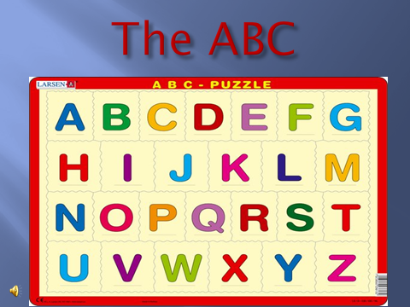

* *Say the English Alphabet!*

*Ағылшын әліпбиін айт!*

***Number 3***

* *Read these words! Мына сөздерді оқы!*

**London name**

**Kazakhstan seven**

***Number 4***

* *Name the numbers! Сандарды ата!*

**110 21**

**14 28**

**8 45 13 57**

**5**

***Number 5***

* *Translate! Аудар!*
* ***Cәлем*! Қалың қалай?**
* ***Қайырлы таң***!
* ***Сау болыңыз***!

***Number 6***

* *Introduce your friends! Өзіңнің достарыңмен таныстыр!*
* *Hi! This is my friend! Her name is Alma. This is Nurlan. ……*

***Number 7***

* *How many letters in this word?*

***NAME*** *- ?*

***Teacher*** - ?

***Number 7***

*Spell the word “London”*

*L-O-N-D-O-N*

* Ok! Now, our juries, please, give their points for their project works!

**VI. Conclusions and marks/ points**

* Let our juries count teams’ points, and we’ll sing and dance together!

**Physical-musical break:**

Let’s sing and do ittogether!

***“If you happy and you know it clap your hands”***

If you happy and you know it clap your hands,

If you happy and you know it stamp your feet,

If you happy and you know it, and you really want to show it

If you happy and you know it clap your hands…

* Well, now … Our “At the party” competition is over! I wish you good luck every success, children! Thank you for your activities, and taking parts in this competition!
* See you soon! Good bye!