**Grade \_\_\_\_\_\_\_\_\_\_\_ Name \_\_\_\_\_\_\_\_\_\_\_\_\_\_\_\_\_\_\_\_\_\_\_\_\_\_\_\_\_\_\_\_\_\_\_\_\_\_\_**

**Tasks for the Summative Assessment for the term 1**

**Listening**

**Task 1.**  Listen and colour.

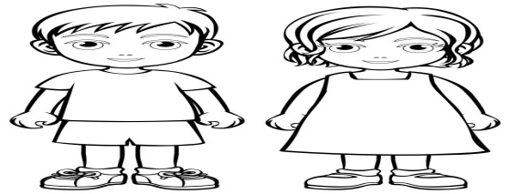

**Reading**

**Task 2.** Read, spell and match pictures to the words.

|  |  |  |
| --- | --- | --- |
| **1.** | http://www.clipartbest.com/cliparts/4c9/o8p/4c9o8pMgi.jpeg | **Friends** |
| **2.** | Картинки по запросу help clipart | **Football** |
| **3.** | http://images.clipartpanda.com/friend-clip-art-cover-clip-art.jpg | **Help** |

**[3]**

**Writing**

**Task 3.** Complete the words.

|  |
| --- |
| **Tr Sh H** |

|  |  |
| --- | --- |
| 1. http://cdn.grid.fotosearch.com/CSP/CSP507/k5070560.jpg | **\_\_\_at** |
|  |  |
| **3.**http://images.clipartpanda.com/trousers-clipart-jTxEdajec.gif     1. **pngtree-comfortable-shorts-vector-or-color-illustration-png-image_2030335** | **\_\_\_ ousers**  **\_\_\_orts** |
|  |  |

**Use of English**

**Task 4.**  Look at the pictures and make up 2 sentences.

1. 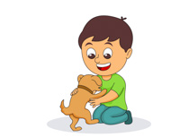 2. 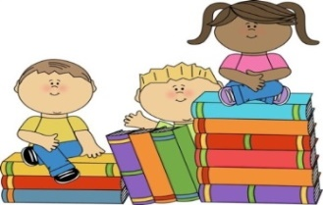

3. 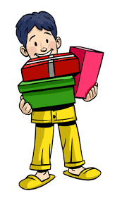 4. 

**[2]**

**Speaking**

**Task 5.** Look at the pictures and ask your classmate 3 questions. Use some words from the box in your answers.

|  |
| --- |
| Yes, please. No problem. Sure. Here you are. Sorry, I need it.  Sorry, it’s not mine. Sorry, I cannot. |

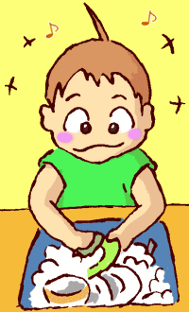 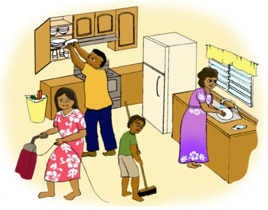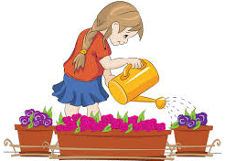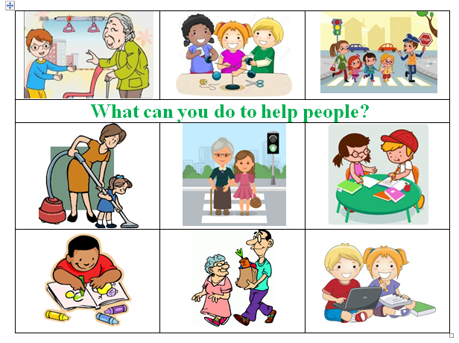

*Example:*

* P1.: Can you wash the dishes?
* P2.: S

**Mark scheme**

|  |  |  |  |
| --- | --- | --- | --- |
| **Task №** | **Answer** | **Mark** | **Additional information** |
| 1. | Colours the boy’s shorts red. | 1 |  |
| Colours the girl’s dress yellow. | 1 |  |
| Colours the boy’s shorts blue. | 1 |  |
| 2 | Matches 1st picture to the word ‘Football’ correctly; | 1 |  |
| Matches 2rd picture to the word ‘Help’ | 1 |  |
| Matches 3th picture to the word ‘Friends’ | 1 |  |
| 3. | 1.Hat | 1 |  |
| 2.T-shirt | 1 |  |
| 3.Trousers | 1 |  |
|  | 4.Shorts | 1 |  |
| 4 | The boy has got a puppy/a dog. / | 2 | Learner should makes up 2 sentences for any pictures. Any other answers are acceptable if learners use singular and/or plural nouns in the sentences to describe the pictures. One mark is awarded for 1 correct sentence. |
| There are many books./ Children have got many books. |
| The boy has got 3 gifts/ presents. |
| The girl has got 4 balloons/ beautiful balloons. |
| 5 | *Possible questions and answers:*  Can you wash the dishes? / Yes, I can / I can wash dishes / Sure / No, I cannot | 3 | Learners should ask only 3 questions. Any other questions are acceptable if they are grammatically correct. One mark is awarded for 1 correct question. |
| Can you cross the street? / Yes, I can / Sure / I can cross the street / No problem / No, I cannot |
| Can you help me with cleaning? / Yes, I can / Sure / No problem / I can clean the house / I can help you with cleaning / Sorry, I cannot |
| Can you give me the book, please? / Sorry, It’s not mine / Yes, I can / Yes, please / Here you are / Sorry, I need it |
| **Total marks** | | **15** |  |