Grade ___________ Name _______________________________________

Tasks for the Summative Assessment for the term 1

Listening
Task 1. Listen and colour.

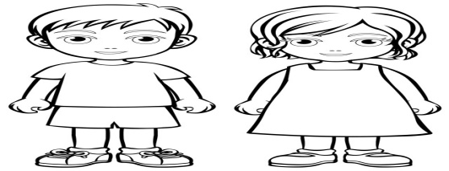

Reading
Task 2. Read, spell and match pictures to the words.

1. |  | Friends
2. | 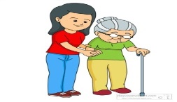 | Football
3. | 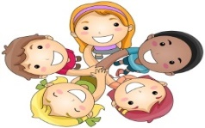 | Help
[3]
Writing
Task 3. Complete the words.

Tr Sh H

- 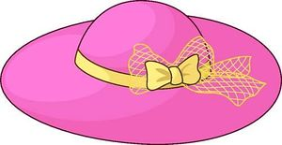 | ___at
3.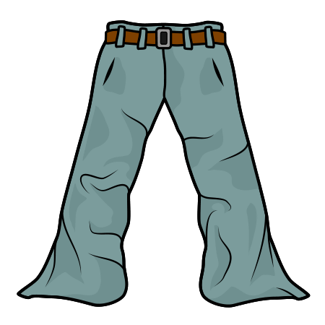  - 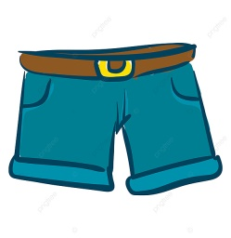 | ___ ousers  ___orts
Use of English
Task 4. Look at the pictures and make up 2 sentences.

- 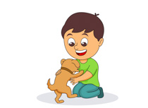 2. 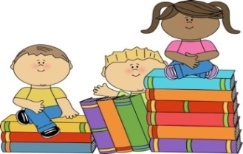

3. 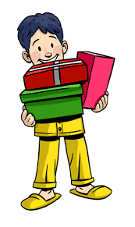 4. 
[2]
Speaking

Task 5. Look at the pictures and ask your classmate 3 questions. Use some words from the box in your answers.

Yes, please. No problem. Sure. Here you are. Sorry, I need it.
Sorry, it’s not mine. Sorry, I cannot.
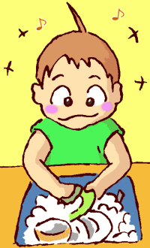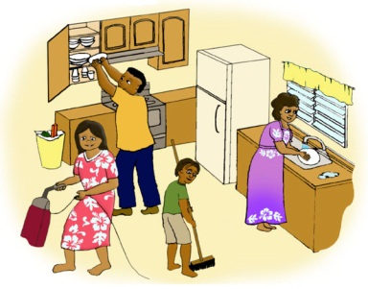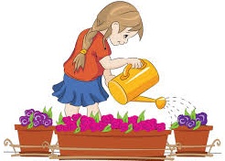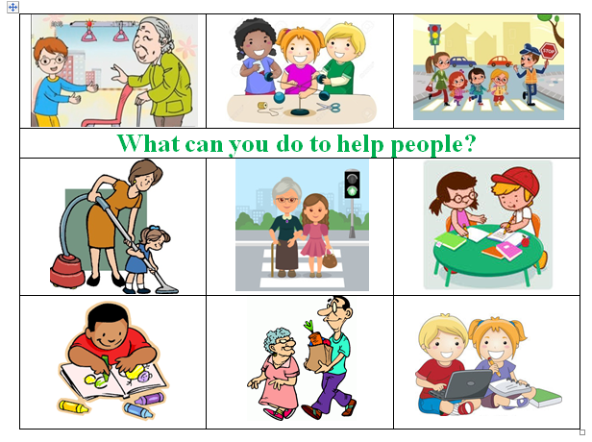

Example:
- P1.: Can you wash the dishes?
- P2.: S

Mark scheme

Task № | Answer | Mark | Additional information
1. | Colours the boy’s shorts red. | 1
1. | Colours the girl’s dress yellow. | 1
1. | Colours the boy’s shorts blue. | 1
2 | Matches 1st picture to the word ‘Football’ correctly; | 1
2 | Matches 2rd picture to the word ‘Help’ | 1
2 | Matches 3th picture to the word ‘Friends’ | 1
3. | 1.Hat | 1
3. | 2.T-shirt | 1
3. | 3.Trousers | 1
 | 4.Shorts | 1
4 | The boy has got a puppy/a dog. / | 2 | Learner should makes up 2 sentences for any pictures. Any other answers are acceptable if learners use singular and/or plural nouns in the sentences to describe the pictures. One mark is awarded for 1 correct sentence.
4 | There are many books./ Children have got many books. | 2
4 | The boy has got 3 gifts/ presents. | 2
4 | The girl has got 4 balloons/ beautiful balloons. | 2
5 | Possible questions and answers:  Can you wash the dishes? / Yes, I can / I can wash dishes / Sure / No, I cannot | 3 | Learners should ask only 3 questions. Any other questions are acceptable if they are grammatically correct. One mark is awarded for 1 correct question.
5 | Can you cross the street? / Yes, I can / Sure / I can cross the street / No problem / No, I cannot | 3
5 | Can you help me with cleaning? / Yes, I can / Sure / No problem / I can clean the house / I can help you with cleaning / Sorry, I cannot | 3
5 | Can you give me the book, please? / Sorry, It’s not mine / Yes, I can / Yes, please / Here you are / Sorry, I need it | 3
Total marks |  | 15

