Lesson plan

Long-term plan Unit 7: The natural environment |  |  |  |  | School: Mukur secondary school
Date: |  |  |  |  | Teacher name: Erzhanova A
Grade: 2 |  |  |  |  | Number present: |  | absent:
Theme of the lesson: |  |  |  |  | The weather
Learning objectives(s) |  |  |  |  | 2.L3 understand the main points of short, slow and carefully articulated talk on routine and familiar topics features such as colour and number  2.S3 use a limited range of basic words, phrases and short sentences to describe objects, activities and classroom routines  2.UE3 use common adjectives in descriptions and to talk about simple feeling
Lesson objectives |  |  |  | All learners will be able to:  - understand main points of familiar topics featured  - Use basic words  Most learners will be able to:  - Understand and use basic words, phrases to describe objects and activities  Some learners will be able to:  - Use topical words and phrases practice using short sentences  - Apply common adjectives in descriptions
Assessment criteria |  |  |  | Pronounces basic words and phrases describing things  Recognize the mean information in a short talk on familiar topics
Value links |  |  |  | Ls will work together as a group/pair showing respect and being polite with each other, respect to the natural environment
Cross curricular links |  |  |  | Nature study, Art,
ICT skills |  |  |  | PPT, Video
Previous learning |  |  |  | Seasons of the year (winter, autumn, summer, spring)  What seasons is it now?  It is summer
Plan
Planned timings | Planned activities |  |  |  |  |  |  | Resources
Beginning  5mins | Learners are introduced the Los.  Greeting  T divides class four groups: winter, autumn, summer  Ls choose cards about seasons and Ls create 3groups  1.Warm up.  Ls answer the question and repeat previous lessons  - What are you change winter’s colour? White  - What colour is the brightly sun? Yellow  - What colour is the sky? Blue  - What will be spring flowers? Green  T: -So, you are very good pupils! Are you know song about year. Let’s sing song  Spring is green  Summer is bright  Autumn is yellow  Winter is white  Very excellent! So pupils our new theme “The weather” |  |  |  |  |  |  | Flashcards (flower,snow, yellow leaf, snowman, bird, fruit,skate)  PPT  Colour  Flashcards of the season  Video  Song
Middle  10 mins  5 mins  5mins  3mins  7 mins | 2. Presentation  “Look, say, match”  Teacher shows video about weather words then repeat new words in the picture and then they must match words and picture [I]  “Baskets” [P]  Ls must put in the basket words that do not appropriate to the weather  Rainy, sunny, book, head, sun, pen, foggy, snowy, water, food,  “Just a minute”  1st group Ls must be create words about the weather with letters  2nd Ls must be remember words about the weather and say by doing  3rd group answer the question  What is the weather in spring?  What is the weather in autumn?  What is the weather in summer?  What is the weather in spring?  Ls must be answer “It’s …..”(differentiation by task)  Teacher gives feedback for differentiation tasks with smiles  3. Ph. Training  “Listen and do”  Ls listen to the song “The sun comes up” and do the actions  4.Practice  “Bingo”  Teacher understand how to use common adjectives with noun about the weather  Ls must choose the weather words and match this words with adjectives  Strong (қатты) wind  Heavy (нөсер) rain  Thick (қалың) fog  hot (ыстық) sun |  |  |  |  |  |  | Video. Flashcards  https://youtu.be/-862zFhAHe8  basket, word papers  word papers  flashcards  https://youtu.be/XcW9Ct000yY
End  5 mins  2mins | “Who is the best ?” project work  Ls must be draw seasons and describe project work  Task : Listen to the teacher : Draw seasons and describe  Descriptor: A learner  - Draw seasons of the year  - Describe weather short sentences  Reflection of the lesson.  Teacher understands how to use this feedback  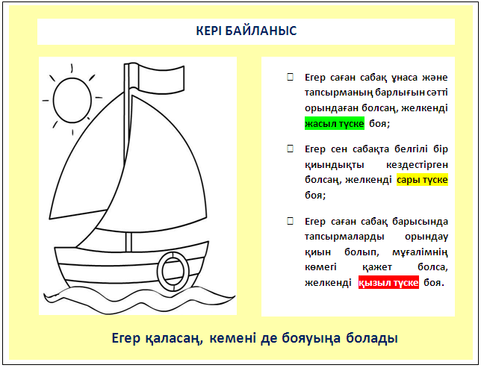  - if you like lesson or do all task you should colour sailing with green  - if you have a problem you should colour sailing with yellow  - if you need teacher’s help you should colour sailing with red |  |  |  |  |  |  | Papers markers  Picture of the ship, colourful pensil
Additional information
Differentiation – how do you plan to give more support? How do you plan to challenge the more able learners?  Support for weaker students: working in pairs/groups, phrases  Challenges for more able students: Encouraged to do more writing; assist weaker students. |  |  | Assessment – how are you planning to check learners’ learning?  FA  Monitoring  Checking the task  Feedback on the work |  |  | Health and safety check  ICT links  Video, Ph.Training
Differentiation can be by task, by outcome, by individual support, by selection of teaching materials and resources taking into account individual abilities of learners (Theory of Multiple Intelligences by Gardner).  Differentiation can be used at any stage of the lesson keeping time management in mind  Pair work, group work |  |  |  |  |  | Health promoting techniques  Breaks and physical activities used.  Points from Safety rules used at this lesson.
Reflection  Were the lesson objectives/learning objectives realistic? Did all learners achieve the LO?  If not, why?  Did my planned differentiation work well?  Did I stick to timings?  What changes did I make from my plan and why? |  | Use the space below to reflect on your lesson. Answer the most relevant questions from the box on the left about your lesson.
Summary evaluation

What two things went really well (consider both teaching and learning)?
1:

2:

What two things would have improved the lesson (consider both teaching and learning)?
1:

2:

What have I learned from this lesson about the class orachievements/difficulties of individuals that will inform my next lesson?

