LESSON 8: Unit 1 All about me  1 to 20 (11-20) |  |  | School: Stavropolka Secondary School
Date: |  |  | Teacher name: Rogova V.V.
Grade: 1 |  |  | Number present: |  |  | absent:
Learning objectives(s) that this lesson is contributing to |  | 1.L1 recognise short basic instructions for a limited range of classroom routines spoken slowly and distinctly  1.S3 pronounce familiar words and expressions intelligibly  1.UE2 use cardinal numbers 1 - 20 to count
Lesson objectives |  | All learners will be able to:  listen and repeat numbers  say and recognize verbs  Most learners will be able to:  recognise and name numerals 1-10  say and recognize verbs without mistakes  Some learners will be able to:  recognise and name numerals 1-20  make word combinations with verb + objects
Previous learning |  | Numbers 1 to 10
Plan
Planned timings | Planned activities |  |  | Learners’ activities | Evaluation |  | Resources
Beginning  5 min | ORGANISATION MOMENT:  T. invites learners to stand in a circle and to greet each other, to ask & answer the questions:  What is your name? My name is.....  How are you? I am fine, thank you.  What’s his / her name is …  His / her name is ...  Name a colour (blue)  Warm-up activity  Repetition: colours (pupils need jump from one to another coloured sheet of paper and name the Colours) |  |  | Pupils answer the questions |  |  | Pictures of Sharks,  Coloured sheet of paper, numbers  Flashcards with coloured numbers
Middle  20 min | Presentation of the topic of the lesson  T shows the pictures which represents the numbers e.g.: for number 6 the picture dogs, 7 picture of rabbits, 8 picture of cats, 9 picture of penguins, 10 picture of bears (11-20)  Playing the game  Ss dance in a circle. When T stops the music and says one number Ss should stand together according to the number (numbers 1-10)  Teacher demonstrates simple plus sums producing written numerical answers, e.g.: 3+3=6, 6+1=7, 4+4=8, 8+1=9, 5+5=10  PREPARATION  A blindfold memory number/colour activity, played with the class divided into two teams. Before being blindfolded learners survey a board with number [1-10] shapes on it – each number is a different colour. Blindfolded learners find a number and say number and colour e.g. black eight.  Get one learner from each team to try and win as many points for the team as they can. Then change learners and one or two of the numbers and begin again.  Feedback: Colour jumbled numbers 1-10 according to the teacher’s instructions: Ten is white. Two is yellow. Six is black. One is red. Three is green. Nine is pink. Four is blue. Eight is purple. Five is orange. Seven is grey. |  |  | Pupils do the task  Pupils play a game  Pupils do the instructions | Verbal evaluation |  | Numbers – video and flashcards  Video (sounds)
10 minutes | FORMATIVE ASSESSMENT  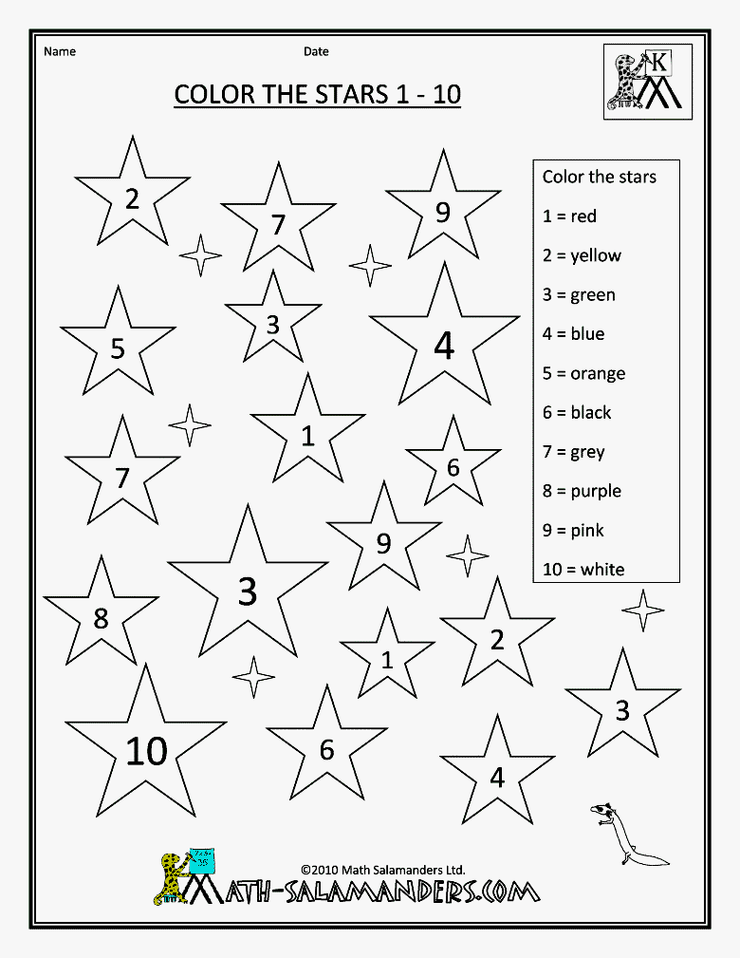  Give instructions such as: Colour 3 red... OK...3 is red. 3.Give feedback by projecting numbers coloured the correct colours |  |  | Pupils given a with a range of jumbled numbers 1-10 to colour according to Teacher’s instructions |  |  | worksheet
End  5 min | Ask the pupils which is their favourite number (1-10). Ask them to write it on a piece of paper. Then to decorate it.  THE LESSON IS OVER.  GOOD BYE. |  |  |  |  |  | Pictures

