Sports in Kazakhstan

5 класс

Валитова М.О
учитель английского языка КГУ ОШ Жаңақала.
Learning objectives(s) that this lesson is contributing to | 5.L3 understand an increasing range of unsupported basic questions on general and curricular topics  5.W6 link, with some support, sentences into coherent paragraphs using basic connectors on a limited range of familiar general topics  5.S6 communicate meaning clearly at sentence level during, pair, group and whole class exchanges
Lesson objectives | Learners will be able to:  - Guess the theme of the lesson by answering the questions.  - Name, define and understand the name of sports.
Lesson plan
Planned timings | Teacher's actions  Sports in Kazakhstan | Pupils` actions | Assessment | Resources
10  minutes | ORGANISATION MOMENT:  Teacher greets students  (W) Brainstorming  Look at me. I’ll show you pictures, please talk in pairs and guess the topic.  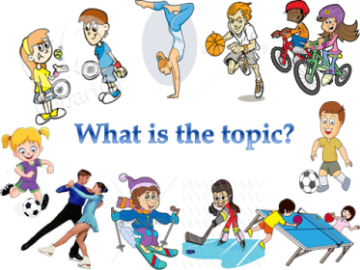  -What is the topic? -Do you know types of sports? - What’s your favourite sport?  I’ll divide the pupils into 3 groups “Football”, “Basketball”, “Volleyball” | Students respond to greeting and take their places  Students discuss the question and report back to the teacher. | - | Student’s book  pictures
20  minutes | MAIN PART  1.(W)Presentation new words  Football, Boxing,Judo,Cycling,  Tennis, Wrestling, Skiing, Golf, Swimming, Gymnastics,Horse riding  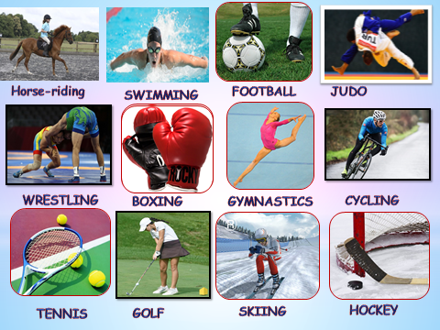  II.(G)Speaking  Text: My favourite sport  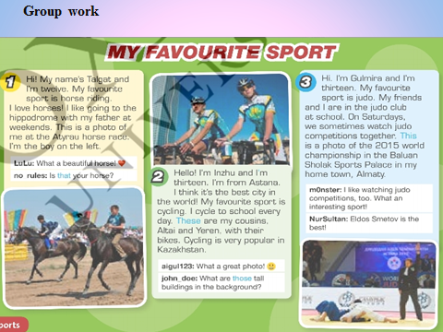  III.(W) Listening  Watch the video. What is the text about?  IV. (I) Speaking Differentiation by task  1.A level Read the text and mark the sentences True or False  1. Cycling is a popular sport in Kazakhstan. 2.They wear red and orange cycling clothes. 3.The country wins lots of medals in boxing at every Olympics. 4.Gennady Golovkin is a great basketball player. 5.Bauryzhan Islamkhan is a young football player.  2. B level Fill in the correct verb.  involve have win wear watch play  1.Lots of people ______ games between the teams in the Kazakhstan Premier League. 2.Pro Astana cyclists ______ lots of medals. 3.There are lot’s of games that ______ horses. 4.He also _______ for the national team. 5.Lots of people in Kazakhstan ______ got a bike. 6.They _______ blue and yellow cycling clothes.  3. C level  Make dialogue about Sports in Kazakhstan. | Listen  CD 1  Each group retell the text to other groups.  Answer the questions  Complete the sentences  Students watch the video and make up the dialogues. | Emoticon  Emoticon, marks | PPP slides 1-3  Video-  Student’s book  Video- https://youtu.be/JaxDvIY2IlU
10  minutes | ENDING THE LESSON:  On the lesson I was… Active \ passive  I’m …with my answers. Satisfied \ not satisfied  The lesson seemed me … To be long \ short  My mood now become… Better \ worse  The knowledge I’ve got today is… Useful \ useless  Exercises seemed me … To be difficult \ easy  The lesson was … Interesting \ boring  The lesson is over. Good-bye! | Underline the words | Feedback | Cards

