Lesson plan

Unit 2. Light and Dark |  | School:19
Date:22.10.21 |  | Teacher’s name: Dzhexenbinova Aliya
Grade: 3A |  | Number present: |  | absent:
Theme of the lesson: Clothes

Learning objectives that the lesson is contributing |  | To talk about clothes
Learning objectives |  | 3.S - give short, basic description of people and objects;  3. W -write short phrases to identify people, places and objects
Lesson objectives |  | By the end of the lesson learners will be able to:  - describe clothes at a statement level  - write sentences about clothes  - apply clothes-related words in speech
Assessment criteria
  - talk about clothes
  - elicit the clothes-related words from the audio-text
  - describe clothes in a written form
  - use the lesson-related words in speech
Value links |  | Respect to each other
Level of thinking  (Bloom’s Taxonomy) |  | Understanding/ Remembering
Extra materials |  | Cards with clothes and posters.
Plan
Planned timings | Planned activities(replace the notes below with your planned activities) |  |  |  | Smiles resources
Beginning the lesson  Checking up h.t  Phonetic drill  Middle | Organizational moment.  Greetings  -Goodmorning,children!  -I’m glad to see you.  -Sit down, please.  -How are you?  -I see that everyone is fine so we can start our lesson.  -What season is it now? What date is it today? What day of the week is it today? Is it cold or warm today?  -What was your home task?-  -Ex 4 p19  -To learn the riddle and also draw picture about favourite clothes  -ok.are you ready?  Ok,Lets begin our lesson.  Now, let`s do phonetic exercises. Repeat after me… (слайд 3)  Zip up your /jacket/  Pull on your /hat/  Put on your /boots/  Just like that  Wrap your neek with the /scarf/  You only need one  Slip on your /mittens/  We are gonna have fun  Ok.children.Tell me please ,what are they ?  -They are clothes. Yes,you are right.And  The Theme our lesson is "Clothes"  Children, look at the active board. I will introduce you with new words:  Task 1. Work with book  Listen to the tape recording and match the words with pictures.  Ex5 p20 P.b  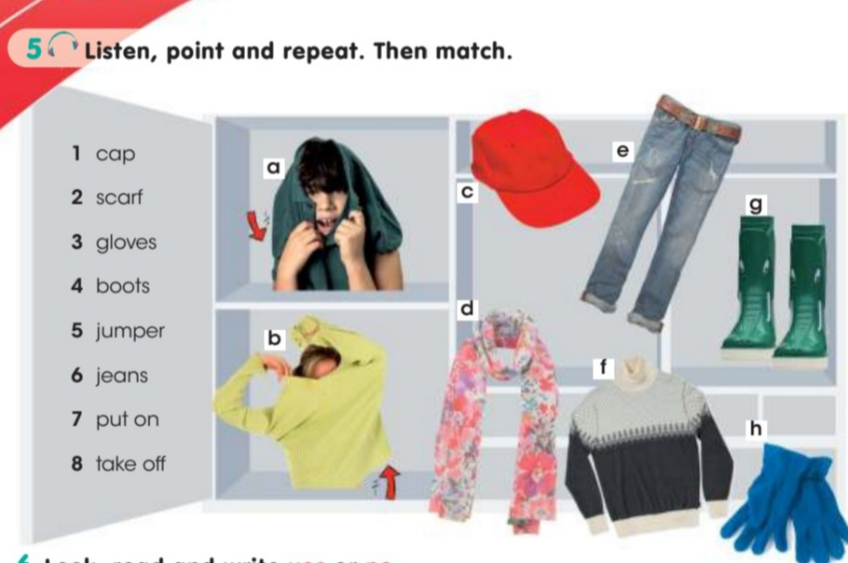  Descriptors:  A learner  - Listens to the text  - Matches the words to the pictures  Ex6 p20 P.b  Choose and complete(Выбери и заверши)  Here you can see the words relative to clothing .And  here you can see the words relative to Profession & also  4 pictures &8numbers  Here you should write what clothes do this numbers stand for  Have you done?Ok.  Children are you tired?  If you are tired Let's see a physical minute and together we will repeat  Task 2  Work with group. Students ask questions using the words in the box:  Do you ...?  Children, I want to divide you in to two groups. There are some sweets in the box. And everyone choose sweets for themselves.  Ok. now who has pink clothes sit where pink T-shirt &  who has yellow clothes sit where yellow T-shirt  I will give you 2posters with a picture of a boy & a girl. And you will dress them  Descriptors:  Use new words  Task 3 Working with cards in a group  Unscramble the letters.  Pca- cap. A blue cap.  Fcsar  Slvoge  Uemrjp  Nsaje  Bsoto  Descriptors:  A learner  -Unscrambles letters  -Makes phrases  Task 4. Reading  My favourite clothes are jeans and a T-shirt. In summer I wear a T-Shirt and shorts. When it’s hot and sunny, I wear a cap and sunglasses. When it’s a bit colder, I wear jeans, socks and trainers when I go to the park with my friends. When it’s rainy, I wear a raincoat and rubber boots. In winter I wear a sweater and trousers. When I go out, I wear a jacket and boots. When it’s snowy, I wear a hat, a scarf and gloves.  - read the text  Are the sentences True or False?  1. Mark favourite clothes are a jacket and shorts.  2. He wears a T-shirt and shorts in summer.  3. When it’s hot and sunny, he wears socks.  4. When it’s a bit colder, he wears sunglasses.  5. When it’s rainy, he wears a raincoat and rubber boots.  6. In winter he wears a sweater and trousers.  7. When he goes out, he wears jacket and boots.  8. When it’s snowy, he wears shorts and trainers.  Descriptors:  1.F 2.T 3.F 4.F 5.T 6.T 7.T 8.F |  |  |  | The Clothes poster.  Smiles Pupil`s book for Kazakhstan Grade 3  Author: Virginia Evans, Jenny Dooley, N.Mukhamedjanova  CD1  Smiles Activity  book for Kazakhstan Grade 3  Author: Virginia Evans, Jenny Dooley, N.Mukhamedjanova
  scarf | [ skɑ:f ] | шарф
  tie | [ tai ] | галстук
  blouse | [ blauz ] | блузка
  dress | [ dres ] | платье
  shorts | [ ʃɔ:ts ] | шорты
  t-shirt | [ 'ti:‚ʃɜ:rt ] | футболка
  socks | [ sɔks ] | носки
  tights | [ taits ] | колготки
Ending the lesson | traffic light method for summing up assessment  Home assignment
Additional information
Differentiation – how do you plan to give more support? How do you plan to challenge the more able learners? |  |  | Assessment – how are you planning to check learners’ learning? |  | Health and safety check
By task:  Less able sts name the clothes on the picture  More able sts create sentences for the pictures.  By support:  More able sts are challenged by leading roles in group discussion.  Less able sts are lead by guiding questions, wait time strategy, gestures, list of key words to the learning objective achievement  By learning styles:  Visual learners are prompted through visual aids with clothes (pictures, poster)  Auditory learners are supported by audio files and live talk |  |  | traffic light assessment: |  |  | Health saving technologies.

