LESSON 1: |  | Unit 3 My family and friends  In my house
FORM:  Date: |  | 1 “б” 1 “е” 1 “г” 1 “а” 1 “в”  10.11.2021
Teacher name: |  | Dina Shamiyeva
Learning objectives(s) that this lesson is contributing to |  | L3 recognize with support common names and names of places; recognize the spoken form of a limited range of everyday and classroom words  1.L9 recognize the names of letters of the alphabet
Lesson objectives |  | All learners will be able to:
- name some members of family without teacher support
- name some things in the room
 |  | Most learners will be able to:
- use «Who is» «What is» to identify things
- answer some questions concerning their families
 |  | Some learners will be able to:
- talk about their families
- describe their room
Assessment criteria  Can/do |  | - talk about his/her family;  - pronounce topic words intelligibly  - describe pictures  - do correct use “This is …”  - can answers the questions
Cross-curricular links  Collaborative learning |  | Art
ICT skills |  | Listening skills of recording
Plan
Planned timings | Planned activities (replace the notes below with your planned activities) |  | Resources
Beginning  5 minutes  10 minutes | ORGANIZATION MOMENT  Warm Up:  Review home task.  Teacher will have Learners move into a circle. Revise the previously studied colors, numbers, letters: red, blue, green, yellow, orange, purple, etc. A-Q, 1-20  T gives different coloured shapes. To divide into groups  Game – ABC bingo  - Explain the aims of the lesson:  - Have you got a desk? Look at me. Today we are going to learn the things in our room in English. \procedural questions\ |  | Visual aids from previous lessons  slides  № 2, 3,4  slide № 5
Middle  10 minutes  8 minutes  End  7 minutes | DEMONSTRATION  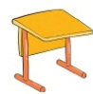  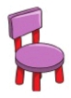    - Teacher demonstrates new words on the board  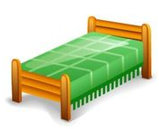  - Pupils repeat new words after teacher in chorally and individually. \individual support\  bed, chair, table, desk, TV, cupboard  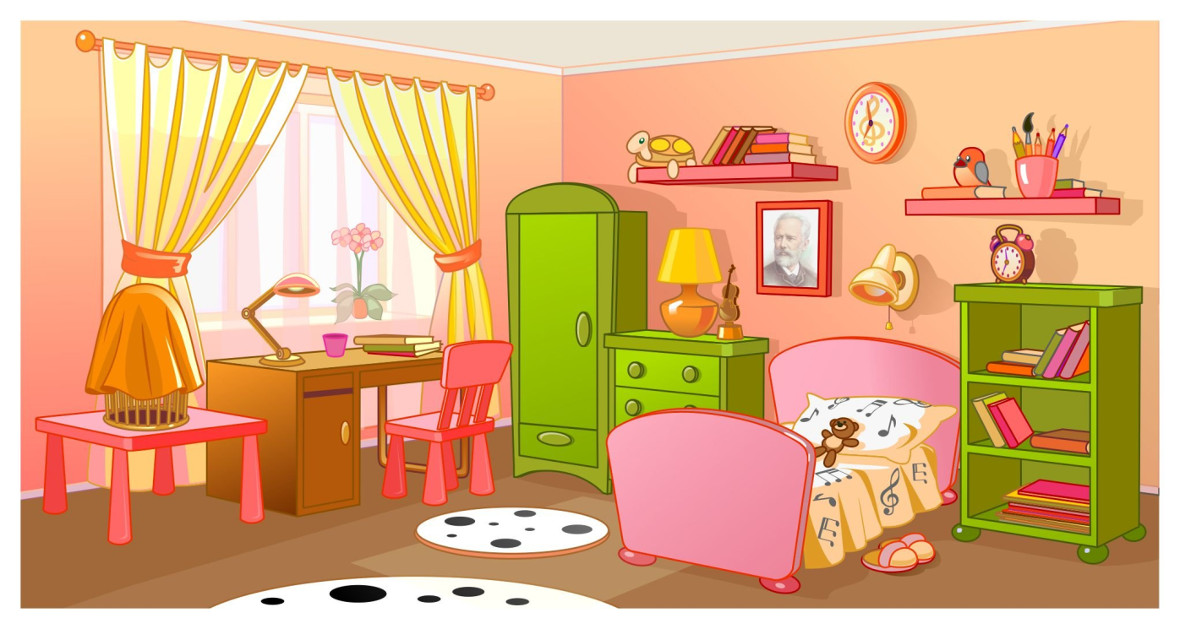  - Pre-listening: Using flash cards explanation “This is …” \individual support\ \ I’ll use method modeling. I’ll support their answers. \modelling\ Assessment with gestures.    While listening: Learners repeat familiar sentences when they are listening.  - Post listening: The teacher will show cards, and the pupils will find things in the room  - Pair work in group. Talk to your friend. Say about your room. \S-S methods\ Learners talk about room each other.  7. Physical training  T. shows the video and Ss should sing along the song and do the actions together with T.  2. Conclusion Individual work.  Answer the question. \Individual assessment by gesture\  1. Have you got a TV? \convergent question \  2. Have you got a table? \convergent question  3. Have you got a chair? \convergent question  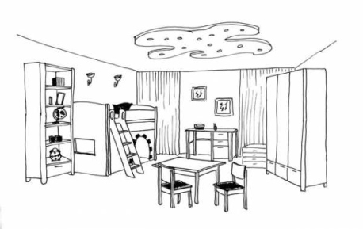  3. Group work. Draw your room. \checking understanding\Each group presents their room. \collaborative learning\,\ self assessment\  4. FEEDBACK  Use three colures. Red – not understand. Yellow – partly understand. Green – understand. Learners will write their names on stickers and will stick to determined color. |  | slide № 6  PPT  flash cards  Vocabulary Cards “Family”  Song  “My family”  Video https://www.youtube.com/watch?v=0OzABZ8BPi4  Picture with members family

