Lesson plan
Theme of the game-lesson: “A magic trip to English land”
The aim of the game-lesson:

- to increase pupils’ interest in a subject;

- to develop thinking, speaking, reading and writing skills;

- to revise previously taught vocabulary about Animals, Body parts, School things and prepositions.

Teacher 1: Good afternoon, dear children! Today some guests are present at our lesson! Welcome to our game-lesson, dear guests and pupils! Dear friends, today you are passengers of this bus. We are going to travel to English land with a little funny bus.
There are 6 stations and every station has an interesting task for you. And now our trip is began. Are you ready? Let’s start our trip! Good luck!
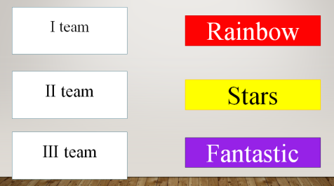
Teacher 2: The 1st station is “Greeting”
Let’s introduce our teams!
1st team is “Rainbow”
2nd team is “Stars”
3rd team is “Fantastic”

Teacher 1: The 2nd station is “Vocabulary”
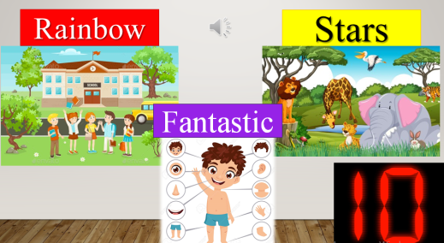

There are 3 themes- about School, Animals and Body parts. For the team “Rainbow”- School, for the “Stars”- Animals and for the “Fantastic”- Body parts. Let’s check your vocabulary. How many words do you know? For the each right word 1 point.
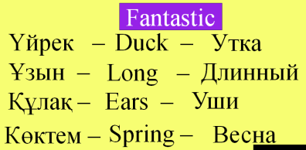
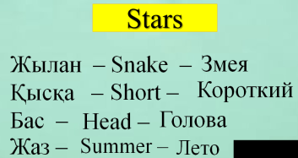
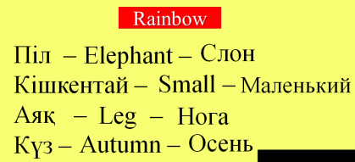
Teacher 2: The 3rd station is “Translate”

There are given 4 words for each team. The teams should translate the words into English and into Russian. For the each correct answer 1 point.
Teacher 1: The 4th station is “Who is faster?”
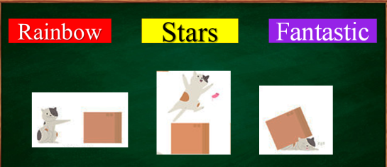

There are given 3 pictures and 4 sentences and 1 extra sentence. Each team should match the sentences with the pictures. For the each correct answer 1 point.
Teacher 2: The 5th station is “Have got or has got?”
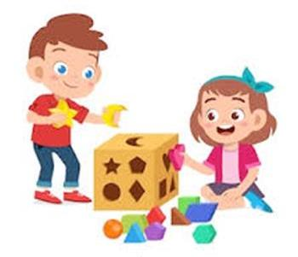



Work in groups. Look at the pictures and make a sentences with have got / has got. For the each correct sentence 1 point.
Teacher 1: The 6th station is “Winners”
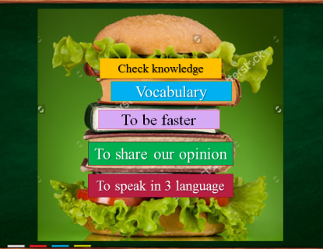

Giving marks. Giving feedback and certificates. Finishing the game-lesson.

