Unit: | Animals
Teacher name: | Asylbekova V.K
Date: | 24.09.2021
Grade: 3 | Number present: | Number absent:
Theme of the lesson: | Body parts 2
Learning objectives(s) that this lesson is contributing to | 3.L6 understand some specific information and detail of short, supported information or talk on a limited range of general and some curricular topics 3.S1 make basic statements which provide personal information on a limited range of general topics
Lesson objectives | Learners will be able to:  Understand and pronounce body parts correctly  Make up sentences by using have/has got  Draw and define names of body parts
Lesson plan
Planned timings | Teacher's actions | Pupils` actions | Assessment | Resources
7-9  minutes | ORGANISATION MOMENT:  Teacher greets students  Watch and listen to music about body parts. Pupils must guess the theme of the lesson.Teacher introduces new words | Students respond to greeting and take their places | - | https://www.youtube.com/watch?v=xYkxpzM0sJU  Presentation1
25-28  minutes | MAIN PART  Task 1  Context 2 min  Our first task is work with new words.  Vocabulary 5 min  Working with words  Choral repetition.  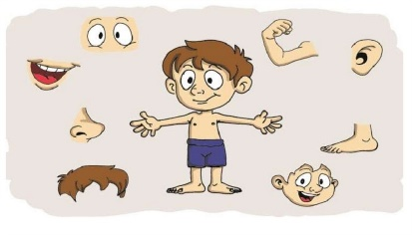  Teacher break up the monotony by changing the speed or volume and students change their responses accordingly.  Task 1.Touch myself  Teacher says names of body parts loudly and pupils touch their body parts  teacher familiarize have/has got  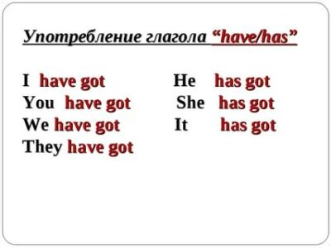  Task 2.My body  Descriptors:  1.collect body parts  2.use has got  Task 3.Who am I?  Pupils describe animals by descriptors. One of student comes to board and other pupils describe animals by their describing pupil must guess name of animals.  Descriptors:  1.describe animals correctly  2.use have/has got  - . | Listen to teacher  Learners simply repeat words after teacher.  - Name the body parts .  make sentences using have/has got  Collect body parts | Formative assessment with stickers  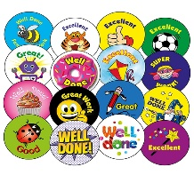  Evaluate by stickers | Presentation2  Presentation3  Presentation4  Cards with pictures  Pictures of animals
8  minutes | ENDING THE LESSON:  Draw animals on sheets  Well what did we do in our lesson?  -Evaluation of the lesson  Give the home task | Children say Good bye! | Feedback | Sheets of papers

