LESSON: Water, water everywhere  Module 7 Lesson 5 A beach story 2 |  | School: №45
Date: 20.04 |  | Teacher’s name: Nurbolatova R.
CLASS: 3 | Number present: | absent:
Learning objectives(s) that this lesson is contributing to | 3.3.6.1- understand with considerable support, some specific information and detail in short, simple texts on a limited range of general and some curricular topics;  3.4.8.1 – include appropriate use of a full stop during guided writing of short, familiar sentences.  3.UE13 use can to talk about ability and to make requests and offers • use can / can’t to talk about permission
Lesson objectives | All learners will be able to:  Understand simple texts, use the new words during the lesson.
Lesson objectives | Most learners will be able to:  Make sentences using the modal verb can.
Lesson objectives | Some learners will be able to:  Ask and answer the questions using the modal verb can.
Previous learning | Actions: waterski, sail, surf, pool, dive Structure: He is sailing. She is surfing
Plan
Planned timings | Planned activities |  |  | Smiles Resources |  |  | Teacher Notes
Beginning the lesson  3 min | Greeting  Warm up: Song “hello”  Check the home task |  |  |  |  |  | https://www.youtube.com/watch?v=tVlcKp3bWH8
Presentation  and practice  5 min | Present the new words:  Strategy: “Pictionary”  skateboard [ˈskeɪtbɔːd] скейтборд тебу  do karate [duː kəˈrɑːti] каратэмен айналысу  jog [ʤɒg] жай жүгіру  hop [hɒp] бір аяқпен секіру  skip [skɪp] скакалкамен секіру  have a picnic [hæv ə ˈpɪknɪk] пикникке шығу  play the violin [pleɪ ðə ˌvaɪəˈlɪn] скрипкада ойнау |  |  |  | Track 22
2 min | Step 1 ex.17 Listen and match  Strategy “Matching”  Answer key:  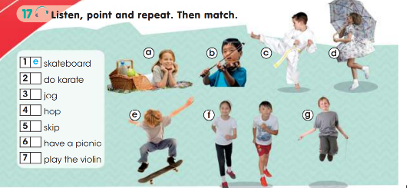  e – skateboard  c – do karate  f – jog  d – hop  g – skip  a – have a picnic  b – play the violin  Descriptor:  A learner:  - pronounces the word correctly;  - matches the pictures. |  |  |  |  |  |  | Poster
10 min | Explain the modal verb “can”  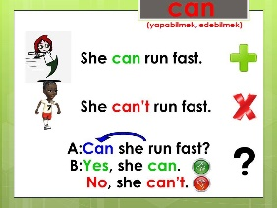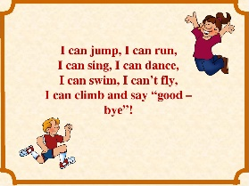 |  |  |  |  |  |  | Presentation.
7 min | Step 2 ex.18 Complete Korkem’s poem. Then say which thing is not Korkem’s  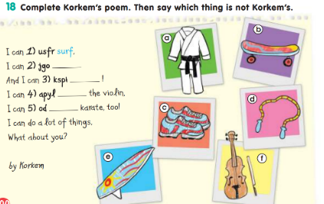  Answer key:  - surf  - jog  - skip  - play  - do  Descriptor:  A learner:  - finds the word;  - writes the word without mistakes;  - says the extra activity.  Step 3. Make sentences using the modal verb can.  Descriptor:  A learner:  - makes some sentences using the words. |  |  |  | Track 23 CD2 |  |  | Poster
3 min | Step 4 Play a game  Teacher reads a sentence. Pupils show with gestures.
Ending the lesson  7 min  2 min | Step 5. Answer the questions.  Teacher gives all pupils questions and they should answer.  For example: Can your brother play the violin? No, he can’t.  Descriptor:  A learner:  -reads the question;  -answers the question.  Reflexion.  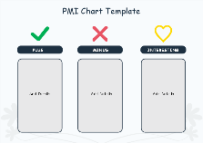  Home task: P.B.p 101 ex.19 |  |  |  |  |  |  | Worksheets
Additional information
Differentiation – how do you plan to give more support? How do you plan to challenge the more able learners? |  |  | Assessment – how are you planning to check learners’ learning? |  |  | Cross-curricular links Health and safety check ICT links  Values links
intensive monitoring and support for weaker learners in the writing task challenging stronger learners in writing task to include further information |  |  | Formative assessment:  Teacher Assess orally  “three claps”  “traffic lights”  Assessment criteria:  “Plus-minus-interesting” |  |  | cross-curricular links: Physical education

