Unit 7: Food and drinks |  |  |  | School:Koyandy secondary school
Date: |  |  |  | Teacher names: Tasova Tolganai
Grade: 1 |  |  |  | Present : 15 | Absent: 0
Theme of the lesson: |  |  |  | Things I like
Learning objectives(s) that this lesson is contributing to |  |  | 1.S1make basic personal statements and simple statements about objects  1 S5 produce words in response to basic prompts.  1. S3 pronounce basic words and expressions intelligibly  1. UE9 use basic present simple forms [positive and negative] to give basic personal information
Lesson objectives |  |  | - All learners will be able to:  listen and repeat the words, follow the instruction according to the task  Make up correct sentence about the things they like and dislike  - Most learners will be able to:  recognise and name some words according to the topic  follow the instruction according to the task  Make more than 1 sentence correctly using different sentence structure  - Some learners will be able to:  Read and write some of the words from the topic
Assessment criteria |  |  | - Students will have succeeded in this class if they:  Talk about people,objects and class routine  Follow the instruction of the teacher immediately with support  Say at least 2 sentences about what they like and dislike correctly
Language objecives |  |  | milk, soup, fish, ice cream, cookies, juice, pizza, salad, banana  Do you like….? Yes, I do.  Do you like ….? No, I don’t
Value links |  |  | - Respect and cooperation by:  Listening to the teacher  Listening to each other  Take turns  Encourage each other  Helping each other
Cross curricular links |  |  | Kazakh, Russian, Art, Music.
ICT skills |  |  | PPT -By teacher, interactive websites
Previous learning |  |  | Story time – Practice the phrases: The witch has a black cat not a white dog.  Revision of the words – colours, nature vocabulary, animals.
Plan
Planned timings | Planned activities (replace the notes below with your planned activities) |  |  |  |  |  | Resources
0-5 min  5-7min  7-10 min | CLASS ROUTINE:  Get students ready to the class by greeting them, asking questions about weather:  Good morning children!How are you today?What day is it today? Is it Monday today?  STARTER:  Warm up activity  [W] Brainstorming:  Working with presentation:  T:Let’s watch the video.Teacher asks students to look at the video and repeat.Teacher shows the video about “Go bananas”  T:What did you see at the board?How do you think what are we going to speak about?  P-s:About food and drinks  T:Yes,of course  INTRODUCTION:  Teacher put on some pictures on the board to show objectives and criteria, also teacher says what kind of rules learners should keep at the lesson  DEVELOPMENT:  [D] Tell the learners about what they are going to do today:  So as you probably guessed we will learn today – food and drinks. You will learn 8-9 new words and how to say what you like and what you don’t like eating.  By the end of the lesson you should name me 6 words correctly and make 2 sentences with some of them. So, what will you have to do?  Also I have a question. How will I know that you can do it?  But tell me how do good students behave when they work in groups? What should you do if you know the answer?  Teacher uses visuals of different types of food to introduce /revisit food vocabulary. Teacher models I like… I don’t like in building up two groups of food items on the board beneath a happy/sad face |  |  |  |  |  | https://www.youtube.com/watch?v=PKyuJhHQCfI  PPT slides  board, marker
10-15min  15-20 min.  20-22 min  23-30 min  30-35min  35-40 min | Activity 1[W] [I]Teacher drills pronunciation of the words correctly. Once they repeat after the teacher, then they repeat individually.  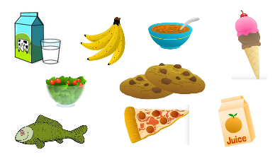  Interaction partner: T-S  Descriptor: A learner  pronouns the words correctly  Points to the picture and says what she/he likes and doesn’t like.  Example: I like juice but I don’t like tea  Check list assessment:  I can pronouns the words  I can point to the picture  I can say what I like  Differentation:  Activity 2[W]Teacher shows one example about the letters then learners should guess themselves other food names according to the letter  Interaction pattner:T-S,S-S  Descriptor:A learner  guess the names of food.  Check list assessment:  I can say the letter  I can say the food names  I can say the food names according to the letter  Differentation:  Activity 3[W]SONG. Do you like …? Listen to the song and repeat the gestures teacher shows. Then sing and dance the song together. Teacher asks questions about the song:  Interaction partner:T-S  Descriptor: A learner  Sing and dance.Answer the questions  Check list assessment:  I can sing song “Do you like?”  I can dance  I can answer the questions  Differentaton:  Activity 4[G]Play a game “What is missing?”  Before playing, teacher divides the learners into 2 small groups and gives the capital letters of the food for each group. Teacher shows pictures of food on the board and students name them all with their eye open. After teacher says to close the eyes, teacher takes one card away. Students open the eyes and name what is missing. When learners guess the word teacher asks some questions about the picture:  How many are they?  What color are they?  Do you like it?(yes, no)  Are they yummy?  Are they yucky?’  What is the first letter of …….?  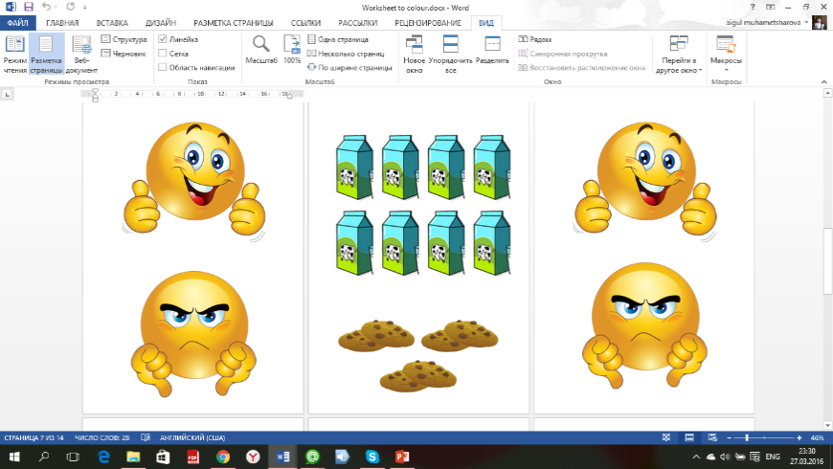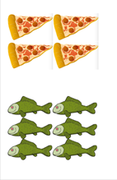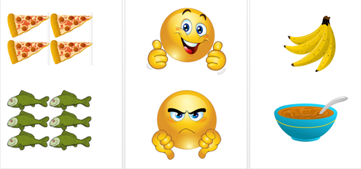  Interaction partnner:T-S  Descriptor: A learner  Answer the questions.  Check list assessment:  I can name the food  I can answer the question  I can say the colour  Differentation:  Activity 5[G]Drill the sentences prompts I like \ I don’t like  Go back to the pictures which every small group guessed and make up sentences together with students.  Do you like….? Yes, I do. it’s yummy  Do you like ….? No, I don’t. it is yucky!  Interaction patner:T-S,S-S  Descriptor:Answer the questions  Check list assessment:  I can answer the questions  I can make the sentense  I can say the colour  Activity 6 LISTEN AND UNDERSTAND THE SENTENCES.  [I]To summarize the lesson teacher gives learners worksheets and asks to sit down. Teacher explains the instruction and learners should follow. The task is to find the food and colour.  Descriptor:  finds the food  finds a colour.  Check list assessment:  I can find the food  I can find the colour  I can answer |  |  |  |  |  | PPT-8 slide  PPT- 7 slides  cards on the board  https://www.youtube.com/watch?v=frN3nvhIHUk  letters and supporting pictures ‘Yummy and Yucky’  picture  Picture  https://slideplayer.com/slide/8236228/
40-43 min  43-45 min | Feedback (stairs)  Ask learners to rise their worksheets and check how many words they could identify and if they are able to:  Name 6 words of food correctly  Say a sentence correctly  Say 2 sentences correctly  Home task – learn the words (cards, make sentences) |  |  |  |  |  | Smiles  https://www.123rf.com/photo_10564101_smiles-and-trumbs-up-and-down.html
Additional information
Differentiation – struggling learners will be given more prompts to help them speak. More able learners will be encouraged to make their speaking more complex. |  | Assessment - by the teacher, self assessment may be done by the students as the teacher asks questions about what they have learnt when they draw and do crafting. Also the result of the flower will show which words they remember |  |  |  | Health Safety.  Physic activity,  Using active board less than 10 minutes

