LESSON: Unit 2 My school  Classroom objects and classroom actions |  |  |  |  | School: Secondary school gymnasium “Bilim”
Date: 12.10.2021 |  |  |  |  | Teacher: Kadirova Ingkar
CLASS: 1 K |  |  |  |  | Number present: |  | absent:
Learning objectives(s) that this lesson is contributing to |  | 1.L1 recognize short instructions for  basic classroom routines spoken slowly and distinctly  use cardinal numbers 1-20 to count  1.S1 make basic personal statements and simple statements about objects  1.S2 count classroom objectives by using word “How many?”
Lesson objectives |  | All learners will be able to:
- listen and repeat the names of classroom objects and actions
- say and recognize verbs
 |  | Most learners will be able to:
- recognize and name some classroom objects
- say and recognize verbs without mistakes
- count classroom objects and say: ten pens, six books
Some learners will be able to:
Understand to count to 20 using word “How many?”
- recognise and name all classroom objects
- make word combinations with verb + objects
Previous learning |  | Numbers 1-20
Plan
Planned timings | Planned activities (replace the notes below with your planned activities) |  |  |  |  |  |  | Resources
Beginning | ORGANISATION MOMENT:  - T. gathers Ss in a circle and asks to hold each other’s hands. In a circle T. and Ss say ‘Hello’ three times altogether. Sing a song “Hello”  - In a circle T. asks Ss to count from 1-15 every S. says one number and it is his/her own number. Ss should not forget it. As soon as T. says the number that S. who hears his / her own number should go to his /her new place with prepared task on it.  - T. should prepare all fifteen coloured numbers before the lesson and put on each S’s desk,.: Ss-1,5,8,12 have green colours,. S-2,4,6,10,15 have red colours.Ss-7,9,11,13,14 have purple colours.  - Checking up home work  -What was your home work for today?  -Find the stickers  Ss show homework |  |  |  |  |  |  | https://www.youtube.com/watch?v=gghDRJVxFxU  Flashcards with colored numbers  Smiles activity book (p.31)
Middle    -   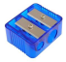 | MAIN:  - T. asks Ss to look at the board and listen new words. T. demonstrates new words of the lesson using PPT of classroom objects and Ss should repeat after  - T.: Look at the picture, listen and repeat after me  - desk book pen bag ruler schoolbag classroom rubber pencil case sharpener etc  - T. giving puzzles of school things: a pencil, a pencil case, a ruler .Ss work in pairs. When Ss finish gathering their puzzles they may say the word in English, Kazakh or Russian.  - Playing game “Close your eyes and find the name of things” T. asks to come one student from 3 groups and close their eyes by scarf. Then student should find one classroom object from the teacher’s bag and say its name.  - T’s instruction (keys):  - What’s this?  - It’s a pencil.  - What’s this?  - -It’s a book… e.g  “How many?”  Explain to children where can we use it and count things by asking “How many?”  Watching the video then count classroom objects. Do exercises from activity book.  - Join, find and trace  Worksheet school objects. Word search |  |  |  |  |  |  | PPT: classroom objects  video from YouTube Smiles Module1 “My school”  Puzzled cards: a book, a pencil,a ruler  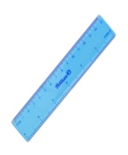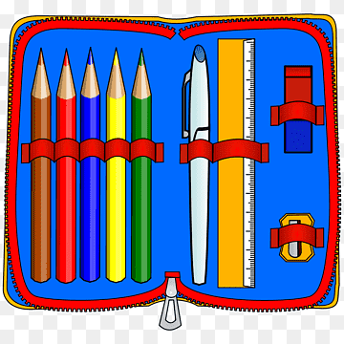  Pictures of classroom objects  scarf  PPT: classroom objects  video from YouTube Smiles Module1 “My school”  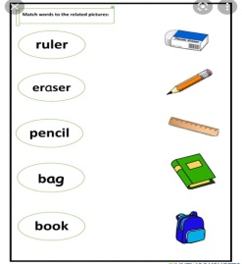  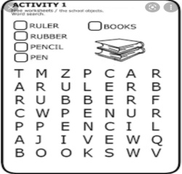  Using interactive board
End | Ss practice saying classroom objects in English when T. shows the picture.  Reflection:  Self-assessment: Hand signals 1. What have you learnt today?  2. Which task do you like?  Learners make comments about the lesson orally. Teacher asks learners to look at lesson objectives they set at the beginning of the lesson and think and say what they did well in the lesson and what needs improvement. I hope the lesson was interesting and useful for you. |  |  |  |  |  |  | Pictures
Additional information
Differentiation – how do you plan to give more support? How do you plan to challenge the more able learners? |  |  |  | Assessment – how are you planning to check learners’ learning? |  | Cross-curricular links  Health and safety check  ICT links  Values links
- Create mixed ability pairs |  |  |  | - through questioning and the redirecting of questioning in feedback activities  - through observation in pair & group work  - through formative assessment |  | - Music, Art & Math  - Formative assessment and warming up activity develop Ss’ critical thinking skills and understanding about academic honesty  - Ss will become more careful towards their school things  - White board is used no more than 5 minutes
Reflection  Were the lesson objectives / learning objectives realistic?  What did the learners learn today?  What was the learning atmosphere like?  Did my planned differentiation work well?  Did I stick to timings? What changes did I make from my plan and why? |  |  | Use the space below to reflect on your lesson. Answer the most relevant questions from the books on the left about your lesson.
Summary evaluation
What two things went really well (consider both teaching and learning)?
1.
2.
What two things would have improved the lessons (consider both teachings and learning)?
1.
2.
What have learned from his lesson about this lesson about the class or individuals that will inform my next lesson?

Singing a “Hello” song
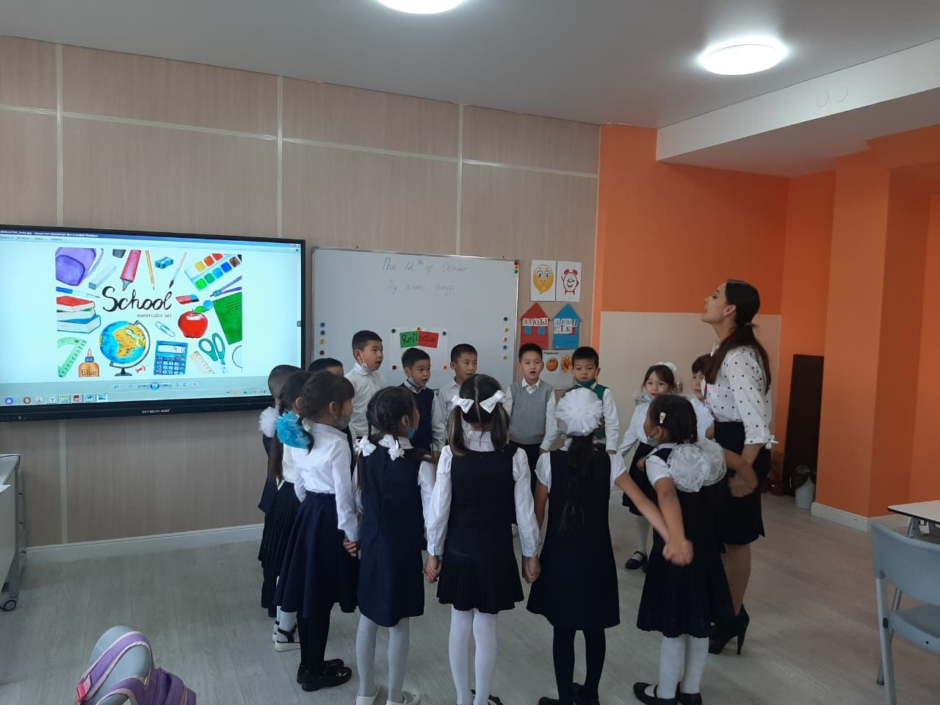
solving puzzles of school things
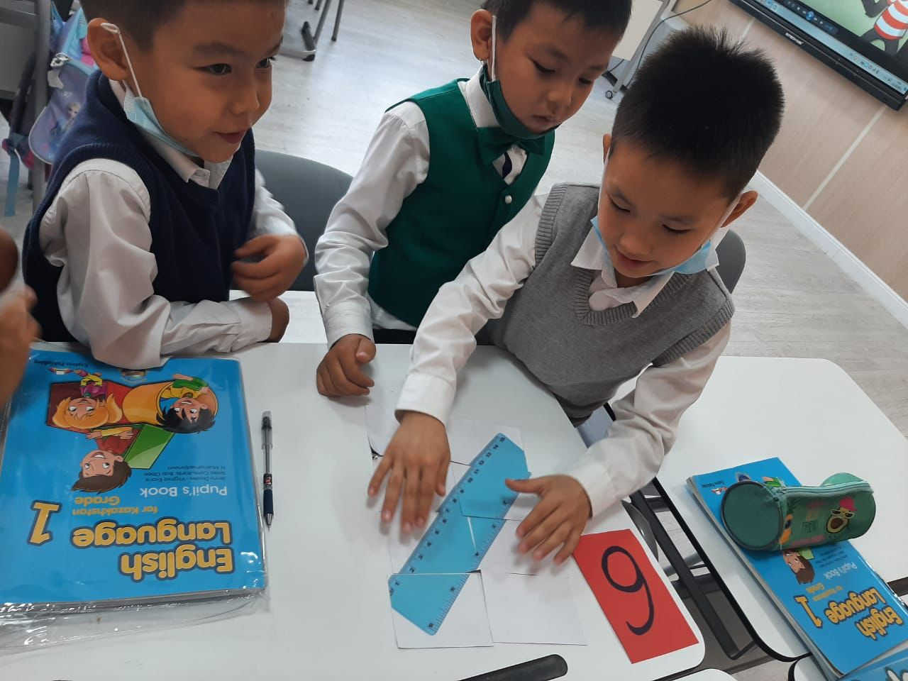
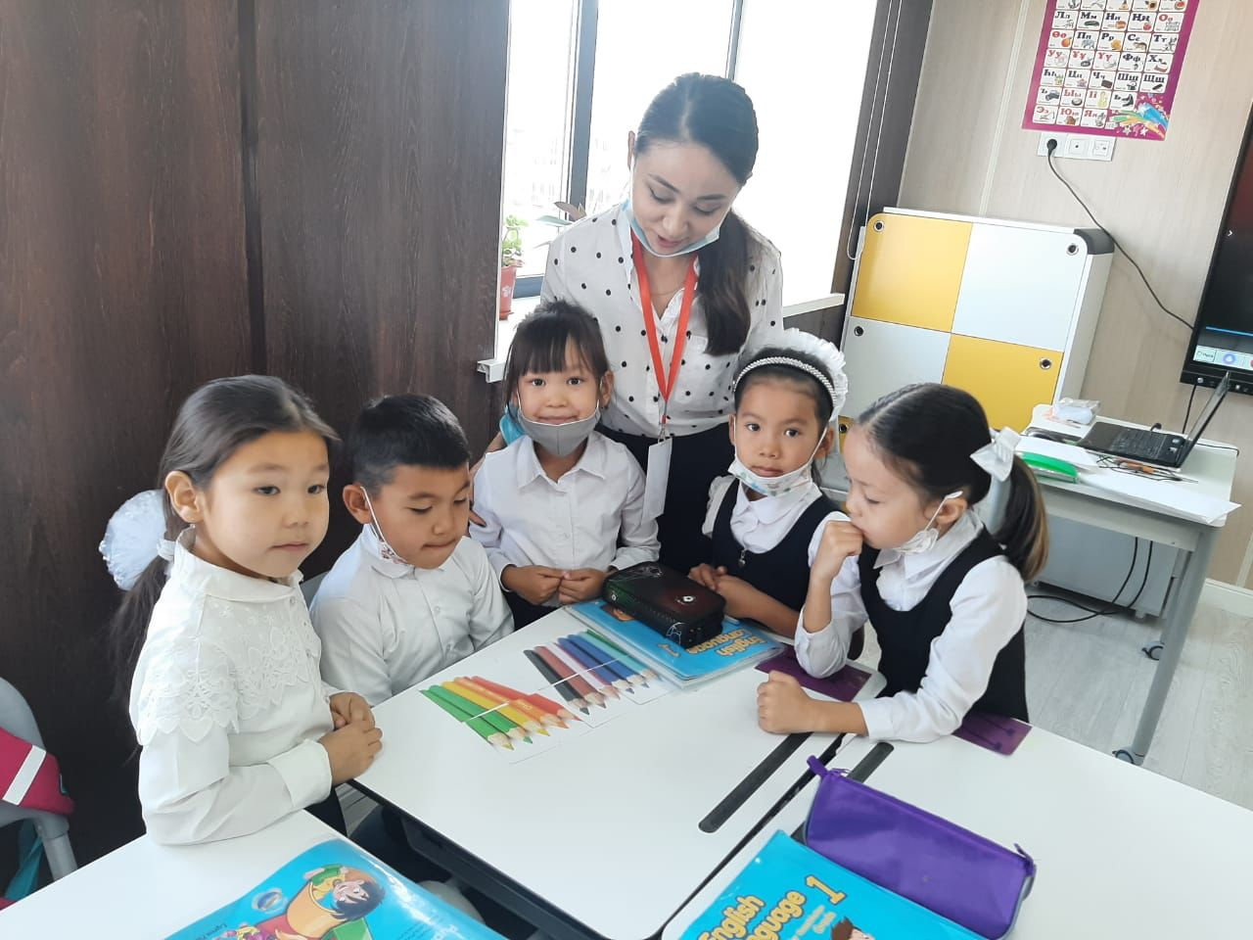

Matching
