Lesson plan
Unit: | My family and friends
School: | №2 Qoiyandy secondary school
Teacher name: | Ospanova Asemgul Muratovna
Date: | 06.10.2021
Grade: 2 Ғ | Number present: | Number absent:
Theme of the lesson: | My house
Learning objectives(s) that this lesson is contributing to | 2.R1 read and spell out words for others  2.W2 write letters and familiar high frequency words when read aloud or spelt
Lesson objectives | Learners will be able to:  Learn the new words  Sing a song  Answer the questions
Planned timings | Teacher's actions | Pupils` actions | Assessment | Resources
5  minutes | ORGANISATION MOMENT:  Teacher greets students  I’m a big house  I’m a little house  Big, little  Big, little  What was the home work?  Children now check your home tasks. I will speak Kazakh words about family and we will translate in to English language. | Students respond to greeting and take their places  Review the words about family | -
10  minutes  10  minutes  5  Minutes  5  Minutes  5  minutes | MAIN PART  Today we shall learn new words .To start our lesson I’d like you to study these words.  Chair  Bed  Table  Radio  Tree house  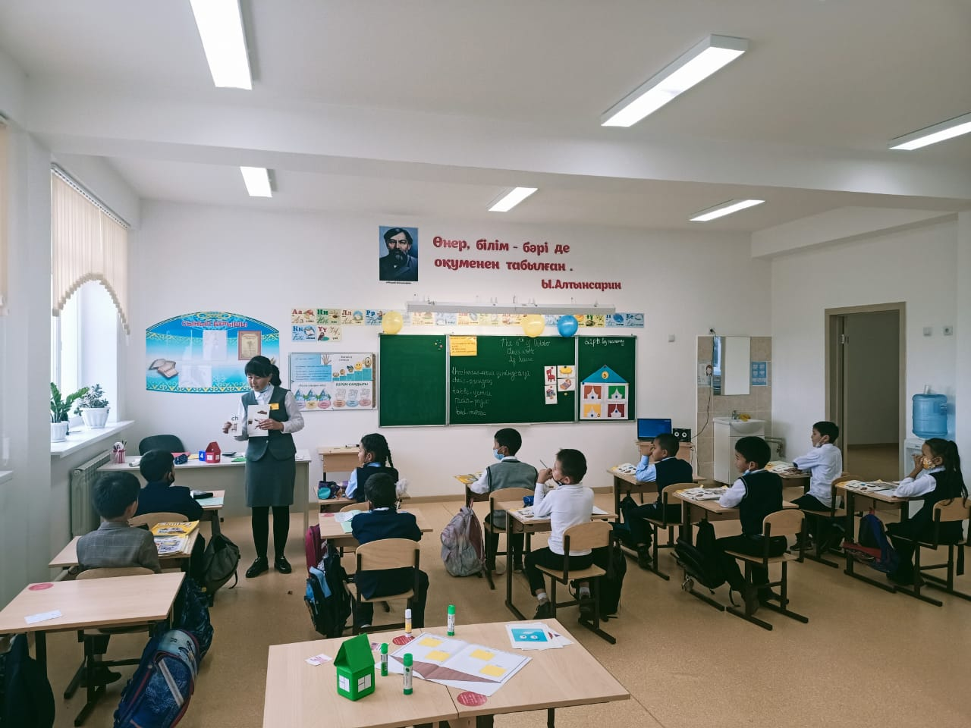  Now listen to audio and repeat. Very well. Now look at the pictures and repeat one by one.  Let’s play the game ‘What picture is missing?”  Writing. Now open your copybook and write the new words.  Individual work. Match the picture with the words. Now look at the board and check yourself.  chair  bed  tree house  radio  table  Singing a song  Now dear pupils we shall listen to the song “Tree house ” , watch the video and and learn new words.  Pair work. Can you answer the following questions? The teacher writes on the board an example  Work in pairs. What’s this?  Teacher divide children into two groups.  Children now come here and take one house.  1 group “Green house;  2 group “Yellow house”  - Task for the 1 group. Find the stickers about house thing  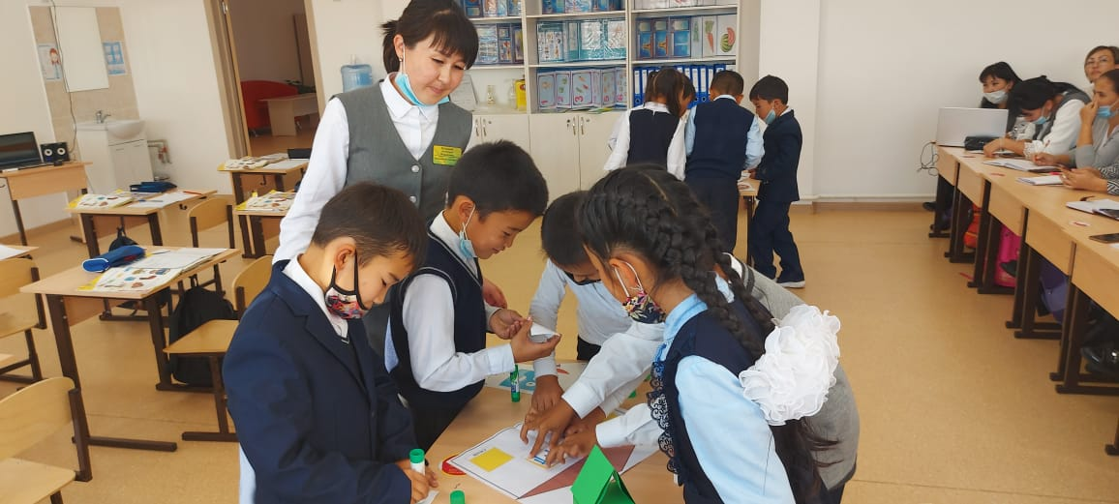  - Task for the 2 group. Find the words house thing  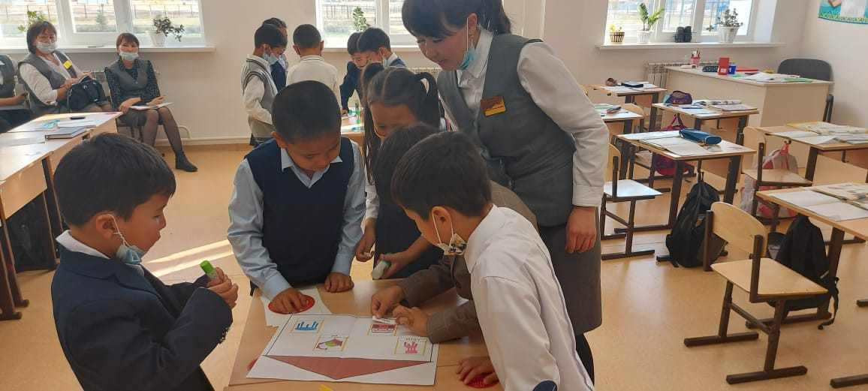  Let’s play the game “ Open your window”  The rules this game. One pupils come up to the black board and throw the box. Then look What number is it ? After find the window 2 and open. See the picture and say What’s this? | Pupils their open your vocabularies and write down the new words from the worksheets.  Children write the new words  It is a chair and etc  They’ll see and practice them later in a song “Tree house”  Children work in group | Formative assessment  Assess yourself  Assess each other | worksheets  song “Tree house ”
5  minutes | ENDING THE LESSON:  - Evaluation of the lesson  Give the home task  If you understand the lesson put your similes in the green houses  If you need help the lesson put your similes in the yellow houses  If you didn’t understand the lesson put your similes in the yellow houses  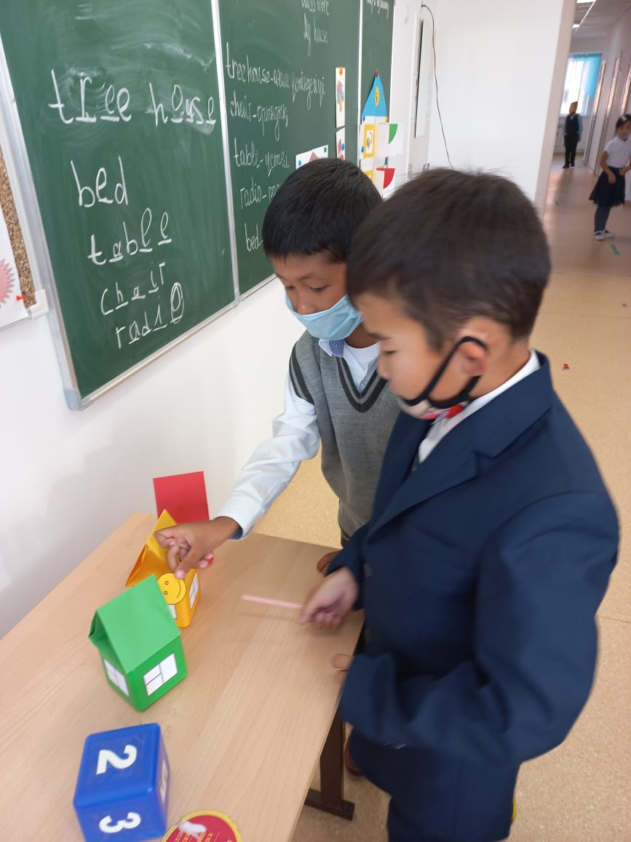 | Children write the name on the card and put on the houses | Feedback | Worksheet

