Short- term plan
Lesson plan

Long-term plan: Unit 6  “Entertainment and Media” |  |  |  |  | School: 47 Uralsk
Date: |  |  |  |  | Teacher name: Khairusheva Raigul Anuarovna
Grade: 7 |  |  |  |  | Number present: |  | absent:
Lesson title: Entertainment and Media
Learning objectives |  | 7.C1 use speaking and listening skills to solve problems creatively and cooperatively in groups  7.L3 understand with some support most of the detail of an argument in extended talk on a limited range of general and curricular topics  7.S3 give an opinion at discourse level on a growing range of general and curricular topics  7.R3 understand the detail of an argument on a growing range of familiar general and curricular topics, including some extended texts
Lesson objectives |  | - explain the previous learned words and answer the questions  - read and understand the main idea of the text  - distinguish fact from opinion  - articulate the right sentence  - express their own opinion about film using appropriate subject-specific vocabulary  - infer from discussion
Assessment criteria |  | - use learned words while speaking  - share their own opinions, ideas and describe text, using key words  - construct sentences according given rule
Value links |  | Patriotism, respect Kazakh culture  Common history, culture and language. (“MangilikYel”, 6)
Cross curricular links |  | Music, Art, History
ICT skills |  | Projector for presenting PPT
Previous learning |  | Learners have learned describing the films (the setting, the plot, the actors, the end, genre)
Plan
Planned timings | Planned activities |  |  |  |  |  |  | Resources
Start  5 min  5 min.  Warm-up | (W) Greeting  T. Good morning, students! Welcome to our lesson!  You have papers on your desks, open them up and you should match the pictures with the action. So, let’s start the 1st group show me one word, the next group match your picture with this word (have you found?) Ok, good these are the steps of our lesson.  Today we’ll  -Speak English;  -Listen;  -Learn new facts;  -Create;  Activity 1 Speaking. Pizza.  Do you like Pizza?  Students choose one piece of pizza and give explanation of words:  Fantasy, comedy, tragedy, adventure, drama, science fiction, horror.  Motivate and praise with thumb.    Activity 2. “4 questions” (Watching video)  Students watch the film “The Old Man” and ask 4 questions  - What is this film about?  - What is genre of this film?  - Do you know who plays in main role?  - Who is Kassym?  So, tell me please, how do you think what is the theme of our lesson?  The theme of our lesson “Entertainment and media”  Open your copy books….  Now, let’s try to answer for these question?  You should find types media. |  |  |  |  |  |  | https://youtu.be/Ir5nJ87Z4zs
3 min  Main part  Middle | Books  Radio  TV  Mass media  magazines  Newspapers  Internet  Perfect!  Now, who want to tell us about your favorite types of media?  Good thank you!  Activity 3. Let’s introduce with the new words with the method of “Gallery”. Go around the class and look at the words on the wall. Then to try understand the meaning of each words and tick on your vocabulary.  If you have written, go to your places  Work with vocabulary.  Thriller  Comedy  Science fiction  Adventure  Fantasy  Drama  Musical  Romance  Terrifying  Exciting  So, let’s practice, listen and repeat after me the words.  Task 1. You should match the words with their meaning. (cards)  - Thriller  - Comedy  - Science fiction  - Adventure  - Fantasy  - Drama  - Musical  - Romance  - Terrifying  - Exciting  a. film with exciting plot or involving crime  b. to make an audience lough  c. fiction based on imagined future scientific or time travel  d. an unusual and exciting or daring experience  e. the faculty or activity of imagining impossible things  f. an exciting, emotional, or unexpected event  g. a play or film in which singing and dancing play an essential part  h. a feeling of excitement and mystery associated with love  i. causing extreme fear  j. someone or something that produces intense, thrilling feelings or emotions  Your time is over. I want to check how many correct answers you have.  Descriptor: matches synonyms correctly.  Activity 4. The next task will be listening.  Task 2 You should listen to the exercise and complete the sentences.  - Yerbulat Toguzakov is the actor _____plays the main role.  - Sheep are farm animals _____ have thick wool.  - A shepherd is a person _____ looks after sheep.  - The steppe is the place ______ Kassym takes his sheep.  - Football is a sport _______ Kassym likes to watch.  - This is the village ________Kassym and Yerali live.  Let’s check your answers. Who wants to read the 1st sentence?....  Answer key: 1) who 2) which 3) who 4) where 5) which 6) where  Descriptor: A learner  - Choose the right answer according to the talk.  Group assessment: Let’s clap each other.  Differentiation by tasks  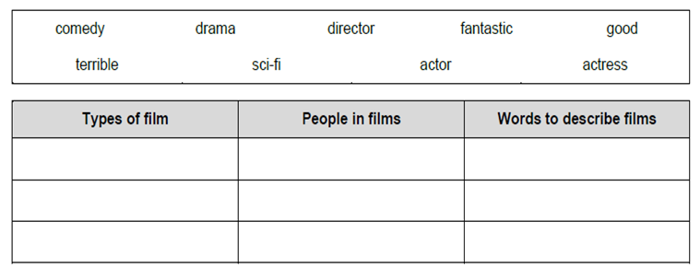  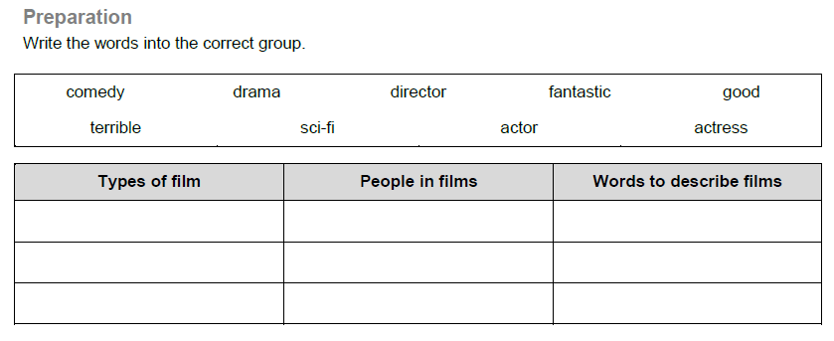  Group A. write the words into the correct group.  Description.  Write words into correct coloumns.  The 2nd group. Write true or false  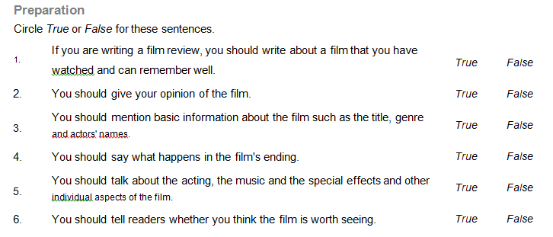  Description.  Write true or false correctly  The 3rdgroup. Fact or Opinion.  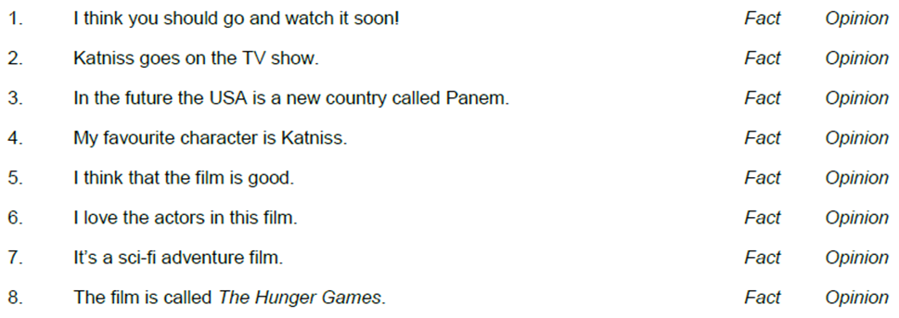  Description.  - Read and understand the text.  - Distinguish fact from opinion  Answers: Activity 5. Make a poster  Group 1 You should write advantages of media  Group 2. You should write disadvantages of the media
5min. | Activity 6 Formative assessment.  I want to give you a formative assessment. You should do it quickly and pass me.  Choose the correct words.  1.The school looks/doesn’t look very nice.  2. Mrs Squeers is/isn’t friendly to Nicholas.  3. Mr and Mrs Squeers talk about food /money.  4. Nicholas eats a lot of/little food.
End  2 min | Feedback  On the plane –I understand everything  On the buss- I need a little help  On the walking man- I need a lot of help
ADDITIONAL INFORMATION

Differentiation – how do you plan to give more support? How do you plan to challenge the more able learners? |  |  |  | Assessment – how are you planning to check learners’ learning? |  | Health and safety check
- More support can be given in the speaking activity when learners define new words, express their opinion on the matter.  - More able learners can be appraised withprovidingthem a kind of creative work to express their opinions |  |  |  | - Facilitate and structure discussions, check students’ understanding through procedural questions  - Through estimating written tasks |  | - Learners will be safely seated at a comfortable distance away from electrical outlets and cables, monitors and recorders.  - Monitor classroom space when students start moving around
Reflection  Were the lesson objectives/learning objectives realistic?  Did my planned activities work well?  Did I stick to timings?  What changes and differentiation should I make next time? |  |  | Use the space below to reflect on your lesson. Answer the most relevant questions from the box on the left about your lesson.
Summary evaluation
1:What two things went really well (consider both teaching and learning)?
2:What two things can improve the lesson (consider both teaching and learning)?
1: What have I learned from the reflection of the learners? (difficulties of individuals or all the learners)

