The secondary school named after Sh. Ualikhanov
___________________________________________
Unit of a long term plan |  | Unit 8 Travel and tourism
Teacher's name |  | Kunassova Elvira Bagitzhanovna
Date: |  | The 9th of April.
CLASS: 9 |  | Number present: | absent:
Lesson title | Present Simple and present continuous for future
Learning objectives(s) | 9.S7 use appropriate subject-specific vocabulary and syntax to talk about a limited range of general topics general and curricular topics  9.W2 write with support a sequence of short sentences in a paragraph on a limited range of familiar general topics  9.W3 write with support factual descriptions at text level which describe people, places and objects
Lesson objectives | - Explain using present simple and present continuous for future  - Talk about travel arrangements  - Ask about time and timetables

Plan of the lesson

Planned timings | Teacher’s activities | Pupils’ activities | Assessment | Resources
Start  5 min | The lesson greeting.  Warm-up  Checking up the homework | Pupils greet the teacher read their homework. |  | English Plus 9  Student’s book p.95
Main part  12 min  4 min  5 min  End  6 min | Grammar:  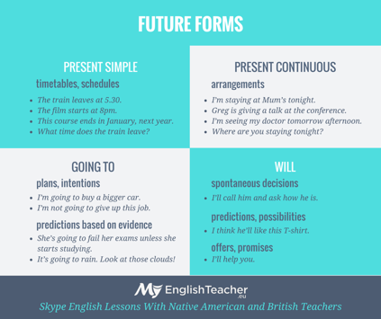  Let’s some practice  1.(A) _____ you (fly) _______ to Dubai next week.  (B) Yes, I ______  2.Mrs. Parkins (give) her students a test in a few days.  3.Hurry! The train (leave) in ten minutes.  4.I (get up) ____________ very early tomorrow morning, at 5 o’clock.  5. The ferry (leave) _______ at 9.00 from Dover and (land)_______ at 10.45 in Calais.  6. Why _________ the exhibition _______ tomorrow?(not open) When ______ it _____ place instead? (take)  7. The piano concert ___________ (not start) at 8 o'clock. It is cancelled.  Descriptors  Learners:  -learn the rule  -complete the sentences  Pair work  “Shoe laces”  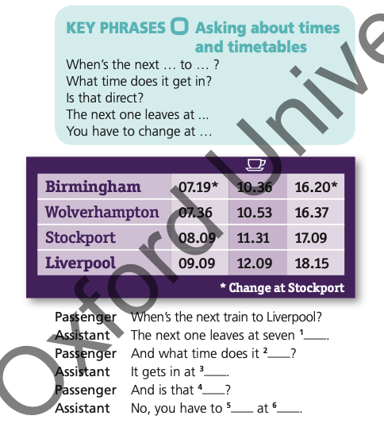  Descriptors  Learners:  -work with partner  -watch the video  -complete the dialogue  Individual work  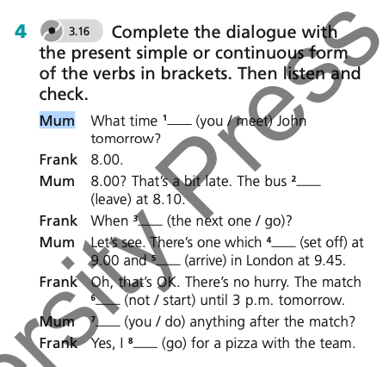  Descriptors  Learners:  -Work individually  -write on copybooks  -complete the dialogue  “GOOGLE FORM”  (TEST)  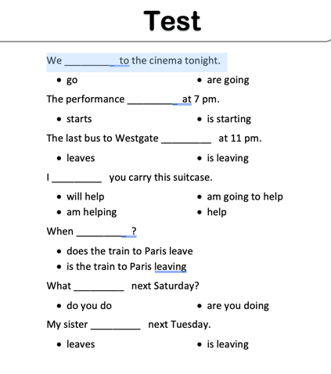  Descriptor  Learners:  -answer the questions  “Traffic light” method  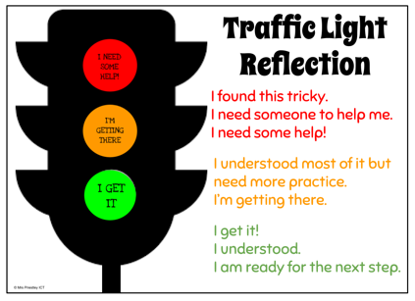 | Listen to the teacher and write down on your copybooks  Write the sentences on their copybooks and complete the sentences  Divide into pairs with shoe laces. Watch the video and complete the dialogue.  Complete the dialogue and write on the board.  Pupils do the test.  Pupils write their attitude to the lesson on leaves and give self-assessme |  | English Plus 9  Student’s book p.97 Slides 1-4  Slide 5  Slide 6  https://youtu.be/C0I4w0ibtwo  English Plus 9  Student’s book p.97 Slides 7  Slide 8  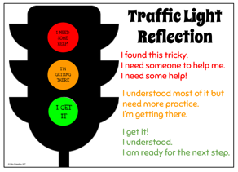  Slide 9
Additional information
Differentiation – how do you plan to give more support? How do you plan to challenge the more able learners? |  | Assessment – how are you planning to check learners’ learning? |  | Health and safety check
Differentiation can be achieved through content (Based on the theory of Multiple Intelligences different tasks are used with the same text).  By support:  Less able learners will be supported through step-be- step instructions, glossaries, thinking time.  By task:  For more able learners additional leveled tasks are offered. |  | Assessment criteria:  - Read the given passage and identify the general information.  - Demonstrate skills of organizing and expressing ideas accurately.  - Illustrate a viewpoint in a discussion.  Descriptors:  A learner  - writes the tasks with present simple and present continuous for future  - selects meaningful information, constructs the answer;  - presents information in the group discussion.  - evaluates the peers’ answers.  Teacher's observation Self-assessment. |  | Health saving technologies.

