Зерттеу тақырыбы: Белсенді әдіс-тәсілдер, білім алушылардың сөздік қоры мен сөйлеу дағдысын қаншалықты дамытады?

Unit: | Entertainment and media
Teacher’s name | Tazhiyeva G
Date: | 23.02.2021
7grade | Numberpresent: | Numberpresent:
Theme of the lesson: | J. Austen’s biography
Learning objectives: | 7.3.8 Recount some extended stories and events on a growing range of general and curricular topics.  Жалпы және оқу тақырыптары бойынша нақты деректер мен оқиғалар туралы айтып беру.  7.4.3 understand the detail of an argument on a range of familiar general and curricular topics, including some extended texts.  жалпы және оқу тақырыбы бойынша мәтіндегі негізгі ойды түсіну.  7.5.3 write with moderate grammatical accuracy on a limited range of familiar general and curricular topics  жалпы және оқу тақырыптарындаграмматиканы дұрыс қолдануды уйрену
Lesson objectives: | - express their opinions about the text  -Барлығы тақырыптағы оқиғаларды айта алады  - identify specific information and analyze thetext  - басым бөлігі нақты деректерді табады және талдай алады  –identify the main idea of the text  -кейбірі мәтіндегі негізгі ойды айта алады
Criteria | -identify the main idea of the text  Негізгі ойды анықтайды  -identify specific information in the text  Нақты деректер мен оқиғаларды талдайды.  - use prepositions in, on, by to write a biography of a person  Жазба жұмыстарында in, on, by демеуліктерін орынды қолданады.
Cross curricular links | Literature
ICT skills | Using internet (padlet, Zoom ,Wordworld platforms)
Previouslearning | Structure and criteria
Procedure | Performance by teacher |  | Performance bystudents | Assessment | Resources
Beginning  3min  5 min  Procedure | Teacher greets students  Brainstorming  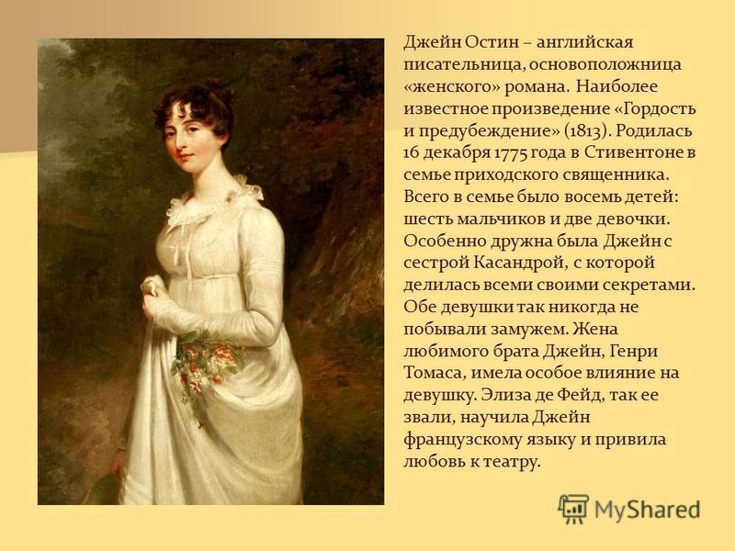  -Look at this picture!  -What do you know about this person?  -What is her name?  Watch the video about J.Austen  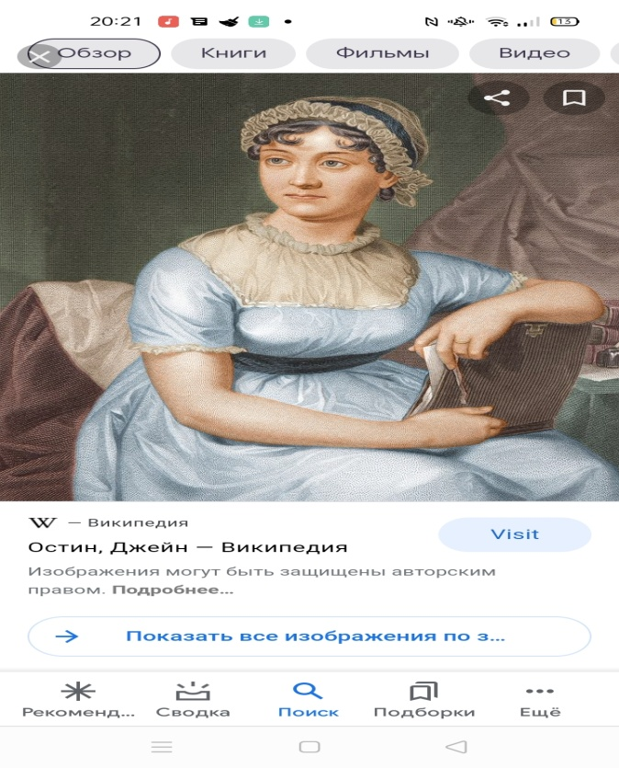  After watching the video we will talk about these questions.  Who is Jane Austen?  Where was she born?  Whom did she live with?  When did she begin to write books?  What is her famous books?  As you guessed, today we’ll talk and learn to write about J.Austen’s biography  Descriptor:  -answer the questions.  - give an information using the dates. |  | Students respond to greeting  (Learners guessed about the theme)  Learners answeres the questions  Prediction:  A: - answers the questions clearly.  B: - answers the questions with some mistakes  C: - answers with difficulties. | Formative assessment:  The teacher assess the students by descriptor | Student’s book p.78
Middle  (25 min)  7 min  10 min  The end of the lesson  10 min  5min | MAIN PART  2.Pre-learning.  New theme. Task1.  Reading the model text. Then discuss the headings 1-5 with paragraphs A-D (оқып болған соң төмендегі срақтар бойынша талқылайды)  - Jane Austen started writing  - Jane Austen’s style of writing and her most famous books.  - Jane Austen’s likes and dislikes  - Jane Austen is still famous today  - A summary of Jane Austen’s life.  Descriptor:  -read the text correctly.  - identify the main idea of the text.  Task 2.  Post- reading The method ``Chronological table``  At first read the text again, translate into group, then write using the prepositions on, in, by and disscuss of J Austen’s biography in the group Using the PADLET board  -Students discusses and writes about J.Austen’s biography. Study the model text and find the time expressions  - Fill in the table.  Key words: In, on, by  1775 Jane Austen  1795  1811  1817  Descriptor:  -use the prepositions in, on, by and find the dates correctly.  -disscuss in the group.  Task 3. «Stars with questions» әр оқушы ұяшық таңдап, сұрақтарға ауызша жауап береді.  1.Where and when was she born?  2.Where did she grow up?  3.Where did she study?  4.What is her most famous character.  5. Jane Austen started writing.  6. Jane Austen’s style of writing  7. Her most famous books.  8.When did she die?  Descriptor:  - identify the main idea of the text  -answer the questions correctly;  Task 4. Answer the question.  -answers the question in short:  What did you take from the lesson?  -What tasks were interesting to do?  -What were the problems?  Descriptor:  - can give their thoughts correctly |  | Predictions:  A: understand the content  -can say the main idea of the text.  B: can say the content of the text.  C:-understand the content of the text.  Predictions:  A: - uses the dates and writes theprepositions accuracy.  B: - uses the dates correctly, writes the prepositions with some mistakes..  C. uses the dates and writes he prepositions with difficulties.  Prediction:  A: - understands the question,answers the questions quickly  B: - understands the question, give short answer  C. –understand the question,answers with difficulties  Prediction:  A: give their thoughts correctlyanswers the questions clearly  B: -answers the questions with support.  C:-answers with difficulties. | Formative assessment:  The learners assess each other by descriptor  Formative assessment:  The teacher assess the students by descriptor.  Formative assessment:  The learners assess each other by descriptor  Formative assessment:  The learners assess each other by descriptor | Video material https://vimeo.com/81208609
Feedback:  -What have you learnt from the lesson? |  |  | -A student completes and gives feedback through the “pudlet” application  “plus, minus, interesting”  “plus” “minus” “interesting”

