Алматы қаласы
«Ғ.Мүсірепов атындағы №86 мектеп-гимназия»
Ағылшын тілі пәнінің мұғалімі
Қайсар Жібек Маратқызы
Sport, health and exercise |  |  | School:
Date: |  |  | Teacher name:
Grade: 8 |  |  | Number present: |  | absent:
Lesson title |  | Sport: Physical activities
Learning objectives(s) that this lesson is contributing to (link to the Subject programme) |  | 8S1.Use new vocabulary on a limited range of general and curricular topics  8C8.To develop speaking skills and improve pronunciation  8U4.To promote the use of Web 2.0 Tool for further self-access study
Level of thinking skills |  | Comprehension, Application, Evaluation
Lesson objectives |  | All learners will be able to: understand the meaning of the new words and word expressions.  Some learners will be able to: revise vocabulary on the theme of sport.  Most learners will be able to: develop speaking skills and improve pronunciation. To practice new words by doing exercises and discussion
Assessment criteria |  | They could learn new kinds of sport in writing exercises  They coped with discussion task very well
Values links |  | Secular society with high spiritually
Cross-curricular links |  | Sports, Medicine, Art, Design.
Previous learning |  | Entertainment
Plan
Planned timings | Planned activities (replace the notes below with your planned activities) |  |  | Resources
Start | Organization moment.  Good morning dear friends, I’m glad to see you! How are you today?  Psychological mood  "Circle of joy" (The teacher and the pupils stand in a circle and say good wishes to each other).  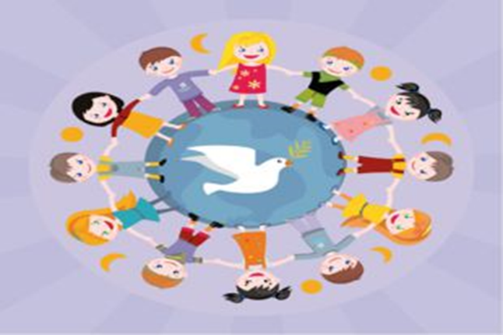
Middle | Today we will discuss new topic, which is called Sport and Health.  Will you tell me what is sport?  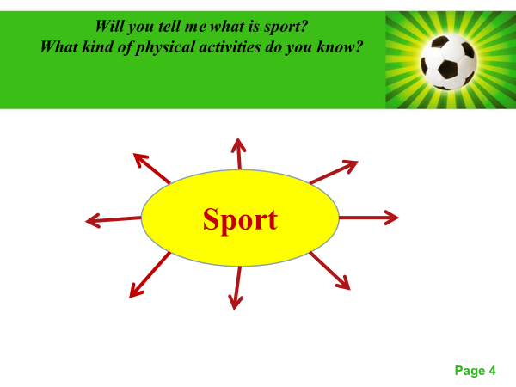  What kind of physical activities do you know? Look at the presentation and make notes.  Aikido is a non-violent Japanese Martial Art  Zumba is an incendiary dance training, based on Latin rhythms.  Boxing is a contact sport, single combat, in which athletes strike each other with their fists in special gloves.  Swimming is an individual or team sport that requires the use of one's arms and legs to move the body through water.  Rugby is a full-contact sport vaguely similar to American football.  Exercise 1.  Answer to these questions:  How often do you do exercises?  Which of these activities do you like doing? (in book)  Which would you like to try? Why?  Which of the above are group activities?  Which are individual activities?  Thank you for your answers!  Exercise 2. Complete the table with the names of the sports people.  Exercise 3.  Complete the sentences with the words below. You can use your dictionary.  rink ring pitch pool team  1.Football matches are played on a……  2.We go swimming in a……  3.You can go ice-skating on a…..  4.Boxing fights take place in a….  5.Rugby is played by…  Well done!  And now you will watch a video about strange sports. Be ready to answer the questions after watching.  1.What’s the difference between Quidditch in the Harry Potter books and in real life?  2.What quality must a Quidditch player have?  Let’s discuss your answers.  Let’s compare your opinions using “Vocaroo”Web 2.0 Tool for Language Teaching.  Please record yourselves individually talking about your answers about sport using your notes. Confident students can do this without their notes. When you have listened to yourselves and are happy with the result, you work in pairs: exchange each other’s recordings and peer check the pronunciation and word stress. |  |  | Interactive whiteboard (IWB)  Computer classroom  “Vocaroo” Web 2.0 tool for language teaching (https://vocaroo.com/) (https://www.youtube.  com/watch?v=PhojXgTEs1s)  Headphones with microphones
  Sport | Sportsperson
  Football | Footballer, football player
  Swimming
  Basketball
  Ice-skating
  Boxing
End | Conclusion of the lesson.  Reflection: Five fingers.  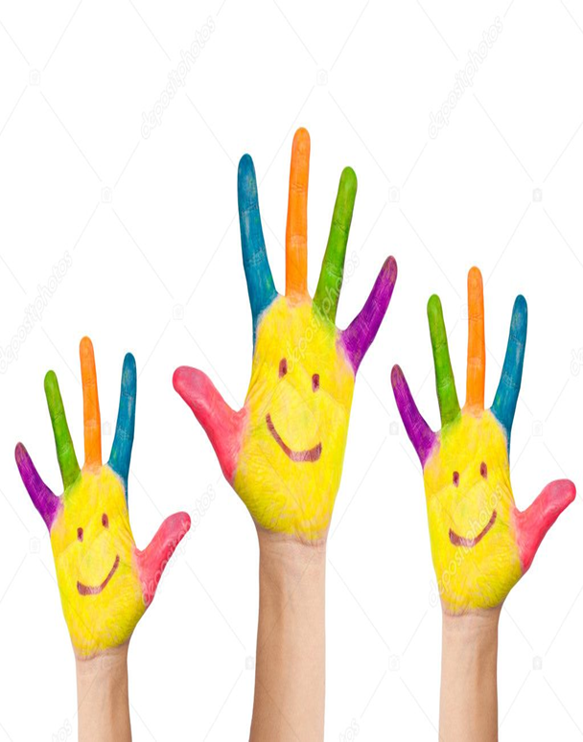  Little finger - thoughts, knowledge, information.  - What have I learned today?  Nameless finger - proximity to the goal.  - What did I do today and what did I achieve?  Middle finger - a state of mind.  - What was my mood, mood?  - What was associated with positive emotions?  - First finger -service, assistance, cooperation.  - How did I help others today?  - Has my relationship with others improved?  -Thumb- cheerfulness, physical condition.  - What did I do today for my health?  Giving the hometask:  Writing. Invent a sport. Think of: name of sport, number of players, place, rules, other information. Present it to the class.

