Lesson plan

Unit of a long term plan‘’Hot and cold’’ |  |  |  | School: Lyceum named Bauyrzhan Momyshuly
Date: |  |  |  | Teacher name: Azhar Zhunussova
CLASS: 4 |  |  |  | Number present: | absent:
Lesson title |  | Weather 1
Learning objectives(s) that this lesson is contributing to (link to the Subject programme) |  | 4.2.4.1 respond to questions on an increasing range of general  and some curricular topics  4.4.7.1 Spell most familiar high-frequency words accurately when writing independently;
Lesson objectives |  | All learners will be able to:  - reply to weather related questions giving short answers with few errors  - spell most familiar high-frequency words accurately when writing independently with 70% accuracy  Most learners will be able to:  - reply to weather related questions giving full answers with few errors  - spell most familiar high-frequency words when writing independently with 80% accuracy.  Some learners will be able to:  - reply to weather related questions giving more extended answers without any errors  - spell most familiar high-frequency words accurately when writing independently with 90% accuracy
Assessment criteria |  | - respond to weather related questions with few errors  - spell accurately most high-frequency weather related words writing independently;
Values links |  | Mutual respect
Cross-curricular links |  | Nature Science
Previous learning |  | Technology
ICT skills |  | Using whiteboard,
Plan
Planned timings | Planned activities (replace the notes below with your planned activities) |  |  |  |  |  | Resources
Start  5min | 1.Greetings  2. Teacher divides children into 2 groups.  «Moving circle» strategy  Students find the parts of the cutting card and find their partners  3.Presentation new theme of the lesson. |  |  |  |  |  | Cards
Middle  5 min  10 min  8 min  2 min  5 min | Eliciting vocabulary.  Month, season, pick up, forest, mushroom, berries, beautiful.  Activity1. Strategy ‘Board game’  Task. Answer the questions  Season  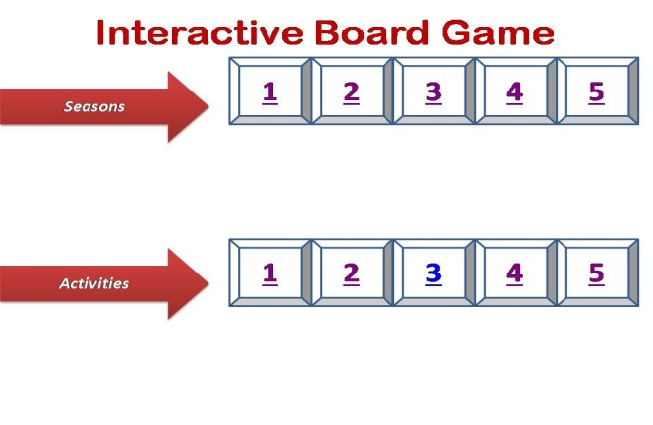  1.March, April, May are months of what season?  2.What season is hot?  3.What months are there in Winter?  4.What season is a rainy season?  5.What season is very cold?  6.In what season we pick up snowdrops?  7.When we go swimming to the river?  8.In what season we can go to the forest and pick up mushrooms and berries?  9.What we can do in winter?  10.What season is a very beautiful?  Descriptor: A learner  - Reads the questions;  - answers the questions;  Differentiation by grouping  Peer assessment  Activity 2. Speaking. Active strategy «Step by step»  Task. Children watch the video and answer the questions on the step  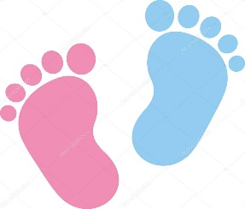  - What colour is Gary’s T-shirt?  - What is the weather like before Gary goes outside the first time?  - What is the weather like after Gary goes outside the first time?  - What clothes does Gary put on when it is snowy?  - When it is raining, is it hot or cold?  - What does Gary go inside to get when it is raining?  - What colour is the umbrella?  - What does the expressions «raining cats and dogs» mean?  Descriptor: A learner  -watches the video;  -replies the questions correctly;  Relax time. Active method “Sing a song”  Differentiation by grouping  Peer assessment  Activity 3.Writing (FA)  Learning objectives  4.4.7.1 Spell most familiar high-frequency words accurately when writing independently;  Assessment criteria  write most familiar high-frequency words accurately about weather  Task. Write down the words putting the letters in a correct order.  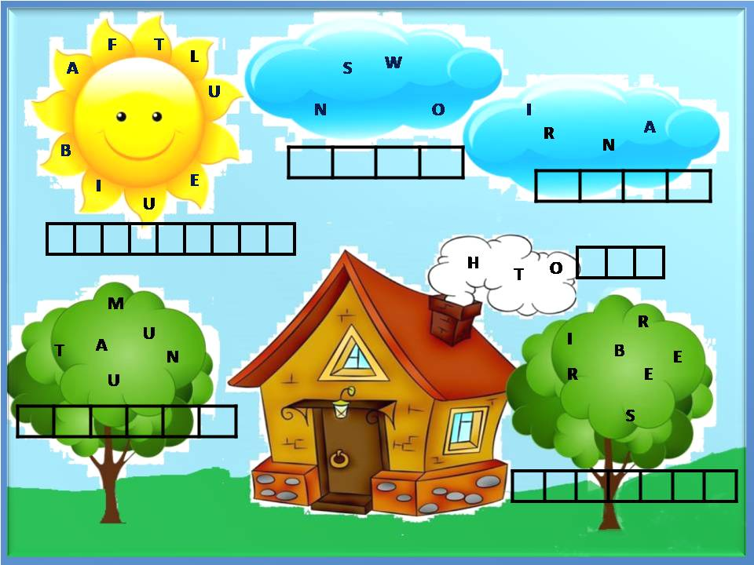  Descriptor: A learner  - looks at the pictures;  - puts the letters in a right order;  -spells the words correctly; |  |  |  |  |  | PPT, pictures with weather  https://drive.google.com/file/d/1FQVou_hLTjC6_jmSc8Dm8Tqd7jxRBzPI/view?usp=drivesdk  https://youtu.be/FIThe99vfK4  Pictures  Handout
End  5min | Reflection “Draw your brain”  Learners draw the outline of a brain in their exercise book and fill it with words that explain what they have learnt during that lesson
Additional information
Differentiation – how do you plan to give more support? How do you plan to challenge the more able learners? |  |  | Assessment – how are you planning to check learners’ learning? |  |  | Health and safety check
More able learners - reply the question write most familiar high-frequency words. |  |  | - Assessment by descriptors motivate the interest of students to learning achievement of the result. |  |  | Health saving technologies. Using physical exercises and active activities.

