LESSON: True friends. I’m always here for you. |  |  |  |  |  |  |  | School: school-gymnasium №1 named after Abai
Date: |  |  |  |  |  |  |  | Teacher’s name: Stepovaya Y
CLASS: 5 |  |  |  |  |  |  |  | Number present: |  |  | absent:
Learning objectives(s) that this lesson is contributing to |  |  |  |  | R6 C2 C9 S3 S4 W3
All learners will be able to:
use some vocabulary from the module
Most learners will be able to:
describe friend’s qualities
Some learners will be able to:
use a wide range of vocabulary from the module to express their view
Previous learning |  |  |  |  | vocabulary from the Module
Plan
Planned timings |  |  |  |  |  |  |  |  |  |  |  | Excel  Resources | Teacher  Notes
Beginning the lesson  7-10 min |  |  | - Greetings  - Making complement each other  Guess the theme  Task 1 Look at the active board and guess the theme of the lesson.  ’’ ‘’’’’  + plural form ending  FA teacher’s assessment  - Telling the aims of the lesson.  - Connecting with Mangelic El strategy  - Checking home task (Flying plane strategy)  TASK 2 Write 5 words in your language, translate them in English and Kazakh  Your task at home was also to prepare pictures for friendship  FA peer’s assessment |  |  |  |  |  |  |  |  |  | PPT  Slides1-3    А4
 | Main Activities |  |  | To practise reading for specific information  Discuss the values of friendship around the class. |  |  |  |  |  |  |  | ex 1p 44
 |  |  |  | To create a poster based on the student’s recipe for friendship  - Explain the task. Allow Ss time to work in groups to create their recipe. Ss collect pictures or make drawings for the poster.  - Students present their posters in a display in the classroom or as a presentation.  FA Descriptor  - Write and draw accurately and clearly  - Be creative  - Pronounce the words correctly  - Participate all members of the command  FA Peer’s assessment Each command  Ss discuss what friendship means to them |  |  |  |  |  |  |  | Ex3p44
 | Ending the lesson |  |  | To listen and read for specific information  - Allow the students time to discuss the problem.  - Play the video to consolidate language.  Conclusion  To write a sentence about values  To me.a ftiendship is --------------------------------  - Explain the task. Allow Ss time to write their sentences.  - Monitor the activity around the class. Ask some Ss to share their sentences.  Reflection Sandwish  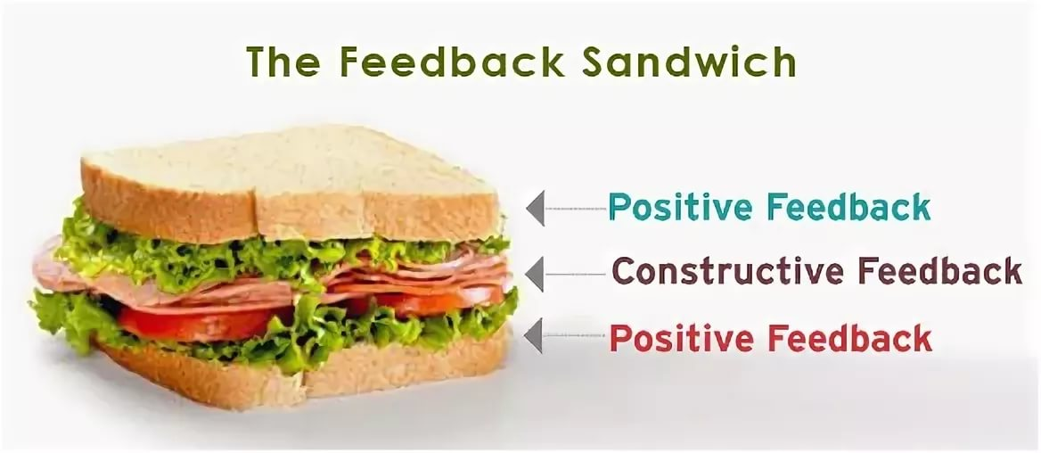  Teacher’s assessment of the lesson (Badges for the best) |  |  |  |  |  |  |  | Video  Case-stydy | Case-study
 | Additional information
Differentiation – how do you plan to give more support? How do you plan to challenge the more able learners? |  |  |  |  |  | Assessment – how are you planning to check learners’ learning? |  |  | Cross-curricular links  Health and safety check  ICT links  Values links
prompt less able learners to ask a range of questions with different questions |  |  |  |  |  | monitor question production in group activity  Peer’s assessment  Smiles badges  Cards |  |  | values links: family
 | To motivate them |  |  |  |  |  | monitor pronunciation of new vocabulary from Module
 |  | Reflection  Were the lesson objectives/learning objectives realistic? Did all learners achieve the LO?  If not, why?  Did my planned differentiation work well?  Did I stick to timings?  What changes did I make from my plan and why? |  |  |  |  | Use the space below to reflect on your lesson. Answer the most relevant questions from the box on the left about your lesson.  Yes,learning objectives were achived.
Yes,I did

No,I didn’t
To give more time for preparation,because the most pupils wrote in reflection that they wanted to complete their craft work.
Summary evaluation

What two things went really well (consider both teaching and learning)?

1: Checking home task
2: Involving to the theme of the lesson

What two things would have improved the lesson (consider both teaching and learning)?
1: To tell descriptors to the children before the task.

2:Timings

What have I learned from this lesson about the class or achievements/difficulties of individuals that will inform my next lesson?
1.Improve work in groups.

