Lesson plan
Unit of a long term plan: Unit 1 |  |  |  | School: “Koksaiek” Secondary School
Date: |  |  |  | Teacher name: Iklassova Gulbanu
CLASS: 8 |  |  |  | Number present: |  | absent:
Lesson title |  | The toughest job
Learning objectives(s) that this lesson is contributing to  (Subject programme) |  | 8.1.1.1 use speaking and listening skills to solve problems creatively and cooperatively in groups  8.2.2.1 understand with little or no support most specific information in extended talk on a wide range of general and curricular topics  8.3.7.1 use appropriate subject-specific vocabulary and syntax to talk about a range of general topics, and some curricular topics  8.3.3.1 give an opinion at discourse level on a wide range of general and curricular topics
Lesson objectives |  | All learners will be able to:  -Find the title of the lesson by emoji  -answer for the gist questions  - find the meaning of the words with support  Make up simple sentences  Watch and find details  Most learners will be able to:  - Make up sentences by using descriptions of jobs  - Match words with definitions with little support  - Watch the video ,job interview,  - Find the details with 100 percent accuracy  - Discuss about the interview  - Some learners will be able to:  - State points about the tough jobs without support  - Discuss in pairs the video if they agree or disagree  - Support peers
Assessment  criteria |  | Listen and discuss about tough jobs  Recognize the details in the video about job description in the interview  Apply topic vocabulary and descriptions about tough jobs  Express opinion about the jobs which don’t require any money
Effective teaching and learning |  | E-learning, Collaborative learning, Modelling, Active learning,
Level of thinking skills |  | Knowledge, understanding, application, high order thinking skills
Values links |  | Respect, openness, Kazakh patriotism and civil responsibility (“Mangilik Yel”)
Cross-curricular links |  | Self knowledge
Previous learning
Plan
Planned timings | Planned activities |  |  |  |  |  |  | Resources
Start  3 min  9 minute  5minute | Organization moment: Greeting, checking attendance  Lesson Hook : Looking at the emoji pictures learners guess the title of the lesson . Teacher elicits answer for some gist questions    Gist questions. Elicitation. Referential questions  1. Have you ever heard a job that you would describe as ‘tough’?  If yes, what was it about the job that you found difficult?  2. What other factors can make a job difficult?  3. Create a list of 5 of the most difficult jobs in the world (If you need inspiration).  4. Create a list of 5 of the easiest jobs in the world.  Pre-teach vocabulary. Word cloud. Learning conversation. Modelling  Learners choose one of the difficult jobs from their list in question 3, look at the word cloud below and choose 10 characteristics that you think a person would need to have, in order to do this job (look up any new words).  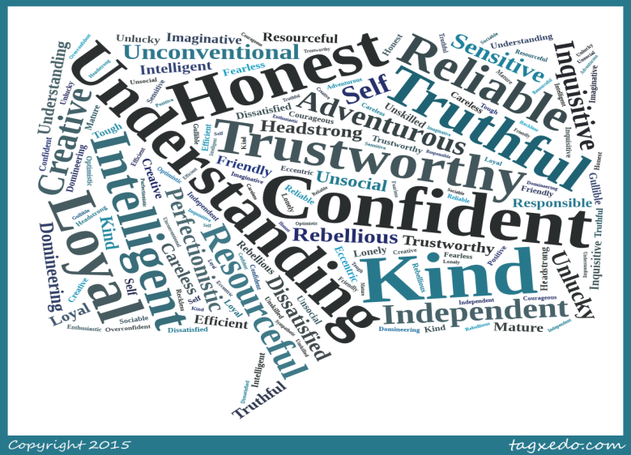  1. Match the words in the table with the definitions below and make up sentences  - Extremely good or impressive.  - Wide-ranging or great in number.  - The ability to move freely.  - A monthly payment for work completed.  - Madness.  - Not genuine or real.  - A state of confusion.  - Without compassion or cruel.  - To a high degree.  - Including or covering everything.  Descriptor: Learners  - Work in a group  - List difficult jobs all around the world  - Find appropriate feature for the jobs in your list  - Match the words with definitions  Assessment: teacher gives points for each correct answer.  Differentiation: by resource- teacher provides learners with prompts in the form of pictures or simplified definitions of new words , if necessary explains the meaning of words from the word cloud by modelling or by TPR  Peer support- learners help each other in collaborative work  While- watching task. E-learning. Learning conversation  Learners write answers for some questions while watching the video and when the teacher pause the video before the ending they try to guess who might by the person who does this job. Teacher elicits different answers from all learners  1.What positions are required :______________________  2. how many hours are intended to work:__________________  3. what qualities should the candidate have?_________________  4. Why there is no vocation;___________________________  5. How much is it paid :___________________  6. Who is the person that acquire this job.______________________  7. Do you agree with this:  2.Post –listening. Discussion:  1. Do you agree/disagree that being a Mum is the world's toughest job?  2. Is it harder to be a Mum or a Dad?  3. Do you think that the interviewees were real or actors? Why/why not?  4. How did the video make you feel?  5. Is it a good commercial? Why/why not?  6. Is buying someone a greetings card a good way of showing gratitude.  Descriptor: Learners  - Work in pairs  - Watch and find the answer for the questions  - Discuss about the toughest job in the world?  Assessment: Peer assessment- while working in pairs learners show agreement and disagreement to the points given by pairs. Teacher monitors  Differentiation: Teacher support : teacher monitors and models one questions and gives more prompts  Peer support: learners are paired as less abled and more abled learners. |  |  |  |  |  |  | http://talk2meenglish.blogspot.com/2015/03/the-worlds-toughest-job-intermediate_8.html  PPT  PPT slide
  Mobility | Salary | Insane | Intense | Awesome
  All- encompassing | Inhumane | Extensive | Fake | Chaotic
5minute  8minutes  7minutes |  |  |  |  |  |  |  | Handouts  http://talk2meenglish.blogspot.com/2015/03/the-worlds-toughest-job-intermediate_8.html  Handout  PPT  Assessment: teacher gives points for each correct answer.
2 minute | Reflection: five fingers |  |  |  |  |  |  | Five fingers  Handout
Additional information
Differentiation – how do you plan to give more support? How do you plan to challenge the more able learners? |  |  |  |  | Assessment – how are you planning to check learners’ learning? |  | Health and safety check
Differentiation: Teacher support : teacher monitors and models one questions and gives more prompts  Peer support: learners are paired as less abled and more abled learners.  Differentiation: by resource- teacher provides learners with prompts in the form of pictures or simplified definitions of new words , if necessary explains the meaning of words from the word cloud by modelling or by TPR  Peer support- learners help each other in collaborative work |  |  |  |  | Assessment: Peer assessment- while working in pairs learners show agreement and disagreement to the points given by pairs. Teacher monitors  Assessment: teacher gives points for each correct answer.  Descriptors |  | Health saving technologies.  Using physical exercises and active activities.
Reflection  Were the lesson objectives/learning objectives realistic?  Did all the learners achieve the lesson objectives/ learning objectives? If not, why?  Did my planned differentiation work well?  Did I stick to timings?  What changes did I make from my plan and why? |  |  | Use the space below to reflect on your lesson. Answer the most relevant questions from the box on the left about your lesson.
Summary evaluation
What two things went really well (consider both teaching and learning)?

1:

2:

What two things would have improved the lesson (consider both teaching and learning)?

1:

2:

What have I learned from this lesson about the class or individuals that will inform my next lesson?

