Unit: | Water, water, everywhere
Teacher name: | Idrissova Aliya
Date:
Grade: 3 | Number present: | Number absent:
Theme of the lesson: | Rain, rain…
Learning objectives(s) that this lesson is contributing to | 3.2.5.1- pronounce familiar words and short phrases intelligibly when reading aloud  3.3.1.1- recognize, identify and sound with support a limited range of familiar words in simple sentences
Lesson objectives | Learners will be able to:  - use most of the adjectives in the speech;  - answer questions with minimum support.
Lesson plan
Planned timings | Teacher's actions | Pupils` actions | Assessment | Resources
10  minutes | ORGANISATION MOMENT:  Teacher greets children  Song “Rain, rain go away”  - Good afternoon children. Sit down, please.  - Who is on duty today?  - What is the weather like today? | Children’s respond to greeting and take their places | -
20  minutes | MAIN PART  New words  Need – қажет  Don’t need - Қажет емес  Teacher explains new grammar  I need when it is sunny.  I don’t need raincoat.  We usually use need/don’t need …  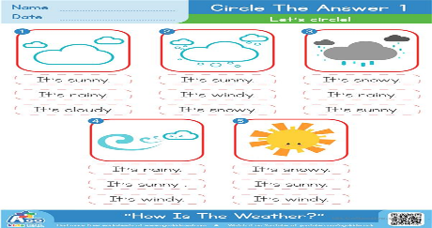  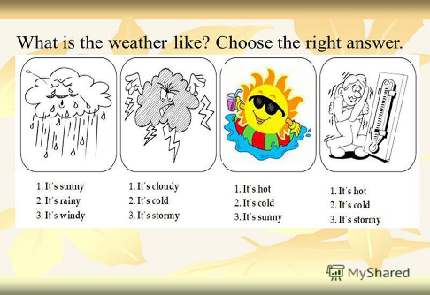  Writing the copybook ex: 1 p 70 (Activity book)  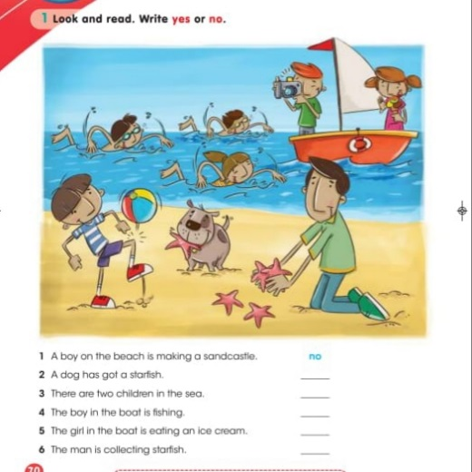 | SMILES3  Activity book  Ex.1 p.70  Pictures of clothes  Posters | Formative assessment
10  minutes | ENDING THE LESSON:  REFLECTION “Weather”  I hope we had an interesting lesson. Thank you!  Now I want to reflect our lesson by indicators and I want to ask you some final questions:  - What is your favorite weather?  - What clothes do you need when it’s rainy?  Rain – don’t understand the material  Snow – I have some questions  Sun – everything is clear  Give the home task  The lessen is over good bye! | Sun, rain, snow  Boots, raincoat

