LESSON 68  Unit 7 |  |  | School: School-lyceum №3  Named after Sh. Ualikhanov
Date:25.02.2020 |  |  | Teacher name: Karatalova S.E
Grade: 9 |  |  | Number present: 15 |  |  | Number absent:14
Theme of the lesson: |  | Film genres around the world
Learning objectives |  | 9 L1 understand a sequence of supported classroom instructions  9 S7 use appropriate subject-specific vocabulary and syntax to talk about a limited range of general topics  9 W5 write independently about factual and imaginary past events, activities and experiences on a range of familiar general and curricular topics  9 UE3 use speaking and listening skills to solve problems creatively and cooperatively in gropus and individually
Lesson objectives |  | All learners will be able to use the main points of supported advanced communication on a range of general and curricular topics  Most learners will be able to explain and compare using vocabulary of general topic  Some learners will be able to explain and evaluate, using appropriate subject-specific vocabulary a limited range of general topics in making sentences
Criteria |  | makes up questions in order talk about main points of listening  uses vocabulary a limited range of common topics  evaluates and proves his mind
Previous learning |  | Revision unit 6
Plan
Planned timings | Planned activities |  |  | Learners’ activities | Evaluation |  | Resources
Beginning  1 min  Watching a video  2min | Org. moment: Greeting learners  Warm-up: The aim of this warm-up repeat film genres and vocabulary according with them.  Then students guess what is the the theme and the aim of their lesson |  |  | Learners watch the video about film genres and vocabulary about film. | Orally comments |  | https://youtu.be/w65e7O1TmM8
Middle  3 min  Individually  In 5 groups  6min  In 2 groups  3min  Individualy  2min  Individualy  3min  In pairs  5min | Task 1 Matching  After watching learners are asked to match the words with their definitions.  Task 2 Checking h/t:  Presentation of own short video with their comments, other groups should guess what film is it.  Task 3 a game “Random wheel” (Girls and Boys commands)  Spin a wheel, and answer the question in order  Task 4 Pre-reading task  Look at the picture, answer the questions:  - What can you see on the picture?  - What do you know about HOLLYWOOD?  - Do you want to be an actor or actress?  Task 5 Reading a topic “Hollywood”  All students look through and read the topic on the slide, try to understand it.  Task 6 Making questions for the topic. Teacher shows a table with TYPES OF QUESTION. Then students make own question according to the number from 1 to 5 (They chose earlier) |  |  | Learners match the words with definitions  Learners present their short video with own comments  Learners choose correct answer in order  Learners sharing their ideas  Learners  read a topic Hollywood  learners put their question according to the number from 1 to 5 | Verbal evaluation  Gestre assessment  Hand signals  Individualy  Individualy |  | Power  Point  Slide 2  Learners’Videos  https://wordwall.net/resource/851363  PPP  Slide 4  PPP  Slide 5  PPP  Slide 6
End  2 min  3min | - REFLECTION  At the end of the lesson, students reflect on:  - If you liked the lesson and learned something new for yourself, and were active, put your star on the top of the mountain  - if you liked the lesson, but you have questions, put your star on the middle part of the mountain  - if you do not like the lesson and you were boring, put your star on the lower part of the mountain  working on by the mountain "Hollywood"  - Reflective thinking  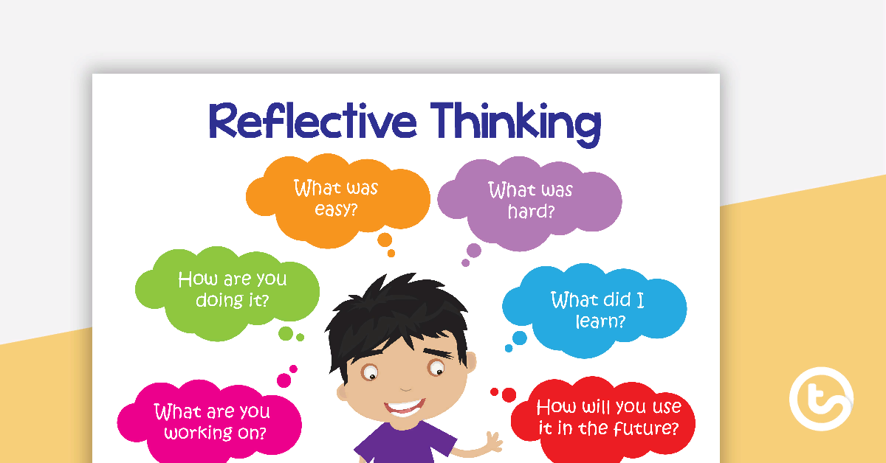  3.Home task: Writing questions to the topic “Hollywood”  Conclusion  Saying goodbye |  |  | Learners  Should draw a star on the top, in the middle, in the lower  Learners analyze their work during the lesson | Self-assessment |  | PPP  Slide 7  PPP  Slide8

