Lesson plan

Unit of a long term plan: Entertainment and Media |  |  |  |  | School: Linguistic school gymnasium 24
Date: |  |  |  |  | Teacher: Zhakina Diana Gabitovna
CLASS: 7 |  |  |  |  | Number present: |  |  | absent:
Lesson title |  | Art and Media
Learning objectives(s) that this lesson is contributing to (link to the Subject programme) |  | 7.R3 understand the detail of an argument on a growing range of familiar general and curricular topics, including some extended texts  7.S5 keep interaction with peers to negotiate, agree and organise priorities and plans for completing classroom tasks
Lesson objectives |  | All learners will be able:  Identify different types of art  Most learners will be able:  Ask and answer the question according to the text.  Some learners will be able:  Express their opinion on the theme
Assessment criteria |  | - Recognize factual details in a given argument related to the topic.  - Support a talk on a given general topic.
Values links |  | to foster student's interest in art, paintings; to implant good taste
Cross-curricular links |  | Art, music
Previous learning |  | Topical vocabulary
Plan
Planned timings | Planned activities (replace the notes below with your planned activities) |  |  |  |  |  | Resources
Start  5 min | Greeting.  “Mosaic”  Teacher divides class into 2 groups by assembling a mosaic.  Open-ended questions.  - Group  Do you like the mural on this building?  Why do you think someone painted it?  Would you like to live in a building like this?  - Group  Do you like this painting?  Why do you think the artist painted this woman?  “What’s the difference”  Teacher shows learner’s two different images and ask them to explore the difference between two, with reasons to support their responses.  T: What do you think what will be our lesson about? |  |  |  |  |  | 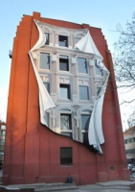
Middle  10 min  10 min  10 min | Lead in.  “Associations”  Media  Art  Students write associations and give definition of these words.  Art any branch of creative work, esp. painting, drawing, or work in any other graphic or plastic medium.  Media all the means of communication, as newspapers, radio, and TV, that provide the public with news, entertainment, etc., usually along with advertising.  Pre-teach. Vocabulary.  concert [ ˈkɒnsət ] концерт  busker [ bʌskər ] уличный музыкант  radio [ ˈreɪdiəʊ ] радио  mural [ ˈmjʊə.rəl ] фреска  newspaper [ ˈnjuːzpeɪpə(r) ] газета  DJ [ ˌdiːˈdʒeɪ ] ди джей  sculpture [ ˈskʌlp.tʃər ] скульптура  journalist [ ˈdʒɜːnəlɪst ] журналист  exhibition [ ˌeksɪˈbɪʃn ] выставка  gallery [ ˈɡæl.ər.i ] галерея  painting [ ˈpeɪntɪŋ ] картина, живопись  graffiti [ ɡrəˈfiː.ti ] граффити  Drilling. (CH), (I), (P), (G)  Verbal assessment.(Good job, Excellent, Brilliant, Well done)  Match the words with the picture  a busker c exhibition e radio g concert i journalist k gallery  b sculpture d graffiti f newspaper h DJ j painting l mural  l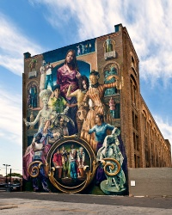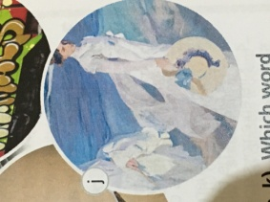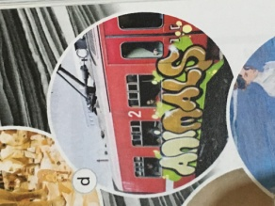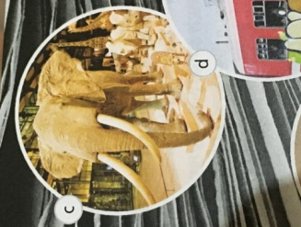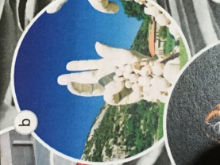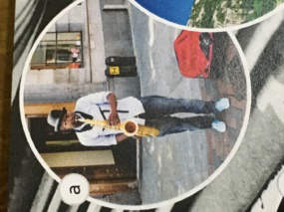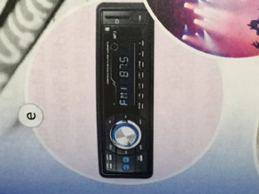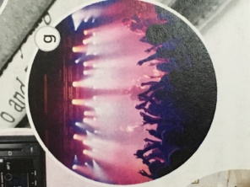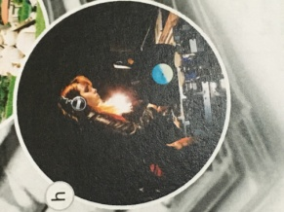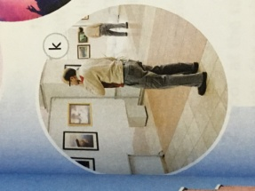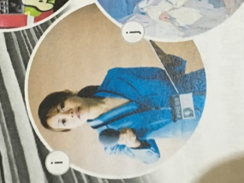f  “Word Scramble”  Unscramble the words.  pinginat cnecrto mlaru jd spurelutc ebiitnoxtih nppewsare bskerus roida gyrllae gifitraf jnalorusti  Classification chart  Classify the words in 3 groups.  busker graffiti concert painting  sculpture radio DJ gallery  exhibition newspaper journalist mural  art Music media  exhibition, gallery, graffiti, painting, sculpture, mural busker, concert, dj, radio journalist, newspaper, radio  Peer-assessment  Learners discuss the questions in pairs.  - Which of the people, places and things in Task 1 can you find near you live?  - Do you buy a newspaper? Why?/Why not?  - What’s your favourite radio station? Do you have a favourite DJ?  - What was the last concert you went to? Did you enjoy it? etc.  Pre-reading  Teacher shows several pictures. Ask learner’s open-ended questions.  -Which pictures do you think are art? Why?  -What makes a person an artist?  -Have you got friends or family members who are artists?  Teacher shows the blog in internet.  T: Today blogs are very popular. Some of you may discuss different topics in online blogs. And now we’ll read some of them. What do you think? What will be the theme of discussion?  While-reading  “Jumbled Text”  The case for: The case against:  My aunt has practiced for years to develop her talent. That’s why she’s an artist.  Of course, I like looking at paintings in galleries, but I also like drawing pictures of my friends or taking photos with my mobile phone.  Art is the result of years of practice. My aunt is an artist. She’s worked hard in her studio for twenty years now. She hasn’t made much money, but that isn’t important.  I’m not very good at these things, but I’m creative. I’m passionate about them, and my friends like them. I think that’s the art!  We look at the Mona Lisa, a Picasso painting, or a sculpture by Michelangelo, and we say, ‘That’s art’.  I’ve loved visiting art galleries since I was very young. Why? Because I like looking at good art. What is art? Art isn’t a drawing that a four-year-old child has done.  It isn’t funny cartoons in the newspaper. And it certainly isn’t graffiti. Some people say, ‘If it’s creative and cool, it’s art.’ I don’t agree.  But what about the amazing graffiti someone has painted on your street? What about the photographs our friends have posted online?  What about the English poster you’ve worked on for hours? Have you made of work of art? To me, art is anything that’s creative.  She’s shown her sculptures in several exhibitions since 2010 – her art is great. Art is very hard, and not many people can do it well.  “True and False”  Learner’s read the article again and say are these sentences true or false? Correct the false sentences.  1 Josh likes doing graffiti. F (He likes drawing pictures or take photos)  2 To Josh, photographs that people post online aren’t examples of art. F (He thinks photos that his friends post online are creative)  3 Josh and his friends like the pictures he draws and the photos he takes. T  4 Kirsten enjoys going to art galleries. T  5 Kirsten believes that art is anything that is creative e and fun. F (She thinks art is the result of years of practice)  6 Kirsten thinks that good art is easy. F (She thinks art is very hard and not many people can do it well.)  Hand Signals  Ask students to display a designated hand signal to indicate their understanding of a specific concept, principal, or process: - I understand___________ and can explain it (e.g., thumbs up). – I do not yet understand ___________ (e.g., thumbs down). – I’m not completely sure about __________ (e.g., wave hand).  Make up a phrase. Match the words in box A with the words in box B  A post good passionate take work make  B at hard online photos about money  Post online, passionate about, take photos, work hard, make money  Complete the sentences.  1 I love painting, but I’m not very … it – some of my pictures terrible! (good at)  2 You have to … to be a good artist. (work hard)  3 Is it okay to … these photos of you …? (post, online)  4 My sister loves to … from painting pictures. (take photos)  5 It’s very difficult to … from painting pictures. (make money)  6 My sister’s really … making sculptures. (passionate about)  Make your own sentences with the collocations.  “Hot microphone”  Teacher invites learner “A” and gives him a microphone. He asks questions from other learners.  Post-reading  Debate “Is everyone an artist?”  Learners work in small groups (for/against). Teacher chooses a timekeeper.  - Learners make notes on different examples to support their opinion.  - Discuss their ideas using their notes.  “Two stars and a wish”  Which group made the best argument? |  |  |  |  |  | Blackboard  Textbook “Eyes Open 3”  Textbook “Eyes Open 3”    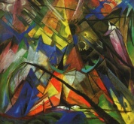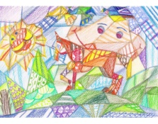  Textbook “Eyes Open 3”  Worksheets  Microphone
End  5 min | “Graffiti wall”  - Divide the class into groups of 3 or 4, and give each group a sheet of poster paper and markers. Write or draw what you have learned about a topic. You can jot down facts, write personal opinions, etc.  - When you have finished, display all the posters on a wall. Then you will do a “gallery walk” to view and discuss what you see on the “graffiti wall.” |  |  |  |  |  | Posters, markers
Additional information
Differentiation – how do you plan to give more support? How do you plan to challenge the more able learners? |  |  |  | Assessment – how are you planning to check learners’ learning? |  | Health and safety check
There are several types of differentiation in this lesson:  - by outcome, indicate what students should be able to do at the end of the lesson;  - by assessment, used several types of formative assessment;  - by support, teacher asks open-ended questions, monitors the class and gives instructions to low level students;  - by grouping, students divided into mixed ability groups;  - by task, students do different tasks according to their level. |  |  |  | - Verbal assessment.  (Good job, Excellent, Brilliant, Well done)  - Peer-assessment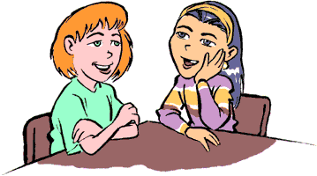  - Hand Signals  - “Hot microphone” 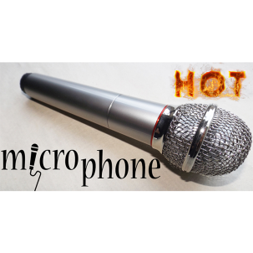  - “Two stars and a wish”  - “Graffiti wall”  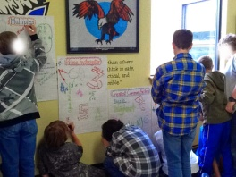 |  | - Health saving technologies.  - Work with the White board not more than 10 minutes.  - Ensure proper ventilation
Reflection  Were the lesson objectives/learning objectives realistic?  Did all the learners achieve the lesson objectives/ learning objectives? If not, why?  Did my planned differentiation work well?  Did I stick to timings?  What changes did I make from my plan and why? |  |  | The lesson objectives were concrete, measurable and realistic. All learners achieve the lesson objectives. Before planning lesson plan I think about how to differentiate, to meet the needs of individual pupils, to engage them in their learning and to enable them all to participate in the lesson, to make it as inclusive as possible. Timing was used productively.
Summary evaluation

What two things went really well (consider both teaching and learning)?
1: “Jumbled text” went really well, students put the two texts in the right order and chose the case for or against.
2: “Hot microphone” used as assessment, high level student asked questions according to the theme

What two things would have improved the lesson (consider both teaching and learning)?
1: Debate “Is everyone an artist?” had difficulties. Students had problems in expressing their opinions. May be the next time teacher should give some prompts.
2: In pre-reading I used some pictures to predict the gist of the text. But students couldn’t do it very well.

What have I learned from this lesson about the class or individuals that will inform my next lesson?

I have learned how to use active learning in my lessons and how to differentiate, to meet the needs of individual pupils, to engage them in their learning and to enable them all to participate in the lesson, to make it as inclusive as possible.

