***My summer holidays***

Everyone knows that for all students the best time of the year is summer holidays. First of all, you’re free from school and may forget about textbooks, lessons, homework for all three months. Moreover, you don’t have to wake up early every day and have all this annoying routine. So you just have the opportunity to relax and enjoy perfect summer time.

As for me, my summer is quite typical from year to year. I usually spend June at home. I get up late all the time and try to be outside with my friends as much as possible. I really enjoy cool summer evenings when my friends and I can go for a walk in the park or ride around the city on our bikes. Also, we like rollerblading a lot. If the weather is bad I normally stay at home playing computer games or just surfing the Internet.

Then July I usually spend in the countryside with my grandparents. I have a lot of friends there as well. We often go to the lake for swimming or sunbathing. It’s always active time and we have a lot of things to do together.

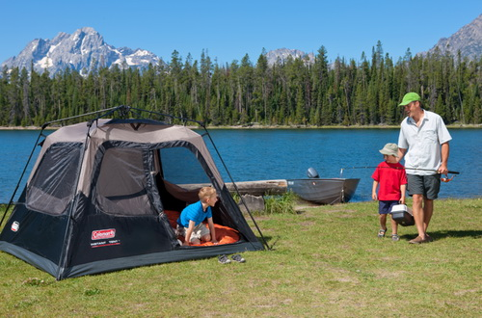

Spend- өткізу

Free time –бос уақыт

As for me- менің ойымша

Enjoy- рахаттану

Opportunity- мүмкіндігі

Countryside- қала сырты

**My country is Kazakhstan**

The Republic of Kazakhstan is situated in the Central Asia. The area of Kazakhstan is 2753000 square kilometers. Its population is about 16 million. The population lives mostly in towns and cities and large villages. The largest cities are Almaty, Karaganda, Chimkent, Pavlodar and Astana. Astana is the capital of the Republic. Astana is situated in the central part of the country.

Kazakh is the official language of the country, but it is not the only lan­guage which people speak in the country. Russian and other languages are spoken here too.

Kazakhstan borders China, Russia, Turkmenistan, Uzbekistan and Kirgizia. There is a long border coast line on the Caspian Sea in the Southwest.

There are a few rivers and lakes in Kazakhstan. The four rivers are the main resources of water in the country. They are Irtysh, in the east, Syr-Darya in the southwest, Illi in the southeast and Ural in the northwest of the country. The largest lakes are Balkhash, Zaisan, Ala-Kohl and Tengis. The flora and fauna of the country are different. They depend on the climate of the area. They are richer in the south and poorer in the north.

The climate of the country is strongly continental. It is cold in winter and hot in summer. Rain usually falls in spring and autumn. Snow falls in all areas but not at the same time. In spring green grass and flowers of different colours cover flat lands and hills.

Kazakhstan has well-developed heavy industry in many cities and towns, As the result of the development of heavy industry the country suffers seri­ous environmental problems. Agriculture takes a very important sector in the national economy. The people of the country grow wheat, millet, corn and cotton.

As a sovereign state Kazakhstan has its own national flag and anthem and national traditions and holidays. The national flag of the country consists of a light blue field at the centre of which there is yellow sun framed by the wings of a flying eagle, also in yellow, with a vertical stripe of national ornamenta­tions near the hoist.

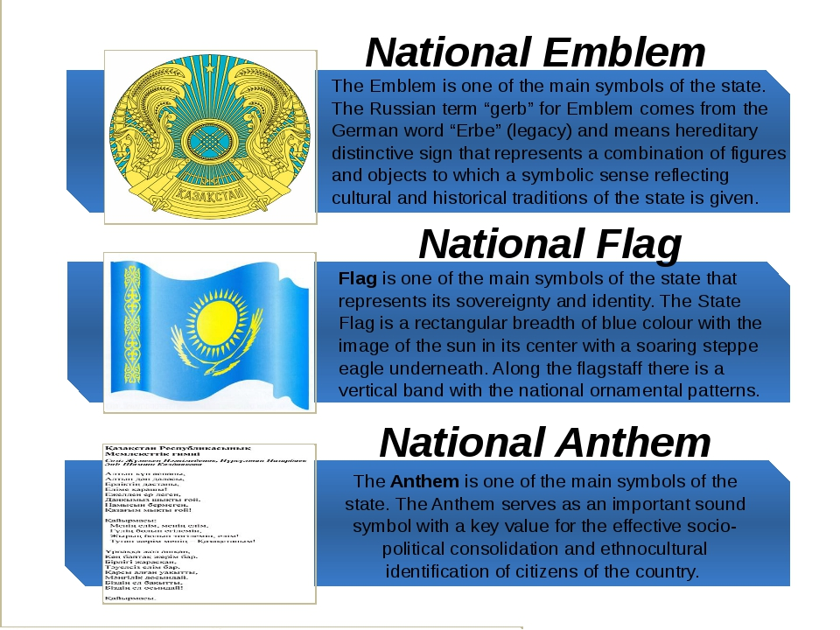

Situated-орналасуы

Population-халқы

Borders-шекарасы

Well-developed-жақсы дамыған

River –өзен

Lake-көл

# **My Favourite Singer (Michael Jackson)**

My favourite singer is Michael Jackson. I like his songs very much because they are full of energy and very melodic. I also like the way he dances.

There were nine children in Michael's family. They lived in a small four room house. Later he lived in a house which has seventeen rooms downstairs and sixteen rooms upstairs. It stands in 2,700 acres of ground. Besides the house there are guest houses, a golf course, a swimming pool, tennis courts, stables, gardens, lakes, forests and a zoo.

A lot of strange stories are told about Jackson. It's difficult to decide whether they are true or not. Michael never gave interviews and was rarely seen in public, except on stage. Certainly his behavior may seem eccentric. In public he often wore a face mask to protect himself from germs, he slept inside an oxygen capsule, which he believed would help him to live longer. But his manager says that Jackson wasn't eccentric. He was just shy. Michael sang in public for the first time when he was five. Since that time he had always been in the public eye. And since that time he had been working like a grown-up.

There were times when he came home from school and he only had time to put his books and get ready for the studio. He often sang until late at night, even if it was past his bedtime. There was a park across the street from the studio, and Michael looked at the kids playing games. And he just stared at them in wonder — he couldn't imagine such freedom, such a carefree life.

He said about himself that in the crowd he was afraid, on stage he was safe. Off stage he felt happiest with animals and children. He was well-known for his childish tastes. It's not a secret that his favourite hero was Peter Pan.

Michael has been called "the child who never grew up", but I think he was a grown-up who was never allowed to be a child.

Whether he was crazy, childish, eccentric or just shy, he was no fool. He created a brilliantly successful image, he made a lot of money and spent it on the things he wanted. Who wouldn't like to do the same?

Singer-әнші, song-Ән, behavior-мінез-құлық,

**My favorite subject**

My favorite subject in school is Mathematics. It is my favorite because I never have difficulty with it and always get good marks in tests.  
I suppose I am lucky to be born with a clear-thinking brain. So ever since young, manipulating numbers and figures came easy to me.

The wonderful thing about Mathematics is that, besides some formulae, there is nothing else to remember. Every step in solving a problem is done logically. Other subjects like History and Geography require a lot of memory work. Remembering dates and other facts is hard work compared with the ease and simplicity of mathematical reasoning.

While Mathematics is simple to me, some of my friends have great difficulty with it. I do not really understand why. They get stuck with simple problems and often give up. So I help them out when I can.

The one advantage I have in being good in Mathematics is that I do not have to spend a lot of time on it. Homework and tests are a breeze. So I have plenty of time left over to study other subjects. Sometimes I feel sorry for my less fortunate classmates who get scolded in class for not completing their Mathematics homework.

Anyhow I have come to realize that human beings can be so different in their abilities while they look similar otherwise. Some of us are lucky to be good in some things. Others may not be so lucky.

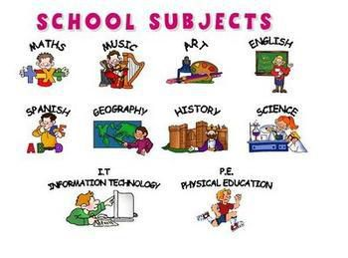

Difficulty- қиындығы. Clear-thinking- айқын ойлау, remember-есте сақтау,