Unit 6: Explorers and inventors  inventors |  | School: A.Rozybakiev
Grade: 3 |  | Teacher name: Moldakhmetova E
Date 11.03.2021 |  | Number present: | absent:
Theme of the lesson: |  | Unit revision
Learning objectives(s) that this lesson is contributing to |  | 3.1.7.1 use contextual clues to predict content in short, supported talk on a limited range of general and some curricular topics;  3.1.9.1 recognise short basic words that are spelt out;
Lesson objectives |  | All learners will be able to:
- ask questions and respond using visuals;
- practice learned vocabulary with support.
Most learners will be able to:
- use most of the words in the speech;
- answer questions with minimum support.
Some learners will be able to:
- ask questions and answer questions with basic words, phrases and short sentences using visuals, complete most of tasks about the animals correctly with no support
Assessment criteria |  | - participate actively in discussion;  - talk about inventions using given vocabulary
Value links |  | Teamwork: Leaners will work well together in pairs showing respect and being polite with each other.
Cross curricular links |  | Lesson is connected Science
ICT skills |  | Usage of presentation of classroom rules; review
Previous learning |  | Inventions in Kazakhstan
Plan
Planned timings | Planned activities |  |  | Resources
Beginning  10 minutes | Greetings  Teacher asks date .day. season and weather.  Warm-up  Project the riddle for the learners and ask them to write the answer in their copybooks. Ask learners what transport it is. More able may share the information they know about bicycles.  I am a type of transport  Although I am not a car  I only have two wheels  Pedals and a handlebar  Checking up home task  Strategy Its on the tip of my tongue  Learners come to the blackboard and take 1 paper from the persons mouth. In the mouth there are pictures learners must say the name of the picture Pictures are shown for guessing.  For example  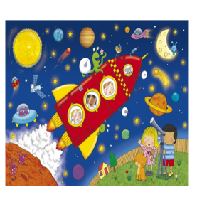Space  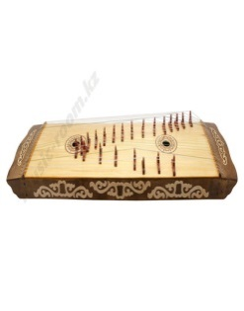Zhetygen  Assessment by teachers motivation words |  |  | Picture
Middle  25 minutes | Teacher divides learners into 2 groups by pictures  1 st group Stars  2nd group Moon  Presentation  Task 1 Strategy True or False  Read the text. Then answer statements True or False  Marco Polo was an Italian explorer . Marco Polo was born in Venice on September. His father was merchant . When he was 17 years old, when he went to China with his father. They went to China to visit Kublai Khan, the emperor of China. The emperor enjoyed Marco Polo’s stories about many lands. When Marco Polo went back to home, he talked about his life in China. In 1298, he went to prison . While he was a prisoner he read his stories about China to another man in prison. The man wrote down the stories. The stories became the book, “The Travels of Marco Polo.” Marco Polo got out (выйти)of prison in 1299. He became very rich and got married, he and his wife had three children. Marco Polo died in 1324.  1)Marco Polo was an Italian explorer 2) Marco Polo was born in Venice, on January  3) His father was singer  4)He was 17 years old, when he went to China with his father  5) They went to China to visit family 6) In 1298, he went to prison 7) The woman wrote down the stories 8)He became very poor 9) He and his wife had five children 10) Marco Polo died in 1324  Group Assessment by pluses and minuses  Differentiation by type of response  Task 2 Put the pictures in the right order  1 6 2  4 5 3  Group Assessment by Fireworks  Differentiation by type of response  Task 3 Strategy Orange pieces  Learners should write 1 Inventions in Kazakhstan  2 Inventions of the XXI century  Group assessment by fireworks  Task 4 Strategy Collage story  Learners should collect pieces of pictures and describe with their own words.  1 My Family 2 Musical instruments  Group Assessment by Fireworks  Differentiation by time allowed  Plenary task Balloons  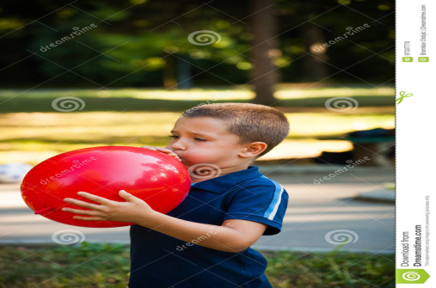  Learners say a word and blow a balloon. If learner says more words balloon becomes big if learner says little word balloon  Descriptor  -Takes the picture and says the word  -Reads the text and finds True or False  -Puts the pictures in the right order  -Writes the inventions on the pieces of orange  -Collects the pictures and describes |  |  | Worksheet 1  Worksheet2  Orange pieces  Pictures  Balloons
End  5mins | Reflection: Apple tree  Learners reflect on their learning:  - What has been learned?  - What remained unclear?  - What is necessary to work on?  - 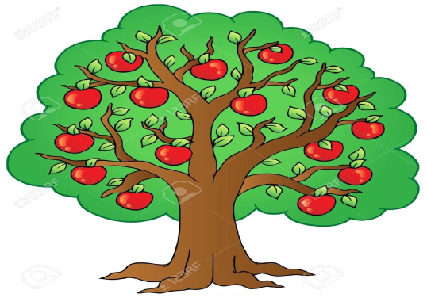  Home task: home task to revise the unit words from flashcards |  |  | Apple tree  Stickers
Additional information
Differentiation – how do you plan to give more support? How do you plan to challenge the more able learners? |  | Assessment – how are you planning to check learners’ learning?
Support for weaker students: working in pairs/groups, phrases  Challenges for more able students: Encouraged to do more writing; assist weaker students.  Pair work, Whole group work |  | Monitoring  Feedback on the work
Reflection

Were the lesson objectives/learning objectives realistic? Did all learners achieve the LO?
If not, why?
Did my planned differentiation work well?
Did I stick to timings?
What changes did I make from my plan and why?

Summary evaluation

What two things went really well (consider both teaching and learning)?
1:

2:

What two things would have improved the lesson (consider both teaching and learning)?

1:

2:

What have I learned from this lesson about the class orachievements/difficulties of individuals that will inform my next lesson?

