Long term plan unit: Unit 1. Home and away |  | School: № 9 named by G. Kaiyrbekov, Kostanay
Date: |  | Teacher’s name: Diana Bakhytbekovna Mussagulova
Grade: 5 |  | Number present: | absent:
Lesson title: Rooms and Furniture (Prepositions of place)
Learning objectives (s) that this lesson is contributing to |  | 5.S4 respond to questions on an increasing range of general and some curricular topics  5.S5 pronounce an increasing range of words, short phrases and simple sentences intelligibly  5.L3 understand the main points of short, supported talk on an increasing range of general and some curricular topics
Lesson objectives |  | All learners will be able to:  - Understand the text “Saule’s new house” in general with little support (key words)  - Respond to teacher’s questions with yes/no answers on the topic “Saule’s new house ” and prepositions of place  - Complete 2-3 sentences correctly using prepositions of place. Ex: There is a vase on the chair  Most learners will be able to:  - Understand the text “Saule’s new house” in general with little support (key words)  - Respond to teacher’s questions with full answers on the topic “Saule’s new house” and prepositions of place  - Complete 4 sentences correctly using prepositions of place. Ex: There is a ball under the chair  Some learners will be able to:  - Understand the text “Saule’s new house” in general without support  - Respond to teacher’s questions and sharing their opinions. Ex: What is this text about?  - Complete 6 sentences correctly using prepositions of place
Assessment Criteria |  | Learners can  make up sentences using prepositions of place,  and describe their rooms in 2-6 sentences on the base on the text “Saule’s new house”
Value links |  | To save the nature, respect and support classmates.
Previous learning |  | Rooms and Furniture (vocabulary+ use of English)
Cross – curricular links |  | Music, Science
Use of ICT |  | Projector
Time | Planned activities |  |  | Resources
Beginning  4 min  1 min  2 min  1 min | 1.Greetings  Learners greet each other and make compliments.  Example: Assel you are so beautiful today.  2. Warm-up “Brainstorming”  Teacher: Watch the video and guess the title of the lesson.  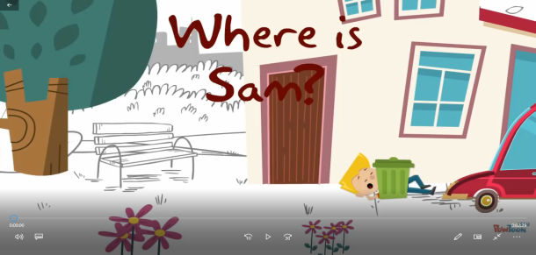  -What is the video about?  - What is the theme of our lesson?  Learners should watch the video and find the theme of the lesson, and answer the teacher`s questions  3. Introduction with the lesson outcomes “Presentation”  Learners read assessment criteria from the screen of active board, and discuss them. |  |  | PPT Slide 1  https://www.youtube.com/watch?v=BjFZbns1ZR0
Middle  33 min  3 min  15 min  3 min  2 min  5 min  5 min  End  3 min | Activity 1. Division into two groups. “Division by multi-colored stickers”.  The learners stand in a circle and close their eyes. The teacher attaches colored paper to each person's back. On teacher’s command all open eyes. After that all learners must silently unite into groups.  Activity 2. Revision words “Snowball method”  Teacher organizes revision of words through “Snowball method”.  Learners throw a ball to each other (in each group), one learner calls the name of furniture and the next learner translates it.  Activity 3–Engage“Discussion”.  Task 1.Teacher: Listen to the text “Saule’s new house ”  (Audio1),discuss it and answer the questions.  1. What is the email about?  2.How many rooms are there?  3.What is Saule’s favourite room?  4. What is her dog’s name?  5. What has she got in her bedroom?  6. What colour is her bedroom?  7. Do you like the text?  8. Does Saule like her room?  Learners can use key words as support.  Key words:  1.anytime – кез - келген уақытта  2.come – келу  3.downstairs – төменде  4.garden – бақша  5.huge - өте үлкен  6.kennel – үйшік  7.singer – әнші  8.visit – бару  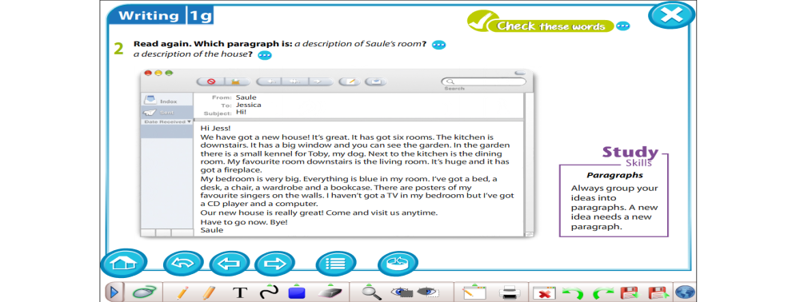  Task 2.Teacher :Which paragraph is a description of Saule’s room? (the 1st group) and description of the house (the 2ndgroup)  Learners answer the question using the text and give formative assessment “2 stars and a wish”(Group assessment)  The 1st star for ….  The 2nd star for ….  And one wish for … .  Activity 4 – “Dynamic pause”( TPR method )  Learners see the video and dance.  Activity 5 - Speaking  Teacher: Look at the picture and fill in the correct prepositions.  Learners fill in prepositions and check themselves according to the keys.  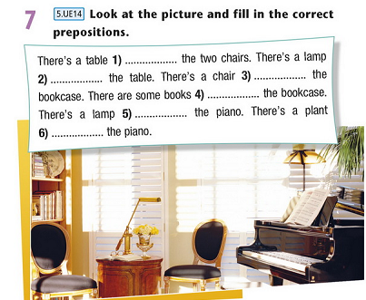  Activity 6- Speaking  Teacher: Draw your ideal bedroom orally. In three minutes compose a few sentences about it, using prepositions of place, and describe your rooms in 2-6 sentences. Tell the class. Learners present their mini - project to each other and give peer formative assessment:  1-2 mistakes – “excellent”  3-4 mistakes – “good ”  5-6 mistakes – “try again”  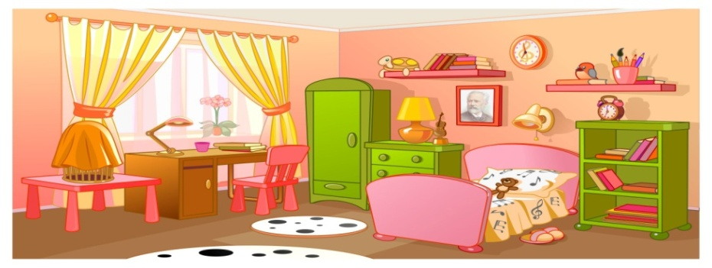  Reflection “Pyramid”  Each learner receives a picture of a triangle, which is divided into three parts: in the lower part you want to record what happened in class, in the middle part that did not understand, and in the upper part of what to work or what to repeat for the next lesson.  Teacher hands in their pyramids and gives feedback to learners. |  |  | stikers  Audio 1. Electronic book Excel 5 grade  Excel for Kazakhstan. Grade5, Student’s book ex.1 p.19)  https://www.youtube.com/watch?v=3bvEqLBwPXg  Excel for Kazakhstan. Grade5, Student’s book ex.7 p.13)  http://printonic.ru/uploads/images/2016/05/11/img_5733369671bd9.jpg
Additional information
Differentiation |  | Assessment | Health and safety check
Differentiation by outcomes (according to the lesson objectives during the lesson)  Differentiation by task (according to the learners’ abilities during the lesson)  Differentiation by ability (according to the learners’ level of knowledge during the lesson ) |  | Formative assessment by:  - Praising words, recommendations, comments of the teacher – during the lesson  - Self – peer assessment - Activity 5,Activity 6.  - group assessment “2 stars and a wish” Task 2, Reflection “Pyramid” | - ICT technology (active board)  - Video no more than 2 min  - Dynamic pause in the middle of the lesson.  - Division into groups gives the learners the opportunity to move.

