Unit 2: Daily life & Shopping |  |  | School:№62
Date:14.10.2020 |  |  | Teacher’ s name:
CLASS: 8 |  |  | Number present: | absent:
Theme of the lesson: |  | Clothing & Shoes
Learning objectives(s) that this lesson is contributing to (link to the Subject programme) |  | 8.R2. understand specific information and detail in texts on a growing range of familiar general and curricular topics, including some extended texts.  8.S7.use appropriate subject- specific vocabulary and syntax to talk about a range of general topics, and some curricular topics.  8.L.1.use speaking and listening skills to solve problems creatively and cooperatively in groups.
Lesson objectives |  | All learners will be able to  read and understand some words from the text and ask questions about a given activity  Most learners will be able to:  ask the questions, answer the questions  Some learners will be able to:  Some learners will be able to: immediately memorize new words and use them correctly and use conversational skills for creative and collaborative problem solving in groups
Assessment criteria |  | -Apply topical vocabulary to talk about the leisure activities and chores  -Listen and deduce the meaning from context  -Write short sentences about leisure activities and chores  -which do at home.
Level of thinking skills |  | Analyzing and creating
Values links |  | respect each other, know how to listen to each other
Cross-curricular links |  | Kazakh and Russian language
Previous learning |  | Leisure activities and chores
Plan
Planned timings | Planned activities (replace the notes below with your planned activities) |  |  |  | Resources
Start  5min | Greeting  I.Organization moment  -Good morning boys and girls!  I am glad to see you!  How are you?  Who is on duty today?  Who is absent today?  What is the date today?  What is your mood today? Point your finger  II.Checking-up of the home task  -What was your home task?  -ok,very nice. |  |  |  | 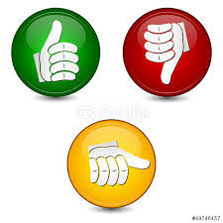
Middle  30min | III. Phonetic drill  Let’s begin our English lesson, before starting our lesson let’s practice our pronunciation! Listen to me carefully and repeat after me all together!  Tongue twister  Peter Piper picked a peck  Of pickled peppers.  A peck of pickled peppers,  Peter Piper picked.  If Peter Piper picked a peck of picked peppers,  where’s the peck of pickled peppers Peter Piper picked?  -Very good! We have just practice our pronunciation.  Solve the riddle  1.Summer house for the head.(panama)  2. Long knitted item,  Needed in the cold, in the summer - no,  Wind it up quickly  He will warm you in the cold.(scarf)  3. In winter you will put on a hat, a fur coat,  And what about summer? T-shirt, ...(skirt)  4.Two brothers  Cannot part:  On the road in the morning  At night to the doorstep(shoes boots)  -What do you think will be our today's lesson topic? Yes you are right. Today's lesson topic will be about clothes and others.  IV. New lesson  Our today topic “Clothing & Shoes”  Open the copy books and write the date and the theme of the lesson.  Vocabulary of our lesson  Look at the pictures and repeat after me!  Subculture- (ˈsʌbkʌltʃə) субмәдениет  Subcultures are different values and norms that a group adheres to in a wider society. In the United States, subcultures can include hippies, goths, hip-hop or heavy metal fans, and even bikers — examples are endless. ... The biker gang is an example of a subculture. In the picture you can see different subcultural people who are dressed according to their wishes.  Express-(ɪkˈspres) экспресс(поезд)  An example of express is a train that gets you where you are going five times faster than other trains.  Loose-( luːs)кең киім  For example: these are loose pants  Long-sleeved-(lɒŋ) жеңі ұзын жемпір  F.e You put on a long-sleeved shirt and cover those track marks on your arm.  Short-sleeved-( ʃɔːt) қысқа жеңі бар киім  F. e Female students are required to wear a short-sleeved blouse  Hoodie-( ˈhʊdɪ)қалпағы бар жеңі ұзын жемпір  F.e In winter students wear a uniform hoodie or sweaters above shirts.  Baggy-( ˈbæɡɪ) қапшық тәрізді  F.e Cara, you can't wear baggy jeans and skater shoes your whole life.  Nerd- (ˈnɜːdɪ)ақылгөй  He was a real nerd in high school  Geek-( ɡiːk)компютер фaнаты  f.example I.T. Kevin, the computer geek?  Whizz-( wɪz)kid-зерек  a computer whizz  Average- ( ˈæv.ər.ɪdʒ)орта ,кәдімгі  The number of spectators at football matches was lower than average last season.  Design-( dɪˈzaɪn) дизайн жоба  F.e In 1960, Pierre Cardin became the first couturier to design men's clothes.  Slogan( sləʊ.ɡən)- ұран  slogan part every republic  Atom- ( /ˈæt.əm)атом  Scientists are working to harness the power of the atom.  Big deal-( bɪɡ) ( diːl)маңызды сәт, мәселе  Going to college is still a big deal.  Gadget-( ˈɡædʒ.ɪt)құрылғы  kitchen gadgets  Read the text  The Skaters  As the name suggest, skaters spend as much time as possible on a skateboard. On Satyrday after breakfast, they text “ See you down the skatepark!” to their friends, grab their boards and go. Even when they’re not skating,they’re talking about it or watching skateboard videos online.They don’t like designer clothes.Clothes have to be loose to let them skate cpmfortable: casual long-sleeved and short-sleeved T-shirts (sometimes both at the same time ), hoodies,baggy jeans and trainers. They don’t usually let their hair grow very long.Their music tends to be loud and fast – punk,hip-hop and sometimes metal.Besides skateboarding,they like hanging out with skaters and playing computer games.  The Techies  Techies live and breathe computers,science and technology.They are the nerds and geeks of the old days, but they are more popular now because they can fix any problem their friends have with their computers and smartphones.These whizz-kids are as happy chatting online as in person-though most their conversation is impossible for the average person to understand.Glasses are common, probably from all the time they spend staring at a screen.You won’t see techies wearing formal clothing.Clothes are generally jeans and a T-shirt, perhaps with a cool science design or a funny slogan like “Don’t trust atoms-they make up everything!” Fashion’s not a big deal for them, though, unless it’s the latest gadget –that’s a must-have!  Questions about the text  What clothes do skaters wear and why do they dress like that?  They wear loose clothes like T-shirt, sneakers and jeans  Do they like designer clothes?  They don't like designer clothes  Besides skateboarding, what do they like to do?  In addition to skateboarding, they like to go skating and play computer games.  How techies look and how they are dressed?  They usually wear jeans and a T-shirt.  They look like nerds  Name the big plus of the techie's work?  They are popular now because they can solve any problem you encounter with your computers and smartphones. And nowadays there is a lot of interest in this profession, and this work should be done by people who are close to computers and have a good understanding of computers.  What's the differents between the techies and the skaters?  Ex-1. Read the texts again. Which teenagers, the Skaters (S) or the Techies (T)...(go to learningapps)  1.can help others with certain problems? …T…  2.dress as they do for practical reasons?.....S....  3.spend a lot of time in front of a screen?....T...  4.spend a lot of time outdoors?..S.....  5. They don't like designer clothes…..S  6. can solve any problem of their friends with computers and smartphones…..T…  7. fashion doesn't really matter to them, unless it's the latest gadget - it's a must!..T..  8. they are wearing casual long and short sleeved tees..S  V. Presentation of new grammar material  Phrasal Verb(фразалық етістіктер)  A phrasal verb is a verb that is made up of a main verb together with an adverb or a preposition, or both.  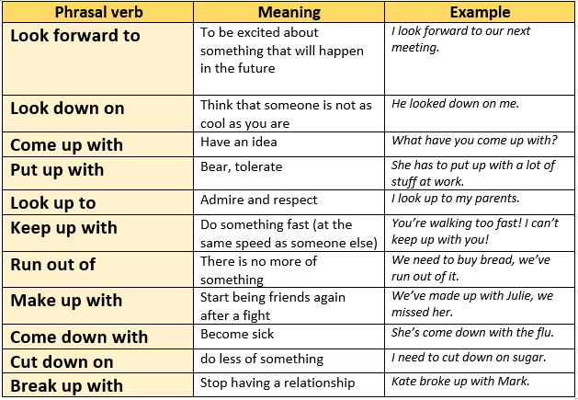  Фразалық етістік – етістіктен және предлогтан,  сонымен қатар кейде үстеуден де тұратын фраза.Ағылшын тілінде екі немесе 3 сөздің тіркесі  for.example  - Look after-қамқорлық жасау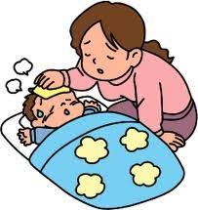  - Get in –кіру  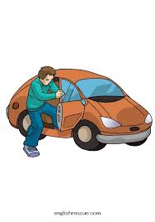  - Look for (key)-іздеу мысалға кілтті іздеу    - Look up to-құрмет ету,үлгі алу  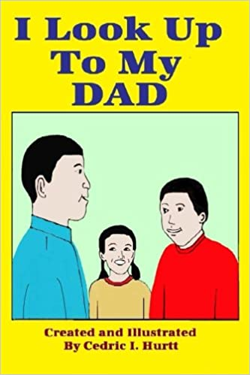  - Look out-сақтан, сақтану    Ex-2 Complete the sentences using phrasal verbs  1.You should look….for pickpockets when you’re in big stores.(out)  2.Paul looked….the shop’s address online.(up)  3.Maria is looking….a pair of boots.(for)  4.He looked….the kids while Anna went shopping.(after)  5.Inzhu made a complaint and the manager said she’d look….the issue.(into)  Hometask: memorize new vocabulary  Describe the style of clothing you like, your musical taste, and the types of entertainment you do in your free time. |  |  |  | Interactive whiteboard  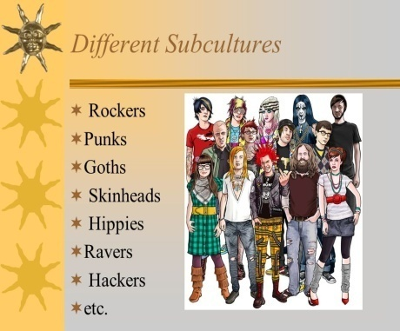  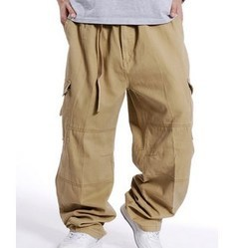  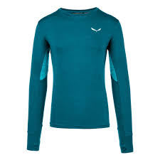  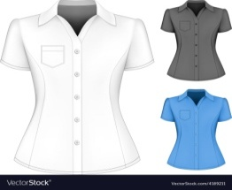  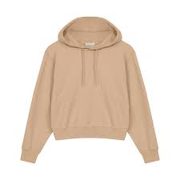  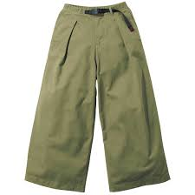    Book  https://learningapps.org/display?v=pt2sq1hwj20  https://learningapps.org/display?v=pep2vau1n20
End  4 min | Reflection  “SMS” paper mobile phones are distributed to students. Write a massage to your teacher or friend about how the lesson went, what else you would like to learn, and rate your during the lesson  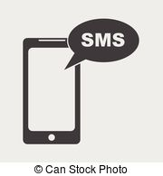  Then collects mobile phones into a paper bag

