Город Тараз
КГУ «средняя школа №34»
Учитель иностранного языка
(английского языка)
Магаова АминБахтияровна
Основная направленность: урок
LESSON: 40 |  |  |  |  | School: №34
Theme: Vocabulary practice |  |  |  |  | Teacher name: Magazova Amina Bakhtiyarovna
CLASS: 1 |  |  |  |  | Number present: |  | absent:
Learning objectives(s) that this lesson is contributing to |  |  | 1.L1 recognize short basic instructions for a limited range of classroom routines spoken slowly and distinctly  1.S1 make basic personal statements about people, objects and classroom routines  1.S3 pronounce familiar words and expressions intelligibly  1.S5 use words in short exchanges  1.S6 make introductions and requests in basic interactions with others  1.R3 recognize and identify some familiar sight words from local environment  1.UE2 use cardinal numbers 1 - 20 to count  1.UE5 use interrogative pronouns which, what, where, how to ask basic questions
Lesson objectives |  |  | All learners will be able to:
- recognise short basic instructions for a limited range of classroom routines spoken slowly and distinctly
- pronounce familiar words and expressions intelligibly

 |  |  | Most learners will be able to:
- make basic personal statements about people, objects and classroom routines
- use words in short exchanges
- use cardinal numbers 1 - 20 to count
 |  |  | Some learners will be able to:
- recognise the sounds of phonemes and phoneme blends
- recognize and identify some familiar sight words from local
- use interrogative pronouns which, what, where, how to ask basic questions

Previous learning |  |  | Transport, daily routine
Plan
Planned timings | Planned activities (replace the notes below with your planned activities) |  |  |  |  |  |  | Resources
Start  5 min | Warm up:  Up- down  Big-small  Read-write  On-under  Hot-cold  Open-close  Fast-slow  Yes-no-I don’t know |  |  |  |  |  |  | https://www.youtube.com/watch?v=_z-1fTlSDF0
Middle  30 min  30 min | Revise the last theme  “Daily routine”  Work in pairs “box and balls”- preposition  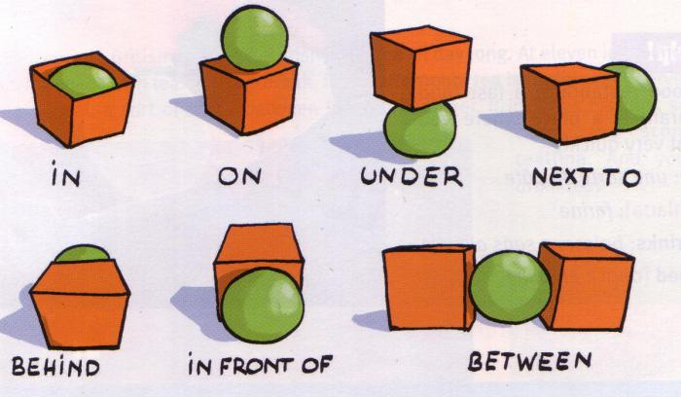  Work in groups  School supplies  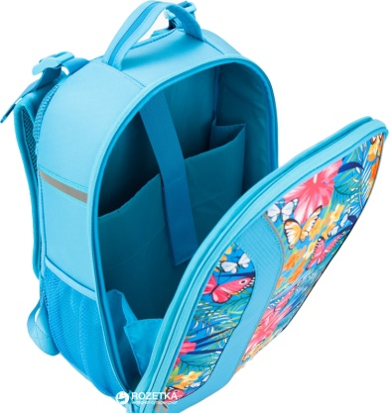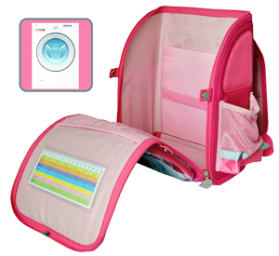  Task # 2  One group with monkeys and another group  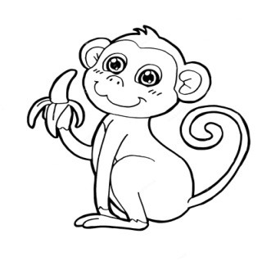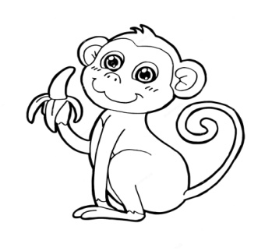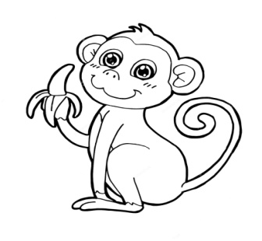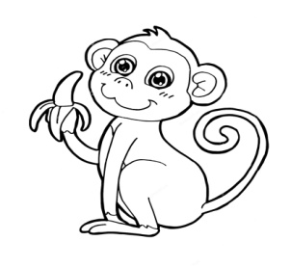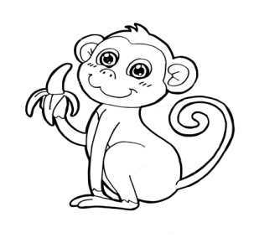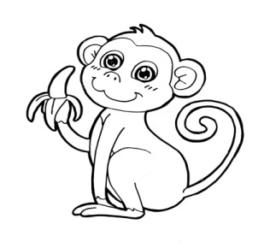  with fish – colors  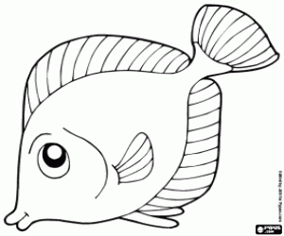  Energizer “monkey banana”  Revise the words on the theme “Family”  A group – mother, grandmother, sister, aunt, girl,woman  B group – father, grandfather,brother, uncle, boy,man  Game “Spidernet” |  |  |  |  |  |  | A learner  - names the objects;  - pronounces topic words and expressions clearly.
End 5 min | worksheets (I)(F)  weather  reflection
Additional information
Differentiation – how do you plan to give more support? How do you plan to challenge the more able learners? |  |  |  | Assessment – how are you planning to check learners’ learning? |  | Cross-curricular links  Health and safety check  ICT links/Values links
- Giving thinking time  - Regrouping |  |  |  | - Worksheets
Reflection  Were the lesson objectives/learning objectives realistic?  What did the learners learn today?  What was the learning atmosphere like?  Did my planned differentiation work well?  Did I stick to timings? What changes did I make from my plan and why? |  | Use the space below to reflect on your lesson. Answer the most relevant questions from the box on the left about your lesson.  ________________________________________________________________________________________________________________________________________  ________________________________________________________________________________________________________________________________________  ________________________________________________________________________________________________________________________________________
________________________________________________________________________________________________________________________________________

____________________________________________________________________________________________________________________________________________________________________________________________________________
Summary evaluation
What two things went really well (consider both teaching and learning)?
1:__________________________________________________________________________________________________________________________________________________________________________
2:____________________________________________________________________________________
______________________________________________________________________________________
What two things would have improved the lesson (consider both teaching and learning)?
1: ____________________________________________________________________________________
______________________________________________________________________________________
2:____________________________________________________________________________________
______________________________________________________________________________________
What have I learned from this lesson about the class or individuals that will inform my next lesson?
___________________________________________________________________________________________________________________________________________________________________________________________________________________________________________________________________________________________________________________________________________________________________________________________________________________________________________________

