Unit:6 Natural world |  |  |  |  | School: № 4 Abay
Date: |  |  |  |  | Teacher name: Duysenbekova Zhansaya
CLASS: 8 |  |  |  |  | Number present: |  |  | absent:
Lesson title: |  |  | Natural environments
Learning objectives(s) that this lesson is contributing to (link to the Subject programme) |  |  | 8.1.1.1 use speaking and listening skills to solve problems creatively and cooperatively in groups  8.2.2.1 understand with little or no support most specific information in extended talk on a wide range of general and curricular topics  8.2.6.1 deduce meaning from context with little or no support in extended talk on a growing range of general and curricular topics
Lesson objectives |  |  | All learners will be able to:  - Find all words in the word search puzzle  - Complete the sentences with specific information with little support  - Understand the mean idea of the listening text with little support  - Present their ideas using short simple sentences  Most learners will be able to:  - To give definitions of the specific vocabulary  - To complete the sentences with specific information with out support  - Talks about the natural environment problems  Some learners will be able to:  - Organize Cause and effect diagram in their groups  - Make up complex questions on the curricular topic  - Discuss the main points of the topic and solve problems in groups
Level of thinking skills |  |  | Application, analyzing
Assessment criteria |  |  | - Identifies the key words from the word search puzzle  - Highlights the meaning of words from the context and gives their definition  - Completes the unfinished sentences according to the listening  - makes up questions about the topic  - Discus in groups and solves given problems
Values links |  |  | Kazakh patriotism and civil responsibility, respect, cooperation, transparency.
Cross-curricular links |  |  | Geography, Ecology, Chemistry
Previous learning |  |  | They know the key words from the topic Travelling. Could speak about the visit to some places in Kazakhstan
Plan
Planned timings | Planned activities (replace the notes below with your planned activities) |  |  |  |  |  | Resources
Start  Middle | Greetings.  Teacher and students greet each other. Teacher interact with questions to concentrate them into the lesson  Brainstorming.  T:What does these words mean? What is common for them?  Shores Nature Forest Earth animals sunrise whales  flowering Seas Elephants planet rain fields world  Teacher shows plays the video clip “Earth song” by Michael Jackson. Learners listen to the words needed to complete the gaps. After finishing the gap filling task teachers asks learners about the meaning of the song. What is the “Earth song” about? Teacher: What do you think what the topic of our lesson is today?  Learners predict the topic of the lesson.  Teacher: A lot of things cause environmental problems. An one of the biggest environmental issues is global warming. Today we are going to talk about global warming.  Task 1. Pre listening. Word Search puzzle.  T: You are going to watch a video about global warming. You will learn about the reasons of the global warming and find out the ways that we can do to stop it. Before watching the video find the words from the word search puzzle. Look at the word search puzzle and find the words on the topic.  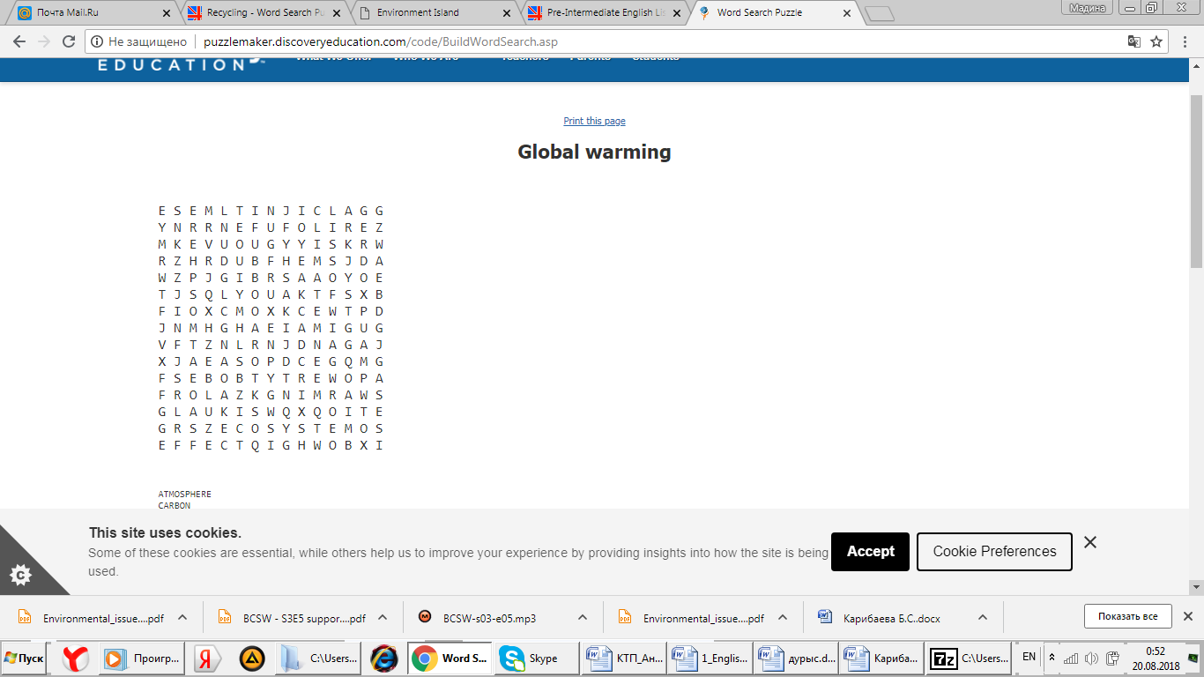  Words: atmosphere, carbon dioxide, climate, ecosystem, extinct, fossil fuel, global warming greenhouse gases, the greenhouse effect, solar energy (or solar power)  Descriptor:  - finds all the words  - Pronounces the words correctly  - gives their definitions or translations  Differentiation: Less able learners are given worksheets of word search puzzle with prompts (first letters are highlighted in the web) to search for. For more able learners teacher gives a task to make up a sentence to one of the words.  A: Peer assessment. Teacher tells learners to swap their worksheets and assess each other according to the assessment criteria and descriptors. Keys are shown on the board. Teacher gives oral feedback.  AFL: Assess orally. By giving oral positive words after the task  Task 2. While listening. Finish the sentence. (I)  T: You are going to watch the video again to complete the following sentences  1.Greenhouse gases are produced by….. (the sun’s rays, and also the actions of people)  2. A greenhouse gas is ………. (carbon dioxide )  3. a clean source of energy is …….. (wind power)  4. Using public transport can help ………(reduce levels of carbon dioxide)  5. The word extinct means….. (something that has died out, and no longer exists)  6. If the planet continues to heat up ………. (then we can expect to experience more extreme weather)  Differentiation by teacher’s support.  For less able students teacher allows thinking time and gives the translations of some words on the sheet of paper. They supported by more able leaner’s  AFL: Self-assessment. The teacher asks students to use their hand to signal their depth of understanding. A fist means: “I don’t understand any of it” all five fingers out means: “I understand it completely.” Students can also signal by raising 1, 2, 3, or 4 fingers.  Task 3 . After listening task . 5Ws activity. (GW)  T: Now watch the video and make up 3 questions about the topic.  Learners work in groups to make up questions on the topic. For ex:  - What causes climate change?  - Why is climate change problem?  - What can we do to prevent it?  Descriptor:  - Makes up minimum 3-5 full questions  - Suggests other ways of solving problems.  Differentiation by support: Teacher allows for less able learners to use L1 when they don’t know the word while answering. Teacher pairs more able learners with less able learners. Teacher gives question structures to less able leaner’s to make up simple questions  A: Group assessment correcting counting the numbers of questions.  Task 4. Speaking. Cause and effect strategy. (GW)  Learners talk to the partner about the topic “ How do we save environment”  Each group is given 2 pictures on the environmental issues and work in groups to think about the problem, its cause, effect and how to solve this problem.  Write problems and solutions appropriate to the scenes in the pictures. When groups finished the activity, they mingle in the classroom to find out about other group’s environmental problems.  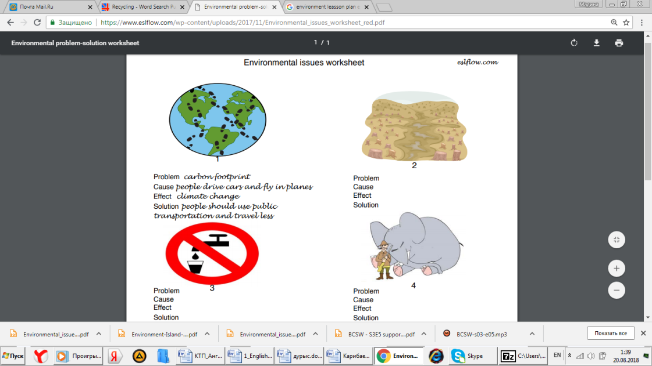  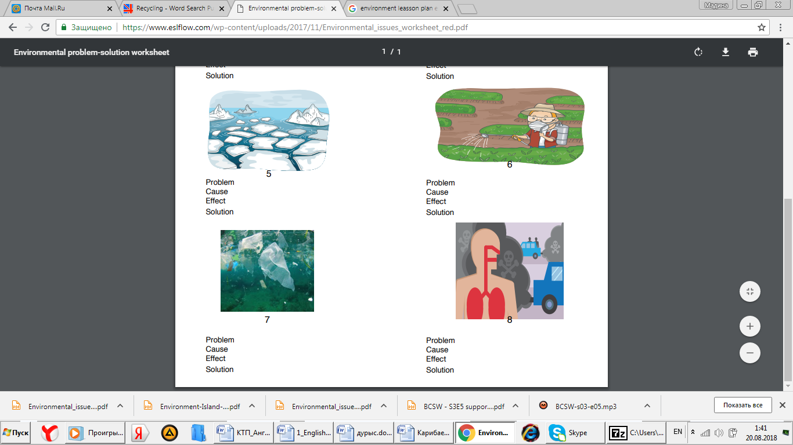  Differentiation by support: Less able students are grouped with more able learners. They use simple sentences from the text book to give their solutions.  AFL: Finger assess |  |  |  |  |  | https://www.esolcourses.  com/content/topics/songs/  michael-jackson/earth-song.html  Appendix 1  Interactive board  https://www.esolcourses.com/content/topics/environment/climate-change/climate-change-listening-activities.html
End | At the end of the lesson, students reflect on:  Post it  What I have learnt?  What I have found easy?  What have found difficult?  What do I want to know now?  Set an area of wall space for students to stick post it notes.  Groups, pairs, individual can answer .  Instant feedback to inform your planning
Additional information
Differentiation – how do you plan to give more support? How do you plan to challenge the more able learners? |  |  |  | Assessment – how are you planning to check learners’ learning? |  | Health and safety check
Differentiation for less able students  Teacher gives students grammatical chart which is written examples of questions.  Differentiation for less able students  Teacher allows for thinking time  AFL: Self-assessment.  Students listen the text and check completed words.  Differentiation for less able students  Eavesdropping supporting.  AFL: Assess orally. |  |  |  | AFL: Assess orally. By giving oral positive words after the task  AFL: Self-assessment.  A: Group assessment  AFL: Finger assess |  | Health saving technologies.  Using physical exercises and active activities.  Rules from the Safety Rules book which can be applied in this lesson.
Reflection  Were the lesson objectives/learning objectives realistic?  Did all the learners achieve the lesson objectives/ learning objectives? If not, why?  Did my planned differentiation work well?  Did I stick to timings?  What changes did I make from my plan and why? |  | Use the space below to reflect on your lesson. Answer the most relevant questions from the box on the left about your lesson.
Summary evaluation
What two things went really well (consider both teaching and learning)?

1:

2:

What two things would have improved the lesson (consider both teaching and learning)?

1:

2:

What have I learned from this lesson about the class orindividuals that will inform my next lesson?

Appendix 1
What about ___________ , what about ___________
What about all the things that you said we were to gain?
What about killing __________ , is there a time,
What about all the things that you said was yours and mine?
Did you ever stop to notice, all the blood we've shed before,
Did you ever stop to notice this crying _______ , the weeping ________?
Aaaaaaaaaah Aaaaaaaaaah
What have we done to the ____________, look what we've done,
What about all the peace, that you pledge your only son?
What about _________ fields, is there a time,
What about all the dreams that you said was yours and mine?
(Repeat Chorus)
Did you ever stop to notice, all the children dead from war?
Did you ever stop to notice, the crying Earth the weeping shores?
Aaaaaaaaaaah Aaaaaaaaaaah
I used to dream, I used to glance beyond the stars,
Now I don't know where we are, although I know we've drifted far
Hey, what about yesterday, what about the ________
The heavens are falling down, I can't even breathe,
What about apathy, I need you, what about __________'s worth, it's our _________'s womb’
What about _________ , we've turned kingdoms to dust,
What about _____________ , have we lost their trust?
What about crying __________ , we're ravaging the seas,
What about _________ trails, burnt despite our please?
What about the holy land,torn apart by creed, what about the common man, can't we set him free?

