Unit: 6. Explorers & Inventors | School: Alga school №2 named after V.I.Patsaev
Teacher name: | Atagulla G.M
Date: | 22.02.2021-23.02.2021
Grade: 3 ә,б | Number present: | Number absent:
Theme of the lesson: | Marco Polo
Learning objectives(s) that this lesson is contributing to | 3.2.6.1-take turns when speaking with others in a limited range of short, basic exchanges  3.2.5.1-pronounce familiar words and short phrases intelligibly when reading aloud  3.1.7.1-use contextual clues to predict content in short, supported talk on a limited range of general and some curricular topics  3.1.6.1- understand some specific information and detail of short, supported information or talk on a limited range of general and some curricular topics
Lesson objectives | All learners will be able to:  Say and pronouns words about sport intelligibly.  Use some short form questions correctly.
Most learners will be able to:
Understand and answer to some factual questions.
Give short answers to simple questions.
Some learners will be able to:
Give the right information about Marco Polo using past simple.
Explore other subject areas (History): to talk about Marco Polo.
Language objective | Work with text, answer the questions.  New words: prison, emperor, Journey, arrive, work, writer
Value links | Teamwork: Leaners will work well together in pairs showing respect and being polite with each other.
Cross curricular links | Lesson is connected History and Geography
Previous learning | travel, China, Kublai Khan, Venice, Genoa
Lesson plan
Planned timings | Teacher's actions | Pupils` actions | Assessment | Resources
Beginning:  10  minutes | ORGANISATION MOMENT:  - Good afternoon pupils! - How are you? - Who is on duty today? Who is absent today? - What date is it today? What day of the week today? Checking up the home task: - What was your home task? | - Good afternoon teacher. - I am find thank you! and you?  - Today is the 22nd of February.  It`s Monday | -
Middle:  20  minutes | MAIN PART  Well, let’s begin our lesson. Today, we will revise our last material and speak about travel. (Watches video about Marco Polo)  Today we have unusual lesson, we have a travel lesson. Before to travel we must buy a ticket. If you answer the questions you can buy a ticket, The winner will be the team that collected more tickets, well who wants to answer?  What was the video about?  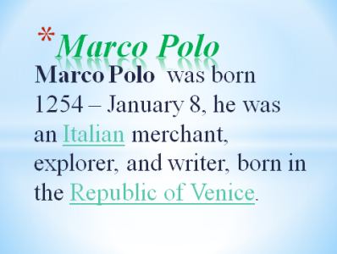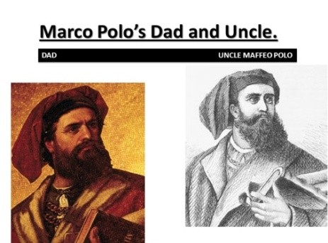  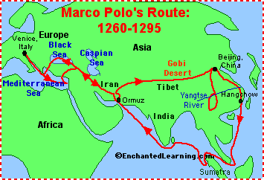   Practise 1st station is called “China’’ In this station there are some tasks, you must do it,  Task 1. Ex 26 read and put the sentences in the right order  Marco Polo on the board. Ask the  pupils, in L1 if necessary, to tell you  what they know about him. Elicit  their answers and write them on the  board  • Pupils’ books open. Go through the  pictures of the story and set the scene by  asking the pupils questions about what  they can see in the pictures   The 2nd station is called “India”  Task #2 Read, choose and complete.  Conversation between Rastichello and Marco Polo.  Oh good job!  Well, children may be you are tired, let’s sing song ”the happy song”  Now let’s continue our travel the next station is called “Turkey”   The 3rd station is called “Turkey” Task #3 put in order. | Listen to teacher  Pupils’ books closed. Write the name  • Pupils’ books open. Go through the  Read, choose and complete.  Pupils put it in order  II New words:  Journey [‘dʒə:ni] - саяхат  arrive [ ə’ raiv ]- келу, келіп жету  emperor[‘empərər]-император  prison [‘prizn ]- түрме  work [wə:k] – жұмыс істеу  writer [‘raitə] - жазушы  There are given pictures with words but you must put it in order, Ok?  1. Polo / was / Italy / in / born / Marco  2. China / big / is a / East / country / in the  3. Marco / Polo / and / was / a merchant /explorer.  4. Marco / in 1254 / was born / Italy / in Venice,  5. Marco / to China / first went / 17 years old. / when he was | Formative assessment | Handout with pictures  (Track 10 CD2)  Pupils book p 88  Slide  their books. Refer  the pupils to the  question and elicit  the correct answer  Play the CD. The  pupils listen and  follow the story in  Pupils book p 89  Activity book p64
End: 10 minutes | ENDING THE LESSON:  Well what did we do in our lesson?  - Evaluation of the lesson  Give the home task  Sing a Good bye song | Children sing a Good bye song | Feedback
Additionalinformation
Differentiation – how do you plan to give more support? How do you plan to challenge the more able learners? | Assessment – how are you planning to check learners learning? |  | Cross-curricular links Health and safety check ICT links Values links
• support weaker learners with further modeling and drilling in their pairs | • check pronunciation of new language through group and individual drilling |  | • cross curricular links: Music
- stronger learners who complete activities quickly should spell new words aloud for others to copy in their notebooks | check comprehension of listening and reading text through follow-up questions
Reflection
Were the lesson objectives/learning objectives realistic?
Did all the learners achieve the lesson objectives/ learning objectives? If not, why?
Did my planned differentiation work well?
Did I stick to timings?
What changes did I make from my plan and why?
Summary evaluation What two things went really well (consider both teaching and learning)? 1: 2:
What two things would have improved the lesson (consider both teaching and learning)?
1: 2:
What have I learned from this lesson about the class or individuals that will inform my next lesson?

