Short term plan |  |  | School: S.Seifullin
Date:10.02.2021 |  |  | Teacher’s name: Abdreyova K
Grade 9 |  |  | Number present: |  | Number absent:
Theme of the lesson: |  |  | Present perfect +since,for
Learning objectives(s) that this lesson is contributing to |  | 9.W3 write with moderate grammatical accuracy on a wide range of familiar general and curricular topics  9.UE9 use appropriately an increased variety of active and passive simple present and past forms and past perfect simple forms in narrative and reported speech on a range of familiar general and curricular topics
Lesson objectives |  | All learners will be able to:
- Identify the difference betweenthe past perfect and past simple.
- Construct the sentences using past perfect and past simple with support.
 |  | Most learners will be able to:
 |  | - Construct the sentences using past perfect and past simple with minimal support.
 |  | Some learners will be able to:
 |  | - Apply past perfect and past simple to talk about events at different times in the pastwithout support.
Assessment criteria |  | Demonstrate the ability to write grammatically correctsentences on familiar topics.  Apply correctly active and passive simple present and pastforms and past perfect simple forms in the context.  Descriptor. A learner:  - uses tense forms correctly;  - fills in the sentences according to the grammar rule.
Value links |  | Respecting yourself and others, being open to experiencing new things.
Crosscurricular links |  | Social studies.
Previous learning |  | Comparing past and present generations.
Useof ICT |  | Smart board for showing a presentation, getting additional information,playing the audio, video files.
Health and Safety |  | Switch off the active board if you do not use it.  If students are tired, do physical exercise with them.  Open the window to refresh the air in the classroom during the break.
Plan
Planned timings | Planned activities |  |  | Resources
Beginning the lesson | The lesson greeting.  The teacher sets the lesson objectives, letting students know what to anticipate from the lesson.  Warm up.  With books close, ask the SS what they remember about the reading text from last lesson. Write on the board the example I visited my gran last weekend and she'd found some of her old photos.  Underline she'd found. Ask: When did I visit my gran? (last weekend). When did she find the photos, before or after I visited? (before I visited).  Tell SS that this tense is called the past perfect.
Main Activities | Using the present perfect, we can define a period of time before now by considering its duration, with for + a period of time, or by considering its starting point, with since + a point in time. FOR and SINCE can also both be used with the past perfect. SINCE can only be used with perfect tenses. FOR can also be used with the simple past.  For + a period of time  for six years, for a week, for a month, for hours, for two hours  I have worked here for five years.  Since + a point in time  since this morning, since last week, since yesterday  since I was a child, since Wednesday, since 2 o'clock  I have worked here since 1990.  Present perfect with FOR  She has lived here for twenty years.  Present perfect with SINCE  She has lived here since 1980.  We have taught at this school since 1965.  Ex. 1.  Ex.2 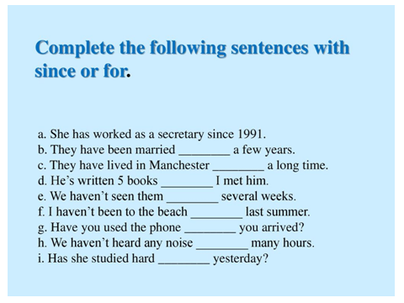  Ex.3 Listening.  Ex.4. |  |  | Board  Projector  Internet  Presentation  Video and images  Handouts with task
Ending the lesson | Giving the hometask.WB ex.4-5 p.7  Self-assessment.How well do I understand?  4 - I can do this and explain it to someone else.  3 - I understand and can do this by myself.  2 - I need more practice.  1 - I don't understand this yet.
End  1min | Feedback: Teacher asks students what task was difficult to them and which pair worked well.
Additionalinformation
Differentiation –  how do you plan to give more support? How do you plan to challenge the more able learners? |  |  | Assessment –  how are you planning to check learners’learning? |  |  | Critical thinking
Differentiation can be achieved by task (selection of learning materials and resources based on student strengths).  By support. Less able learners will be supported through step-by-step instructions, graphic organizers, sentence frames, glossaries, thinking time. Small group learning.  By outcome providing challenge, variety and choice. |  |  | Observe learners when participating in use of English activities.  Record what they considered they had learned from the lesson. Could they express what they had learned about content and language? Could they express which skills they had developed?  Formative assessment is held through observation/monitoring. |  |  | Students think critically, exploring, developing, evaluating and making choices about their own and others’ ideas.

