Директордың оқу –ісі жөніндегі орынбасары ___________ Базылханова А.М.
Unit: Travels and holidays | School: “Secondary school of Karabuta”
Teacher name: | Kasymbekova A.E.
Date: | 24.02.2021
Grade: 6 | .Number present: | Number absent:
Theme of the lesson: | A thank you email
Learning objectives(s) that this lesson is contributing to | 2.U2 Leran to write a letter of thanks  2.L4 Learn to words of thanks  2. Learn to create a dialogue
Lesson objectives | Learners will be able to:  Leran to write a letter of thanks  Learn to words of thanks  Learn to create a dialogue
Lesson plan
Planned timings | Teacher's actions | Pupils` actions | Assessment | Resources
10  minutes | ORGANISATION MOMENT:  Teacher greets students  -Good morning children!  -How are you today?  Please stand up everybody! Take your seats please! Let’s begin our lesson. Who is on duty today? Who is absent?What date is it today? What is the weather like today? | -Good morning teacher  -I`m OK  Students standing in a circle and express warmth to each other | -
10 min  10 min | Let`s start  Missing letters k,a,n,h,t, u,o,y, l,I,a,m,e  Today we will learn to count from A thank you email  Vocabulary  Write a letter- хат жазу  To say thank you- алғыс айту  Thank you ever so much- сізге мың алғыс  Give money to- ақша беру  Thank you once again for everything- барлығы үшін тағы да рахмет  Thank you for being- бар болғаныңыз үшін рахмет  I had a wonderful time with you- мен сізбен керемет уақыт өткіздім  Best regards- ізгі тілектер  - Well done!  Task 1 method- “sequential reading”  Read Tom`s email again and answer the questions.  - Who is Tom writing to?  - What present did she give him?  - What does he promise to do?  .  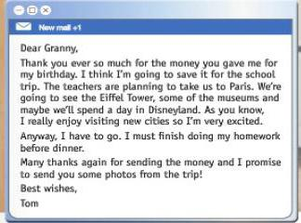  -Excellent!  Task2  Work with the group. Make a poster  Read the email. And answer the questions with group:  - Who write the letter?  - Who is he writing to?  - Why did he said thank you?  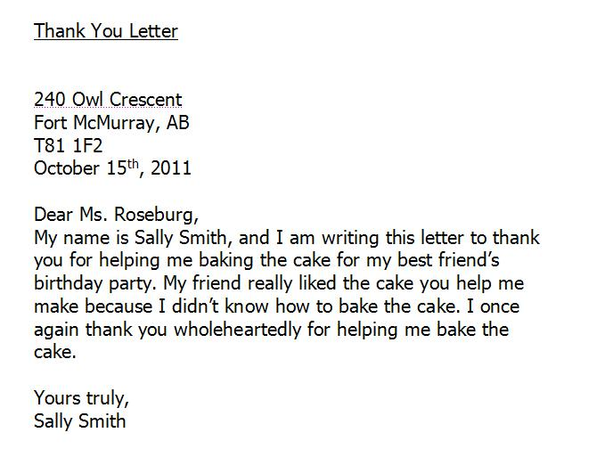  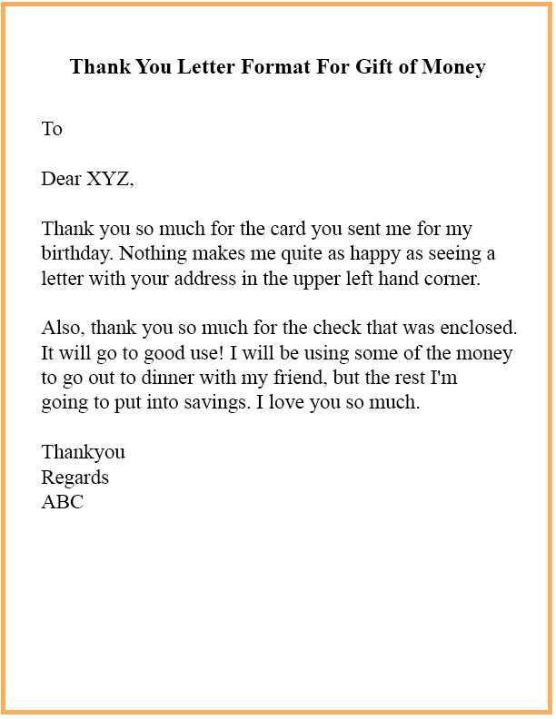  Method: “One riddle -one answer”  Method: “Dictionary Bingo”  Match the words to their meanings  Write a letter, Give money to, I had a wonderful time with you, To say thank you, Best regards, Thank you once again for everything  You've been very active.  Now pupils what's your mood today after the lesson? | Students form words from letter  “Thank you email”  Students writed the words and repeat after teacher  A learner circles the correct answers  A learner  • follows instructions accordingly;  • makes;  • completes the table correctly.  Performs a task I n a group,  Create a poster on the text  Students ask each other`s riddles and answer questions | Formative assessment  Maximum score - 5  Students evaluate each other  Maximum score -5 | Flashcards  Flashcards  Flashcards  poster
10  minutes | ENDING THE LESSON:  Well what did we do in our lesson?  - Evaluation of the lesson  Give the home task: “I`m thank you for you…” essay  Sing a Good bye song | Goodbye, Goodbye see you again  Goodbye, Goodbye see you my teacher.  Goodbye, Goodbye/  I had fun today. | Feedback  Sms me

