|  |  |
| --- | --- |
| *Topic* | Immunity, types of immunity  Иммунитет. Иммунитеттің түрлері |
| *Date* | 22.11.2018 |
| *Class* | 8 grade |
| *Teaching aims* | * To know that vaccination helps individuals to develop immunity against an infection(s) and helps to fight off the infection(s) * To understand vaccines are important to students now and throughout their life * To aware the important diseases prevented by vaccines, and why these are important to young people, including students |
| *Content objectives* | After this lesson, students will be able to:   * describe the immune system, its purpose, and its constituent parts * model the immune system in an abstract way |
| *Language objectives* | **Lexis:** immunity, artificial immunity, natural immunity, vaccine, serum, antibodies, active immunity, passive immunity ,collapses  **Functional language:** comparing, explaining , discussing, analyzing, sorting the cards, describing |
| *Assessment* | * generalize and consolidate knowledge about the types of immunity * find the difference between active immunity and passive immunity * describe the types of immunity |
| *Cognition* | working with definitions and doing research about the topic of “Immunity, types of immunity**”** |
| *Culture* | understanding that topic of immunity is essential for human health |
| *Communication* | * discussing types of immunity * defining key terms * describing difference between immunity and passive immunity |
| *Content* | working with text about “Immunity, types of immunity” and present understanding of the topic |
| *Materials* | Books, A4 papers, colorful pencils, whiteboard |

|  |  |  |
| --- | --- | --- |
| **Stage / Aim** | **Time**  **40 m** | **Procedure** |
| Lead in | 2 min | **T:** Hello everyone!  I am glad to see you.  Please, sit down.  Who is on duty today?  Who is absent today?  I want you to open the copybooks and write down the date.  Today’s lesson is going to focus on “Immunity, types of immunity”. After today’s lesson you will be able to describe the immune system, its purpose, and its constituent parts between active immunity and passive immunity.  We will start with Explanation and we will finish with Activity. |
| Warm up  ( to set the context and activate prior knowledge) | 5 min | **T:** Before we start I want you to open the books on page 88 and think about why you need to put a vaccine  **Ss:** *Students brainstorming why you need to put a vaccine.*  **T:** Well done. Now, Let’s work with new terminology. We will play the game **“Who is faster”**. For this you have to remember the new words that will open on the board. I will give you two minutes to remember. After two minutes the board will be closed. Then you should write the words that you remember in two minutes.  ***Ss:*** *The students will memorize the words and write them in a notebook.*  **T:** Brilliant! Let’s practice these words together. I want you to repeat these words after me! |
| Presentation  (to present the Lymphatic system) | 10 min | **T:** Now, moving on to Explanation let’s open the text on page 88  I want you to work in groups.  1group - artificial immunity  (жасанды иммунитетті түсіндір)  2 group- natural immunity  (табиғи иммунитетті түсіндір)  You need to make a poster and present it.  3 group- write a song with new terms  (жаңа сөздерди қолдану арқылы өлен шығарыңдар)  4 group-module artificial immunity and natural immunity  (табиғи және жасаанды иммунитетті модуль немесе көрініс арқылы түсіндіріңдер)  Иммунитет дегеніміз не?  **http://alashainasy.kz/userdata/01(27).jpg**  Иммунитет (латынша «іmmunіtas» – бір нәрседен құтылу, босау) – қабылдамау, қарсы тұру, ағзаның қорғану қабілеті. Иммунитет – жұқпалы аурулар мен бөгде денеге қарсы тұру. Иммунитеттің негізін салған ғалым – И. И. Мечников. Ағзаны жұқпалы індеттен қорғау тек фагоцитті жасушаларға (лейкоциттер) ғана байланысты емес.Антитела (гр. «anti» - қарсы, орысша «тело» - дене) қанда немесе ұлпада пайда болған бөгде заттарға қарсы ағзада түзілетін ерекше нәруыз. Қарсыденелерді кейде иммуноглобулиндер деп те атайды.«Иммунды серпіліс» - қарсыдененің түзлуі.Антигендер (қарсыгендер) – ағзаға түскен зиянды микробтар, олар бөліп шығарған улы заттар. ЖИТС-жүре пайда болған иммундық тапшылық синдромы. |
| Practice  ( to consolidate the material, to check understanding of the topic) | 8 min | **T:** Now let’s move on to practical activity. I want you to work in pairs and solve the task. (Teacher gives students the envelope with task on it **Attachment 1**). |
| Production (to speak and present the lymphatic system) | 10 min | **T:** Well done. Good job! Now I want you to write a report about which immunity more effective active or passive.  ***Ss:*** *Students do this activity.* |
| Reflection (to reflect on what they have studied) | 3 | **T:** Good job! Thank you. Now, I want you to take stickers and post your tweets about today’s lesson |
| Conclusion (to finish the lesson and set the homework) | 2 | Now, I’d like to recap.  Today we have explored the topic of “Immunity, types of immunity”.  The key things to takeaway is that it has two types of immunity: active immunity and passive immunity .  For the next lesson I want you to read the paragraph on pages 88 and 90 again and do the “Research time” box.  Remember this homeworks is not optional, you must be ready for the next lesson.  Have a nice day! See you soon.  *Т: Хорошая работа! Спасибо. Теперь я хочу, чтобы вы брали наклейки и публиковали свои твиты о сегодняшнем уроке*  *Теперь я хотел бы напомнить. Сегодня мы изучили тему «Иммунитет, типы иммунитета». Ключевыми моментами для вывоза является то, что он обладает двумя типами иммунитета: активным иммунитетом и пассивным иммунитетом. На следующем уроке я хочу, чтобы вы снова прочитали абзац на стр. 54 и 55 и сделали поле «Время исследования». Помните, что домашние задания не являются необязательными, вы должны быть готовы к следующему уроку. Хорошего дня! До скорой встречи.* |

Attachment 1

|  |  |  |  |
| --- | --- | --- | --- |
| **№** | **English** | **Kazakh** | **Russian** |
| 1 | immunity | иммунитет | иммунитет |
| 2 | Artificial | Жасанды | Искусственный |
| 3 | Natural | Табиғи | Естественный |
| 4 | Collapses | Жаппай күйреу | Коллапс, разрушение |
| 5 | antibodies | антиденелер | антитела |
| 6 | Vaccine | Вакцина | Вакцина |
| 7 | Active immunity | Белсенді иммунитет | Активный иммунитет |
| 8 | Passive immunity | Пассивті иммунитет | Пассивный иммунитет |
| 9 | serum | сарысу | сыворотка |

|  |  |  |  |
| --- | --- | --- | --- |
| **№** | **English** | **Kazakh** | **Russian** |
| 1 |  | иммунитет | иммунитет |
| 2 | Artificial | Жасанды |  |
| 3 | Natural |  | Естественный |
| 4 |  | Жаппай күйреу | Коллапс, разрушение |
| 5 | antibodies | антиденелер |  |
| 6 |  | Вакцина | Вакцина |
| 7 | Active immunity | Белсенді иммунитет |  |
| 8 | Passive immunity |  | Пассивный иммунитет |
| 9 |  | сарысу | сыворотка |

9 дұрыс болса- 9 ұпай

6- 8 дұрыс болса- 7 ұпай

1-5 дұрыс болса- 3 ұпай

1 Attachment 2

I want you to work in groups.

1group - artificial immunity

(жасанды иммунитетті түсіндір)

2 group- natural immunity

(табиғи иммунитетті түсіндір)

You need to make a poster and present it.

3 group- write a song with new terms

(жаңа сөздерди қолдану арқылы өлен шығарыңдар)

4 group-module artificial immunity and natural immunity

(табиғи және жасаанды иммунитетті модуль немесе көрініс арқылы түсіндіріңдер)

Attachment 3

**Reflective target**

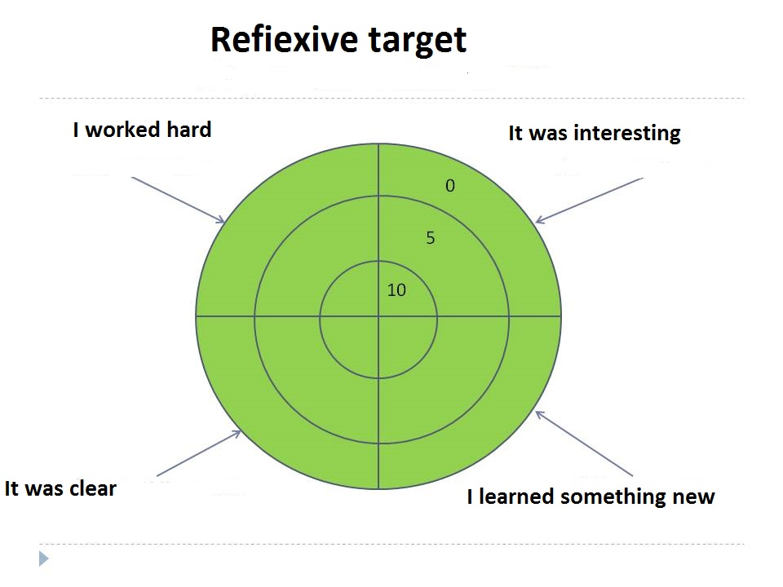

Attachment 4



