Short term plan

Long term plan unit:  Food and Drink |  | Secondary School No.125
Date: |  | Teacher name: Kuatova Aizhan
Grade: 8 |  | Number present: | Absent:
Theme of the lesson: Focusing on food in Kazakhstan
Learning objectives (s) that this lesson is contributing to |  | 8.1.10.1 - use talk or writing as a means of reflecting on and exploring a range of perspectives on the world  8.4.2.1 - understand specific information and detail in texts on a growing range of familiar general and curricular topics, including some extended texts;  8.4.3.1 - understand the detail of an argument on a range of familiar general and curricular topics, including some extended texts;  8.3.4.1 - respond with some flexibility at both sentence and discourse level to unexpected comments on a range of general and curricular topics;  8.3.5.1 - interact with peers to negotiate, agree and organise priorities and plans for completing classroom tasks;
Lesson objectives |  | All learners will be able to: define specific information from the text “Kazakh food” and interact with peers using the names of traditional meals of Kazakh and English and American people via exploring their differences with lots of support  Most learners will be able to: define specific information from the text “Kazakh food” and interact with peers using the names of traditional meals of Kazakh and English and American people via exploring their differences with some support  Some learners will be able to: define specific information from the text “Kazakh food” and interact with peers using the names of traditional meals of Kazakh and English and American people via exploring their differences without support
Assessment criteria |  | Apply talk or writing as a means of reflecting on and exploring a range of perspectives on the world  Identify specific information and detail in texts on familiar topics, including some extended texts;  Define the detail of an argument on familiar topics, including some extended texts;  Answer with some flexibility at both sentence and discourse level to unexpected comments on familiar topics;  Communicate with peers to negotiate, agree and organise priorities and plans for completing classroom tasks;
Value links |  | “Mangilik Yel” Patriotic Act: 3rd value: A secular society with high spirituality
Cross curricular links |  | Kazakh, Russian
ICT skills |  | Interactive board to demonstrate worksheets
Previous learning |  | Grade 8: Learning about healthy food and lifestyle
Plan
Time | Planned activities |  |  | Resources
6 min  9 min  7 min  8 min  10 min | No hands questioning! (Whole class activity)  Differentiation by learning style: I will show this picture on the board to elicit the theme of the lesson, where my visual learners will watch and find, audial learners will listen to my questions and answer.  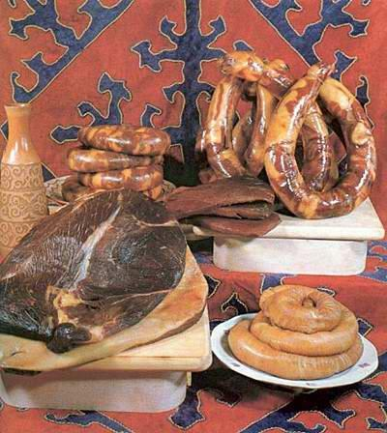  Formative assessment:  Descriptor:  A learner:  - listens to the questions;  - defines the topic of the lesson.  Pair rehearsal (Pair work)  Differentiation by interaction patterns: This time I will ask learners to work in groups. They will discuss and find out the tasks by discussing together.  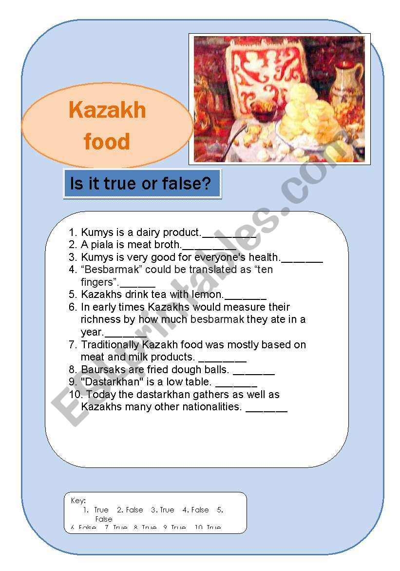  Formative assessment: pair assessment will be used.  New words and new collocations (Whole class activity)  - to give a special welcome  - to offer the place of honor  - fermented mare’s milk  - fried dough balls  - dried cheese balls  - boiled meat and small pieces of dough  - a handmade noodle  - onion stock  - a hardy dish  - a meat broth  - to adopt Kazakh traditions  Skimming (Group work)  Differentiation by levels: learners will read the text about “Kazakh food” for specific information about traditional Kazakh meals.  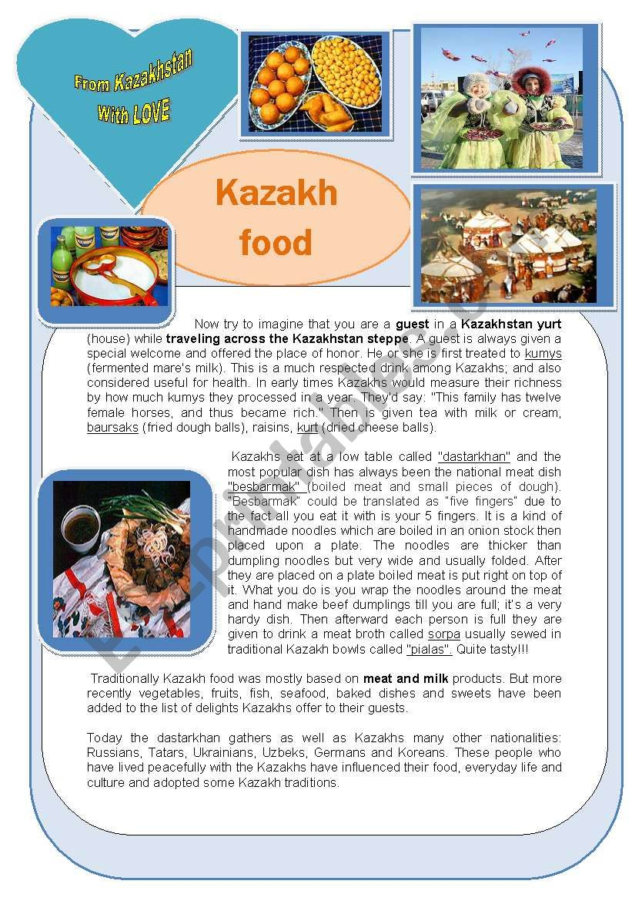  Formative assessment:  Descriptor:  A learner:  - reads the text for specific information about Kazakh traditional meals  Venn diagram (Group work)  Differentiation by resources: I will work with 3 groups of learners: 1st group will compare the meals of Kazakhstan and the UK, the 2nd group will do the task about the UK and USA, the 3rd group will do the task with the USA and Kazakhstan.  Formative assessment:  Descriptor:  A learner:  - defines the traditional meals of compared nationalities; |  |  | https://www.google.ru/search?q=food+in+Kazakhstan+worksheets&newwindow=1&source=lnms&tbm=isch&sa=X&ved=2ahUKEwiN4Mrnxq7sAhWR-yoKHetqAXAQ_AUoAXoECAwQAw&biw=1242&bih=597#imgrc=qpUQ53T_U7CcPM  https://www.google.ru/search?q=food+in+Kazakhstan+worksheets&newwindow=1&source=lnms&tbm=isch&sa=X&ved=2ahUKEwiN4Mrnxq7sAhWR-yoKHetqAXAQ_AUoAXoECAwQAw&biw=1242&bih=597#imgrc=_XlhCMl2sIzkiM  https://www.google.ru/search?q=food+in+Kazakhstan+worksheets&newwindow=1&source=lnms&tbm=isch&sa=X&ved=2ahUKEwiN4Mrnxq7sAhWR-yoKHetqAXAQ_AUoAXoECAwQAw&biw=1242&bih=597#imgrc=m3qzkb_ND-6ZyM
Additional information
Differentiation – how do you plan to give more support? How do you plan to challenge the more able learners? |  | Assessment – how are you planning to check learners’ learning? |  |  | Health and safety check
No hands questioning! (Whole class activity)  Differentiation by learning style: I will show this picture on the board to elicit the theme of the lesson, where my visual learners will watch and find, audial learners will listen to my questions and answer.  Pair rehearsal (Pair work)  Differentiation by interaction patterns: This time I will ask learners to work in groups. They will discuss and find out the tasks by discussing together.  Skimming (Group work)  Differentiation by levels: learners will read the text about “Kazakh food” for specific information about traditional Kazakh meals.  Venn diagram (Group work)  Differentiation by resources: I will work with 3 groups of learners: 1st group will compare the meals of Kazakhstan and the UK, the 2nd group will do the task about the UK and USA, the 3rd group will do the task with the USA and Kazakhstan. |  | No hands questioning! (Whole class activity)  Formative assessment:  Descriptor:  A learner:  - listens to the questions;  defines the topic of the lesson.  Pair rehearsal (Pair work)  Formative assessment: pair assessment will be used.  Skimming (Group work)  Formative assessment:  Descriptor:  A learner:  - reads the text for specific information about Kazakh traditional meals  Venn diagram (Group work)  Formative assessment:  Descriptor:  A learner:  defines the traditional meals of compared nationalities;
Reflection
Were the lesson objectives/learning objectives realistic?
Did the learners achieve the LO?
If not, why?
Did my planned differentiation work well?
Did I stick to timings?
What changes did I make from my plan and why?

Summary evaluation
What two things went really well (consider both teaching and learning)?

1:

2:
What two things would have improved the lesson (consider both teaching and learning)?

1:

2:

What have I learned from this lesson about the class or achievements/ difficulties of individuals that will inform my next lesson?

