LESSON: Module 5 Lesson 5 |  |  |  | School: №10th of secondary school
Date: 21/22.01.2019 |  |  |  | “Our health”
Grade: 6 «Г/З» |  |  |  | Number present: | Absent:
Learning  Objectives (s)  that this  lesson is  contributing  to |  | 6.2.5.1- understand most specific information and detail of supported,  extended talk on a range general and curricular topics curricular topics;  6.3.7.1- use appropriate subject-specific vocabulary and syntax to talk about a  limited range of general topics, and some curricular topics  6.1.9.1- use imagination to express thoughts, ideas, experiences and feelings;  6.3.6.1- communicate meaning clearly at sentence and discourse level during pair,  group and whole class exchanges;  6.4.5.1- deduce meaning from context on a limited range of familiar general and  curricular topics, including some extended texts;  6.1.8.1- develop intercultural awareness through reading and discussion;  6.5.6.1- link, with minimal support, sentences into coherent paragraphs using basic  connectors on a growing range of familiar general topics;
Lesson  Objectives |  | All learners will be able to:  To read and listen for gist, to read for specific information, to listen for specific  information, to order food, to design a healthy takeaway menu
Most learners will be able to:
To read and listen for gist, to read for specific information, to listen for specific
information, to order food, to design a healthy takeaway menu
Some learners will be able to:
To listen and read for gist, to read for specific information, to read for
comprehension, to give health advice, to write a text message giving advice
Previous learning |  | Grammar
Plan
Planned timings | Planned activities |  |  |  | Excel Resources
Beginning the  Lesson | To present a menu  Ask Ss to look at the pictures. Play the recording. Ss listen and repeat chorally and/or individually.  Elicit the L1 equivalent for each word.  Task 1. Vocabulary. Look at the menu. Listen an repeat. What are these words in ypur language?  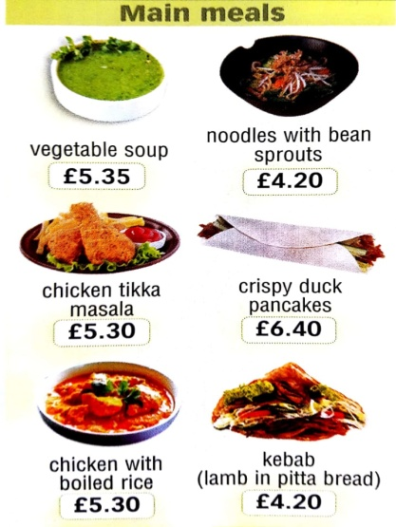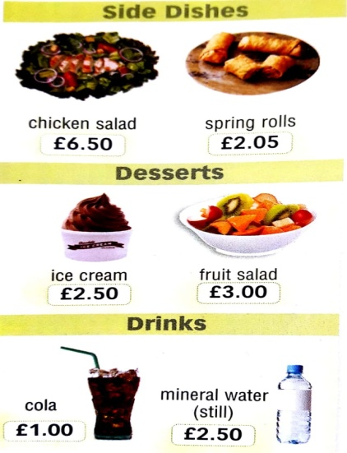
Main  Activities | To consolidate new vocabulary  Ask various Ss around the class to choose items from the menu according to their taste.  Task 2. Choose from the menu and say. Check these words.  Dish nation calorie compared order  [ dɪʃ] [ˈneɪʃən] [ˈkælər]i [kəmˈpeəd] [ˈɔːdə]  Тағам халық калория салыстырғанда тапсырыс  boiled fried immigrant snack owner  [bɔɪld] [fraɪd] ˈ[ɪmɪgrənt] [snæk] [ˈəʊnə]  Қайнатылған қуырылған келімсек басытқы қожайын  To listen and read for gist  Play the recording. Ss listen and follow the text in their books to find out about typical British takeaways.  Task 3. Read and listen to find out.  Healthy takeaway  Brits love takeaway food, but some dishes are healthier some others.  Chinese food. The first Chinese restaurant opened in London over a hundred years ago, and now it’s one of the nation’s favourite takeaways. But next time, try noodles with bean sptrouts, witch has very few calories compared to crispy duck pancakes or spring rolles.    Indian food. British people love curries. They spend 250$ million a year on them and them usually order to much food. Why not share your chicken tikka masala with a friend? Anmd make sure your order boiled rice, which has very little fat, rather than fried rice.    Kebabs. Immigrants from Turkey and Cyprus brought kebabs to Britain. Now they are a favorite nighttime snack. But ask the owner just to put a bit of meat on the pitta bread, and fill it up with salad.  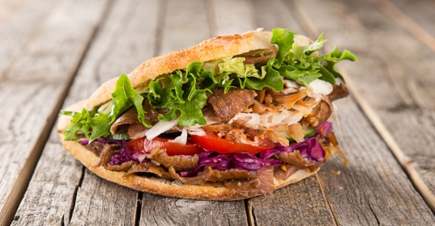  To read for specific information  Give Ss time to read the text again and complete the sentences.  Check Ss' answers. Task 4. Read again and complete the sentences.  - The first Chinese restaurant was opened _______________  - Spring rolls have more calories than _______________  - Fried rice has more fat than _________________  - Brits often eat kebabs at _______________  To check meanings of unknown words  Tell Ss to lookup the meanings of any words in the text they can't understand in their dictionary. Help Ss while they are looking up the unknown words. As an extension, ask Ss to make sentences using the unknown words.
Ending the  lesson | To express an opinion  Ask various Ss around the class to share their personal preference with the rest of the class.
Reflection  Differentiation – how do you plan to  give more support? How do you plan  to challenge the more able learners? |  |  | Assessment – how are you planning  to check learners’ learning?
support weaker learners with further  modelling and drilling in their pairs  stronger learners who complete  activities quickly should spell new  words aloud for others to copy in  their notebooks |  |  | check pronunciation of new  language through group and  individual drilling  check comprehension of listening  and reading text through follow-up  questions

