**Effective planning for team-teaching**

Team-teaching has become one of the pedagogical innovations in Kazakhstan and raises number of questions from the part of school teachers. It is believed that co-taught lessons will become a significant part of Kazakhstani teaching curriculum. With the launch of new educational programs in Nazarbayev Intellectual Schools (NIS) throughout of the country only these schools experience the holistic approach of team-teaching. However, country’s secondary state schools have started applying new approaches since NIS schools are disseminating their teaching and learning experience all over the country. This article shares secondary school teachers’ perspectives and challenges they encountered while experiencing team-teaching with colleagues.

Findings

After interviewing teachers and observing their lessons it was known that teachers are highly inspired with this way of working as well experiencing number of challenges. The key findings the study shows are an effective classroom assessment, the opportunity to manage the classroom with more than fifteen students, motivated students, and the necessity to plan the co-taught lessons effectively.

Effective lesson delivery is always a product of a good planning which in its turn derives from a detailed consideration of each stage of a lesson, including warm-up, introduction or hook, presentation, practice and evaluation.

The lesson begins with a question and a willing class responds with enthusiasm. Two teachers pass a satisfied glance between them and the minutes pass swiftly as another teaching objective is reached.

As the lesson ends the students have experienced an almost casual lesson, one that they enjoyed, and one in which they made good progress. They did not see the thought that went into it, nor did they realize the amount of effective planning it took to achieve it.

Teachers also mentioned the importance of teaching philosophies. Teachers state that for two teachers to work together effectively they need to share a common teaching philosophy. So, before teaching, make sure that you agree with the way your partner teaches. In this way team teaching can continue in harmony.

Most importantly, teachers focus on personalities, it is essential that you get along well with your team teacher, there has to be some kind of friendly relationship between you. There should be a mutual respect and trust. For this reason teachers should be encouraged to choose their team teaching partners.

Once the personalities have been considered the paperwork must begin. Teachers believe that in order to start planning and discussing the coming lessons, it is very crucial to establish good relationship since team teaching requires contribution of each member to deliver effective lessons to enhance students’ learning. One of the teachers state:

“With the pacing document in hand it then becomes the job of each team teaching pair to prepare the lesson plans for each week. There is often a sharing of ideas and resources between teams, but to ensure continuity between the teams we hold a weekly planning meeting. At this meeting we stick to a simple agenda which consists of – what we did last week and how did it go. What we will teach this week and how it will be assessed”.

*Figure 3. Planning wheel*

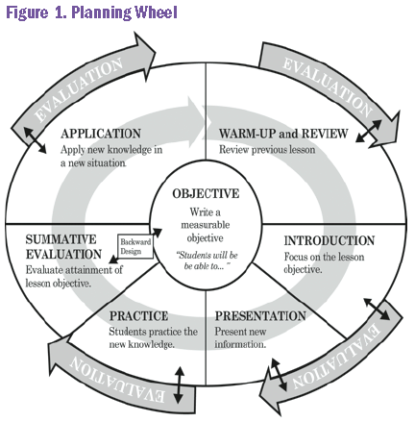

According to teachers, from formal kind of planning a much less formal planning continues. Team teachers are always talking about finding good resources, how to deliver an idea, methods of assessment, helping individual students, and improving what they do from one lesson to another. In this way team teachers hope learn from their mistakes and encourage themselves by their successes.

Teachers confessed that not every pair can start working successfully in team teaching. One teacher states:

“There is one aspect of our work together that we have not yet mentioned, but it is by far the most important, even more important that effective planning. There are many ways of team teaching but in our view only one that will be fully successful, it is this – team teaching has to be a partnership between two equals. That is not necessarily between two people who share an equal knowledge base or experience, but two people who treat each other equally and with respect. Each has something to learn from the other, and each has something to teach.

Effective planning is at the heart of successful team teaching but effective planning can only come from an atmosphere or respect and equality.

Effective planning entails the fulfillment of course plan which is designed for an academic year, mid-term plan- which is developed by teachers for the term and short plans which are daily plans. In order to bring the effective lessons, teachers gather to discuss the upcoming lessons, expected outcomes, resources to be used in those lessons, and, of course, assessment tools, how the students’ learning is going to be assessed. Assessment is important part of the lesson and teachers discuss the details of it beforehand and prepare needed resources.

Teachers emphasize the planning particularly in team teaching, because as two teachers are involved in the teaching process they both should know the details of the lesson to be taught. After teachers appoint the time for lesson plan discussion, each teacher shares his or her ideas for the lesson and asks what the other teacher thinks of it. They ask questions on how this will look like, what are their learning objectives, what classroom strategies would suit best, will there be some group work, pair work, how they are going to observe each student’s participation, which resources they should prepare, and how they are going to assess their learning. Moreover, after the lesson teachers settle again to talk and reflect how the things went in the lesson, should they change something, how did students respond?

An effective lesson does not appear by accident, it requires a detailed understanding of the subject and curriculum, an appreciation of students and their needs, sharing of expertise and methodology and a continual process of planning.

References

1. Graphic acknowledgement: retrieved from - https://teal.ed.gov/tealguide/lessonplanning
2. http://citeseerx.ist.psu.edu/viewdoc/summary?doi=10.1.1.163.1645