LESSON: Unit 3 My family and friend  Family & friends:She is…/ He is …/You are…/I’m… |  |  |  | School: №18
Date: 22.10, 23.10 |  |  |  | Teacher name: Gazizova.M
CLASS: 1 M,Z,E |  |  |  | Number present: |  | absent:
Learning objectives(s) that this lesson is contributing to |  | 1. UE 7 use personal subject pronouns to identify things  1. S5produce words in response to prompts  1. L3recognise with support simple greetings recognise the spoken form of a limited range of basic and everyday classroom words
Lesson objectives |  | All learners will be able to:
 |  | - listen and repeat the words according to the topic “Family & friends:She is…/ He is …/You are…/I’m…”
 |  | Most learners will be able to:
 |  | - recognise and name some words according to the topic“Family & friends:She is…/ He is …/You are…/I’m…”
 |  | Some learners will be able to:
 |  | - nameand use most of the words according to the topic“Family & friends:She is…/ He is …/You are…/I’m…”
Previous learning |  | Unit revision. My school
Plan
Planned timings | Planned activities (replace the notes below with your planned activities) |  |  |  |  |  | Resources
Beginning | Warm up  T. invites Ss to the circle and asks weakerSs different kind of questions (T. asks questions one by one and uses pictures if it is needed. T. can prompt if Sscan’t understand and answer) while stronger Ss are given pictures with prompts to describe. e.g.:  1. Hello. How are you?  2. What is your name?  3. What is her/his name?  4. What colour is it? (yellow, blue, black, red, purple)  5. How many ...... have you got? (pens, books, rulers, desks, pencils)  6. What have you got in your bag? (pens, books, rulers, desks, pencils)  7. What letter is this? (D,T,F,P,S,B) |  |  |  |  |  | Handouts-1  Handouts-2  Handouts-3  Handouts-4
Middle | Main:  - T. invites Ss to stand in a circle and demonstrates the words I’m … You are … e.g.: I’m Assel, You are Denis. The next S. turns to the neighbour S. and says his/her name and next S’s name, e.g.: I’m Denis You are Kira; I’m Kira, You are Masha,etc.  - T. presents new words using PPT: family,mummy, daddy, brother, sister, baby when the words are presented,Ss should repeat after T. Then T. explains the differences of He is and She ise.g.:Mummy – she is, Daddy – he is, brother – he is, sister – she is.  - Then T. says to take finger puppets and demonstrates He is … She is… e.g.: He is Daddy, She is Mummy, He is brother, She is sister, he is baby.  - T. divides Ss into pairs by favouritecolours and asks them to sit together. T. gives finger puppets to practice the words. T. explains that each S. should show his/her finger puppets to his/her own partner and say the word.  - T. practices new phrases in the song about family  several times:-How do you do? -Where are you? -Here I am  (T can give the translation of these phrases)  - Ss sing a song several times using their finger puppets.  At the end Ss sing it themselves without video support using finger puppets.  - T. gives out a family book with the pictures ofrooms and different places and pictures of family members. Ss should cut the pictures and glue them on the appropriate page, e.g.:Mummy is in the kitchen, Daddyis in the office, etc. But there is no right place of pictures it depends on S’s imagination. Let the Ss to work on their own. |  |  |  |  |  | `  PPT  Handouts of finger family  Handouts 1  Handouts of finger family  https://www.youtube.com/watch?v=YJyNoFkud6g  Handouts of family book
End | Plenary  All learners will revise new words using their ‘Family book’. T. asks S. who finishes first to introduce his/her book.  T. awards Ss with smiley faces  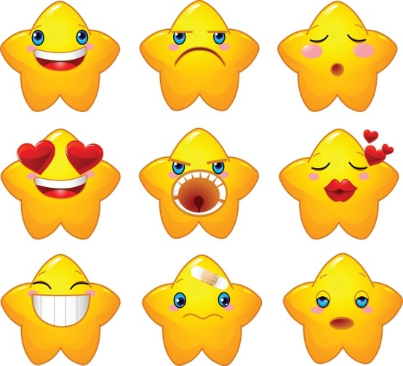
Additional information
Differentiation – how do you plan to give more support? How do you plan to challenge the more able learners? |  |  | Assessment – how are you planning to check learners’ learning? |  | Cross-curricular links  Health and safety check  ICT links  Values links
- When Ss work in a circle T. gives different levelled task according to S’s ability  - Weaker Ss work with T’s support  - Stronger Ss work on their own |  |  | - When T asks questions,Ss sing a song and they do an activity in a circle  - Family book will be assessed by smiley faces |  | - Maths – when Ss count school things  - Kazakh and Russian languages – when Ss name the family members  - Sswill be safely arranged and seated in front of the monitor away from electrical outlets and cables.  - ICT links – when T. shows PPT and presents the song  - Working in a circle Ss will develop their friendship and working with ‘Family book’ Ss will develop their imagination and critical thinking skills.  - Ss will appreciate their family and friends

