План урока 4 класс
Body Language
Абитаева Асем Жамбыловна
учитель английского языка
«Средняя общеобразовательная школа № 43» г. Тараз
Learning objectives(s) that this lesson is contributing to | 4.1.1.1 understand an increasing range of classroom instructions;  4.2.1.1 make basic statements which provide information on an increasing range of general and some curricular topics;  4.3.1.1 recognise, identify and sound with support a growing range of language at text level;  4.4.2.1 begin to use joined-up handwriting in a limited range of written work;  4.5.1.1 use singular nouns, plural nouns – including some common irregular plural – and uncountable nouns, possessive ‘s/s’ to name, describe and label things;  4.5.6.1 use demonstrative pronouns this, these, that, those and object pronouns in short statements, questions and responses
Lesson objectives | Learners will be able to:  talk about ways of communication using demonstrative pronouns this, these, that, those and object pronouns in short statements, questions and responses

Lesson plan
Planned timings | Teacher's actions | Pupils` actions | Assessment | Resources
10  minutes | ORGANISATION MOMENT:  Teacher greets students | Students respond to greeting and take their places | -
20  minutes | MAIN PART  1 Look at the picture. What are the children doing? Have you got any of these gadgets? If yes, what do you use them for?  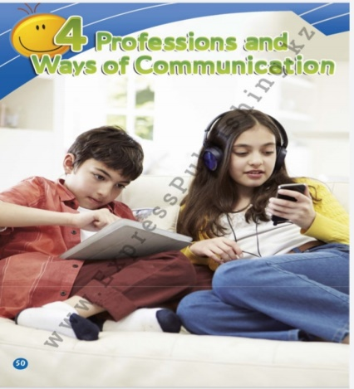  Pupils' books closed. Write the word gadget on the board. Ask the pupils if they know what gadgets are and elicit the names of different gadgets (e.g. tablet, mobile phone, earphones, etc).  Pupils' books open. Ask the pupils to look at the pictures on p. 48 and have a picture discussion. Point to the boy and ask: What is he holding? Elicit: A tablet. Then ask: What is he doing? Elicit answers (e.g. He's playing games.) Repeat the same for the girl. Ask the pupils if they have any of these gadgets and what do they use them for. Elicit answers from individual pupils.  Suggested answer key  I have a tablet. I use it to watch videos online.  Look, read and choose the correct answer.  Read aloud the sentences, one at a time, and ask the pupils to choose the correct word. The pupils look at the pictures and complete the activity orally first, then in writing.  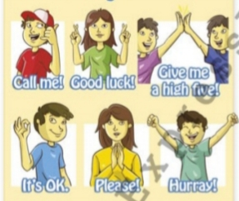  Answer key1 kiss 2 shake 3 hug 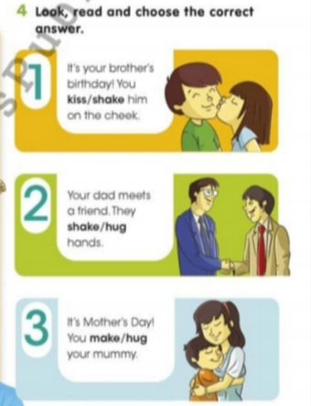 | pupils if they have any of these gadgets and what do they use them for. Elicit answers from individual pupils.  pupils to choose the correct word. The pupils look at the pictures and complete the activity orally first, then in writing.  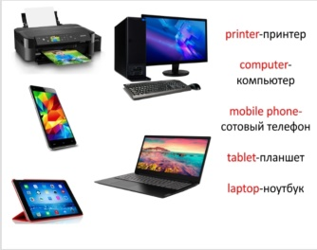 | Formative assessment | Progress Report Cards  PB
10  minutes | ENDING THE LESSON:  Well what did we do in our lesson?  - Evaluation of the lesson  Give the home task  Sing a Good bye song | Children sing a Good bye song | Feedback | https://www.youtube. com/watch?v= Xcws7UWWDEs

