Long-term plan Unit 5: Health and body | School:10
Date: Term 3  Book: Smiles 2 | Teacher name: Dana Sapargalievna
Grade: 2 | Number present: |  | Absent:
Theme of the lesson: | Parts of body
Learning objectives(s) | 2.R1 read and spell out words for others  2.R4 use a simple picture dictionary with support  2.S8 give simple instructions for others to follow
Lesson objectives | All learners will be able to:  - read and spell out words parts of body for partner  - read with support a simple picture dictionary  - give simple instructions for others using cards  Most learners will be able to:  - use a simple picture dictionary for matching without any support  - give simple instructions for others without any support  Some learners will be able to:  - read and spell out words using can\can’t without any support
Language objectives | Parts of body: ear, eyes, mouth, nose, head, shoulders, knees, toes.  Hear, look, eat, touch, open your eyes, close your eyes
Success criteria | - Name the new vocabulary correctly  - Read words  - Spell out words for others  - Follow instructions
Value links | National unity, peace and harmony in our society
Cross curricular links | PE, self-knowledge
Level of thinking skill | Application
ICT skills | Active board, cards, pictures
Previous learning | Modal verb can\ can`t
Plan
Planned timings | Planned activities |  |  |  | Resources
Beginning  0 – 8 min  Middle  8 -35 min | Greeting  (W) Warm up “Touch game”:  Teacher quickly says any parts of body using verb “touch” For example touch your eyes etc., learners should do the teacher’s instructions.  (D) Presentation the lesson objectives:  T: Children, today we are going to learn what we can do with our parts of body.  TPR T introduces new verbs (action verbs) with using cards. The new verbs:  Hear  Eat  Look  Teacher spells out the new words with learners and then gives instructions with new words and learners should show them. Teacher uses nouns such as eyes, ears, mouth and make sentences with them. F\e I can hear with my ears and tells them to learners.  (I)Task 1  Learners should match the pictures with words  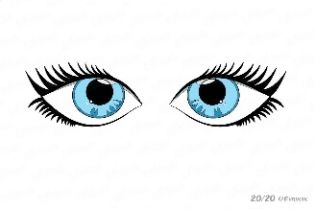 Hear  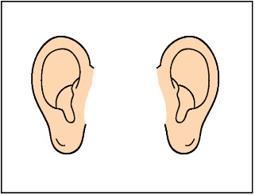 Look  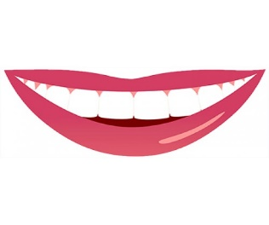 Eat  (P) Task 2 Remote controller  Teacher divides learners into pair groups and gives them a remote controller and learners should do the partner’s instruction. For example S1:  Close your eyes. S2 closes his eyes.  Assessment: peer assessment. Traffic lights. For each correct answer the student gets a green circle  Differentiation by support:  Less able students will be given cards with words of parts of body.  More able students work without any support.  Physical exercise  Head, Shoulders, Knees and Toes  Head, shoulders, knees and toes,  Knees and toes.  Head, shoulders, knees and toes,  Knees and toes.  And eyes, and ears, and mouth,  And nose.  Head, shoulders, knees and toes,  Knees and toes.  Task 3 (I)  Fill in the missing letters. Spell and read the words.  Example:  Eye  Assessment criteria  •Read words  •Spell out words for others  Descriptor  A learner should  •completes the words with the missing letters;  •spells out and reads words appropriately.  Differentiation by Extension: for more able student will be given the same task but in addition to this task they should make sentences using modal verb ‘can’.F e I can look with my eyes. I can eat with my mouth.  4.Task  (G)“Gloves”  Learners should read all the words and find the odd one . One of this word will be odd. For example  1.Head  2.Mouth  3.Eyes  4.Pencil  5.Ear  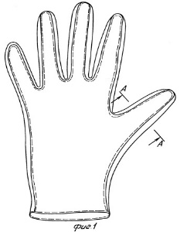 |  |  |  | Body parts song  http://www.youtube.com/watch?v=7y_TUJy2TY8  Pictures  Worksheet 1  Cards  https://www.youtube.com/watch?v=h4eueDYPTIg  Worksheet 2
End  5 mins | Reflection : By asking questions  What can we do with our eyes?  What can we do with our hands?  What can we do with our ears?  What can we do with our mouth?  Hometask: teacher gives cards to student and explains it |  |  |  | https://www.allkidsnetwork.com/worksheets/body/body-missing-letters-worksheet.asp
Additional information
Differentiation – how do you plan to give more support? How do you plan to challenge the more able learners?  Support for weaker students: working in pairs/groups, individually  Challenges for moreable students: Encouraged to do more writing; assist weaker students. |  | Assessment – how are you planning to check learners’ learning? |  | Health and safety check  ICT links  Video, PPT
Differentiation can be by task, by outcome, by individual support, by selection of teaching materials and resources taking into account individual abilities of learners (Theory of Multiple Intelligences by Gardner).  Differentiation can be used at any stage of the lesson keeping time management in mind  Differentiation by task, by outcome, by individual support, by selection of teaching materials and resources taking into account individual abilities of learners. |  |  |  | Health promoting techniques  Breaks and physical activities used.  Points from Safety rules used at this lesson.
Reflection  Were the lesson objectives/learning objectives realistic? Did all learners achieve the LO?  If not, why? Did my planned differentiation work well? Did I stick to timings? What changes did I make from my plan and why? |  | Use the space below to reflect on your lesson. Answer the most relevant questions from the box on the left about your lesson.

